**BANDAGE LAYERS AND THEIR FUNCTIONS:**

The goals of bandaging include limiting hemorrhage, immobilizing the area, preventing further trauma or contamination of the wound, preventing wound desiccation, absorbing exudate, controlling infection, and aiding in mechanical debridement of the wound. When constructing bandages, several principles must be followed to avoid complications. The bandages should be sufficiently padded, applied evenly and snugly, composed of three layers (primary, secondary, and tertiary), and placed to avoid traumatizing the newly formed granulation tissue or epithelium.

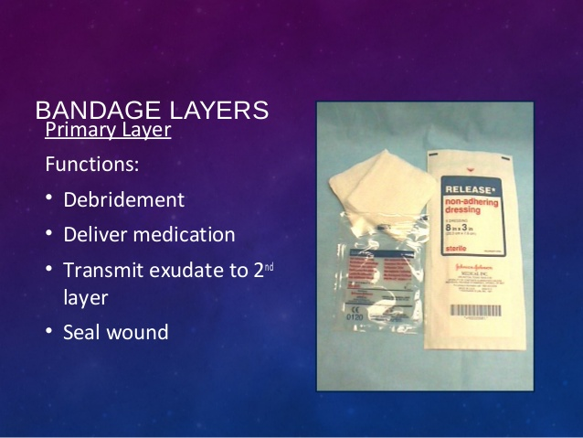

The first or primary layer directly contacts the wound to allow tissue fluid to pass through to the secondary layer. The first layer may be adherent or nonadherent. A nonadherent bandage is usually a fine mesh or foam, nonstick material and is indicated when a healthy granulation bed has developed. This layer prevents tissue desiccation and causes minimal trauma. An adherent bandage uses a wide mesh material that allows tissue and debris to become incorporated into the bandage. This debris is then removed with the bandage change. Adherent bandages are classified as dry to dry, wet to dry, or wet to wet based on the composition of the primary layer. Dry-to-dry bandages consist of dry gauze applied to the wound. The bandages are painful to remove but enable excellent tissue debridement. Wet-to-dry bandages are made with saline-moistened gauze placed directly on the wound. They are also painful to remove but result in less tissue desiccation than dry-to-dry bandages. Wet-to-wet bandages tend to damage the tissue bed by keeping it too moist. Newer bandage materials may be impregnated with various materials, such as silver, to help control infection.

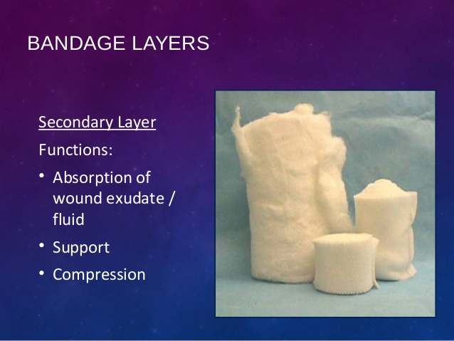

The secondary layer of a bandage absorbs tissue fluid, pads the wound, and supports or immobilizes the limb. This layer is frequently composed of cast padding or roll cotton.

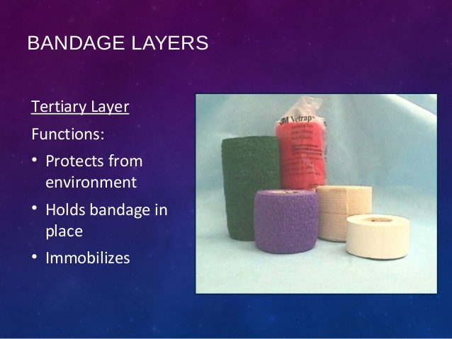

The tertiary layer functions to hold the primary and secondary layers in place, provide pressure, and keep the inner layers protected from the environment. This layer is composed of adhesive tape or elastic wraps.