**Hoof Trimming Technique**

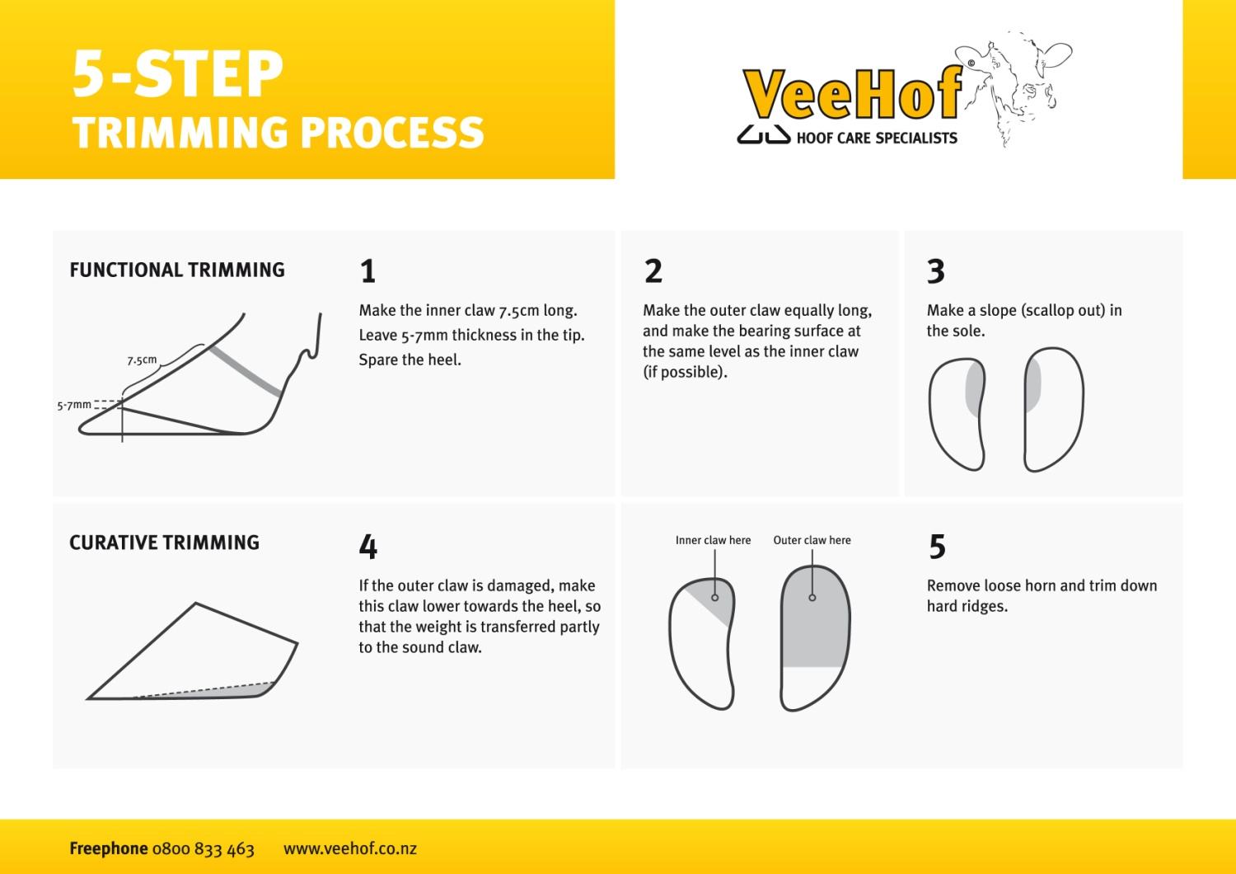

Proper claw trimming forms the foundation of a comprehensive foot health program. By recognizing certain claw trimming fundamentals, one can help reduce the risk of lameness caused by claw trimming miscues.

Following is an overview of the four-step functional claw trimming procedure, which is a slight modification of the original Dutch three-step procedure developed by E. Toussaint Raven. Each and every foot of the cow should be approached under this four-step process during claw evaluations to avoid over-trimming. This functional trimming process can be used to treat claw lesions.

## Step 1: Toe Length

* Start by measuring from the front wall (just below the hairline to the tip of toe) of the inside claw on the hind feet.
* Any claw length longer than 3 inches (7.5 cm) should be removed by making a cut perpendicular to the sole. This leaves a square end on the toe.
* First trim the inside claw on hind feet to the correct length, then trim the outside claws to match. Repeat this process when trimming the front feet, starting with the outer claw first.

***Related trimming tip***: three inches (7.5 cm) is the appropriate toe length for an average Holstein cow. For large cows and bulls, appropriate toe length is 3.25 inches (8.125 cm). Never trim less than 3 inches (7.5 cm), unless it is a young heifer.

## Step 2: Sole Thickness

* Claw length and sole thickness at the toe are directly correlated. Sole thickness should be measured at the tip of the toe where the cut was made. Anything greater than 0.25 inch (0.625 cm) in depth can be removed.
* Sole should be trimmed flat from front to back. Avoid removing horn from the heel of the inside hind claws. Be sure to leave a sole thickness of 0.25 inch (0.625 cm) at the tip of the toe.
* Avoid trimming claws that are less than 3 inches (7.5 cm) in length or have less than 0.25 inch (0.625 cm) sole thickness. Typically in these situations, only the outside rear claw needs trimming to correct overgrowth and imbalance.

***Related trimming tip***: sole thickness should never be less than 0.25 inch (0.625 cm). The sole should not be flexible under finger/thumb pressure.

## Step 3: Heel Depth

* Heel depth should be measured at the heel-wall juncture (outside of claw) from just below the hairline to the bottom of the sole. Only trim horn from the heel when this measurement is more than 1.5 inches (3.75 cm).

***Related trimming tip***: strive to maintain a heel depth of 1.5 inches (3.75 cm). Cows housed on concrete typically lack heel depth.

## Step 4: Claw and Heel Balance

* A flat, weight-bearing surface between the inner and outer claws should be achieved throughout the trimming process. ***Caution***: soles should not be trimmed so they flex under finger/thumb pressure.
* Evaluate claw and heel balance: hold front walls of both claws together and place a flat object across both toes, across both heels, and from toe-to-heel on both claws. No light should be visible underneath the flat surface for heel and toe-to-heel measurements.

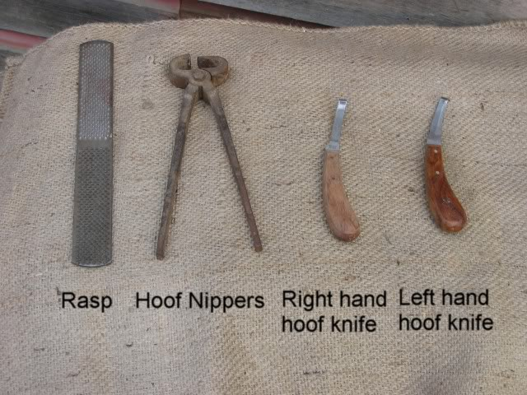 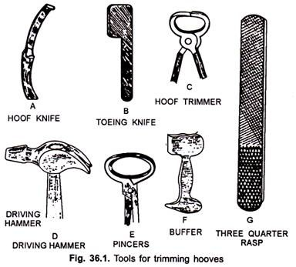

FIGURE 1: TOOLS USED IN HOOF CARE.

### Hoof trimming is vital

Every cow on the dairy should see the hoof trimmer once a year at a minimum – several times per year is even better when there are known problems such as heel wart. Yes, it’s another job that has to be scheduled and managed. Hoof trimming should be part of the regular herd management routine just like vaccination programs and dry cow treatments. If every cow gets her feet trimmed at least once a year, there’s much less chance of foot problems in the future.