**Step 1. Trim toe 'length'** **to 7.5 cm (more or less in some cows)**

For hind feet, trim the inner claw (most normal)

For front feet, trim the outer claw (most normal)

* Start by measuring from the front wall (just below the hairline to the tip of toe) of the inside claw on the hind feet.
* Any claw length longer than 3 inches (7.5 cm) should be removed by making a cut perpendicular to the sole. This leaves a square end on the toe.
* First trim the inside claw on hind feet to the correct length, then trim the outside claws to match. Repeat this process when trimming the front feet, starting with the outer claw first.

***Related trimming tip****: three inches (7.5 cm) is the appropriate toe length for an average Holstein cow. For large cows and bulls, appropriate toe length is 3.25 inches (8.125 cm). Never trim less than 3 inches (7.5 cm), unless it is a young heifer.*

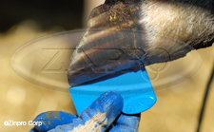

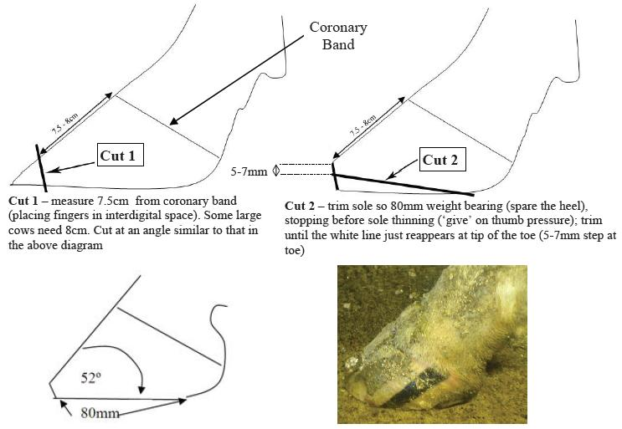

**Step 2. Trim second claw to match trimmed claw - matched rather than measured**

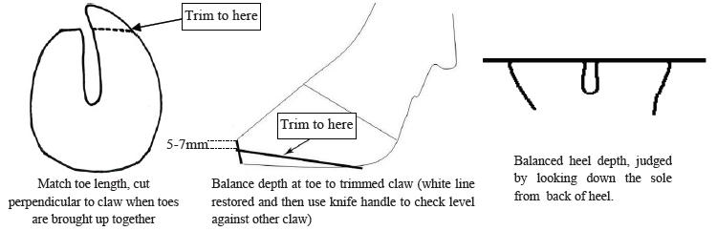

The outer hind claw has a longer natural toe length and so must not be measured to 7.5cm, but should be matched to the correctly trimmed inner claw. Step 2 corrects any obvious imbalances in weight bearing between inner and outer claws.

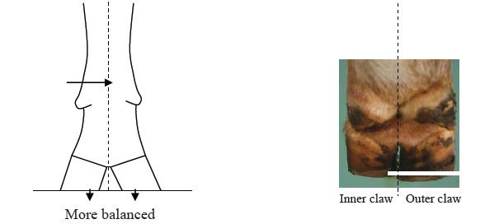

While equal weight bearing is probably ideal, for some animals a naturally shallow heel on the inner hind claw can leave the outer claw over-trimmed and exposed to bruising if completely equal weight bearing is attempted. Therefore, caution is advised when trimming down heels, with frequent checking of sole depth and slight imbalance preferred to thin soles in the heel of the outer hind claw.

**Step 3: Sole Thickness**

* Claw length and sole thickness at the toe are directly correlated. Sole thickness should be measured at the tip of the toe where the cut was made. Anything greater than 0.25 inch (0.625 cm) in depth can be removed.
* Sole should be trimmed flat from front to back. Avoid removing horn from the heel of the inside hind claws. Be sure to leave a sole thickness of 0.25 inch (0.625 cm) at the tip of the toe.
* Avoid trimming claws that are less than 3 inches (7.5 cm) in length or have less than 0.25 inch (0.625 cm) sole thickness. Typically in these situations, only the outside rear claw needs trimming to correct overgrowth and imbalance.

*Related trimming tip: sole thickness should never be less than 0.25 inch (0.625 cm). The sole should not be flexible under finger/thumb pressure.*

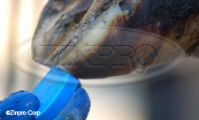 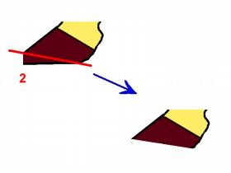

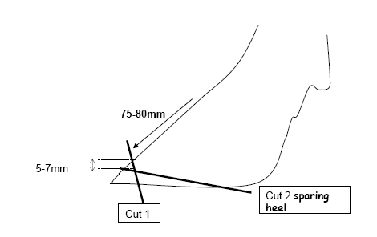

Use hoof knife to flatten walking surface of the toe.  The walking surface is where the white line starts on the axial part of the hoof.

Use hoof knife to blend-in the lateral aspect of the sole over the white line.  Remember to keep it as flat as possible. Try to stay away from the heel area.  It is important to conserve as much heel as possible.

**Dish out the** **ulcer site** (shaded area)

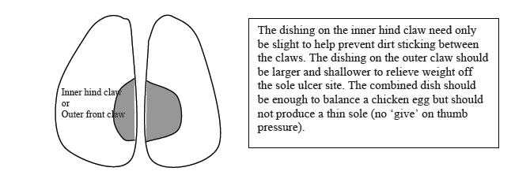

This step transfers weight from centre of the sole onto the wall, toe and heel.

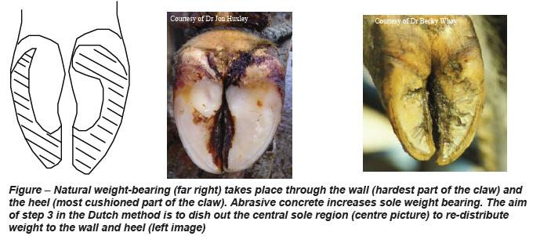

The claw has evolved to absorb concussive forces and bear weight through the heel, wall and sole next to the wall. The heel acts like the suspension, absorbing concussive forces as the foot strikes the ground. The wall is the hardest and toughest part of the claw, able to withstand the wear and tear from harsh underfoot surfaces. Carefully dishing out the central sole will aid this function. To be effective, a greater dished area by 2:1 is required for the outer hind claw compared with the inner9.

That completes the functional trim. For the functional trim, only excess horn should ever be removed. It also prepares the foot for inspection prior to the corrective trim.

**Step 4: Heel Depth**

Heel depth should be measured at the heel-wall juncture (outside of claw) from just below the hairline to the bottom of the sole. Only trim horn from the heel when this measurement is more than 1.5 inches (3.75 cm).

*Related trimming tip: strive to maintain a heel depth of 1.5 inches (3.75 cm). Cows housed on concrete typically lack heel depth.*

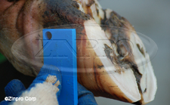

Relieve weight off a painful claw - trim down the heel horn or fix a block to the healthy claw

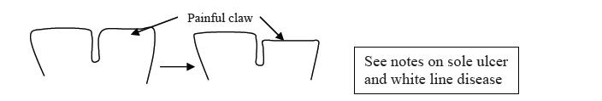

Relieving weight off a painful claw can be achieved in two ways. If there is a good depth of heel horn on the unaffected claw, then the heel horn on the painful claw can be trimmed down (red arrows below). Alternatively, a plastic, rubber or wooden block can be applied to the healthy claw for 6-8 weeks. However, in some cases, bruising or under-run horn may be present on the non-painful claw, making it unhealthy and unsuitable for blocking. These cases require a straw yard or nursing paddock to aid recovery. If in doubt about a case, always ask your vet for advice.

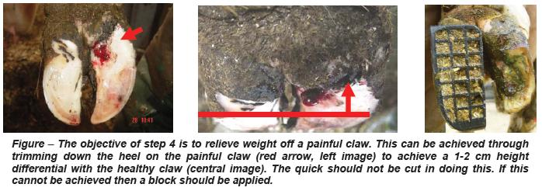

**Step 5: Claw and Heel Balance**

* A flat, weight-bearing surface between the inner and outer claws should be achieved throughout the trimming process. *Caution: soles should not be trimmed so they flex under finger/thumb pressure.*
* Evaluate claw and heel balance: hold front walls of both claws together and place a flat object across both toes, across both heels, and from toe-to-heel on both claws. No light should be visible underneath the flat surface for heel and toe-to-heel measurements.

Open the toes by trimming away sole near the interdigital space of the heel. Make sure not to remove too much sole by concaving a wide area.

When trimming is complete it must provide adequate weight bearing. The two claws should also be of equal size and their two sole surfaces on the same transverse horizontal plane. Removal of the axial (inner) wall is a common mistake made by some herdsmen who feel that the toes should not be touching once trimming is complete. This is a fallacy. If the wall CD was lowered the claw would be seriously destabilized, causing it to rotate inwards and allowing overgrowth of the lateral wall. In the worst case excessive removal of the axial wall might expose the corium, leading to severe lameness. It is preferable not to remove any heel horn unless it is badly under-run, other than as part of cut four. If the heel is only slightly pitted, it is best left alone, since removal of the heel could lead to backwards rotation of the pedal bone and so predispose to sole ulcers.

Remove loose/under-run horn and hard ridges

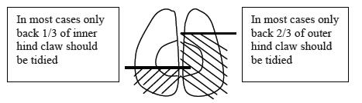

As little serious disease occurs in the front 2/3rd of the inner hind claw, and front 1/3rd in the outer claw, then tracts or under-run horn should not be pursued in these regions. Loose horn around the base of the sole ulcer, in the heel or around white line lesions should be removed (red arrows below). However, cutting into the "quick" should be avoided at all costs to prevent unnecessary pain, scarring and severe infections spreading to the deeper tissues. The final stage is to ensure there are no sharp ridges that could injure the teats or legs, checked by running the hand over the claw.

