Hoof trimming in cattle:

Forelimb: The medial claw carries most of the weight
Hindlimb: The lateral claw carries most of the weight
This is important to note as the more weight-bearing claws are more prone to pathology such as ulcers, it is also important to know how to functionally trim these claws so as to ensure the cows weight is balanced and even.

First step: Trim toe length to 7.5-8 cm, beginning with the medial claw on the hind limb and the lateral claw on the forelimb.
This can be done using hoof nippers. The nippers must be held so that it is parallel to the slope of the front wall and the cut off the toe is made so that it is perpendicular to the floor.
Sole thickness is measured so that the height of the toe is about 5-7mm, the sole is then trimmed to these measurements, sparing the heel as much as possible.

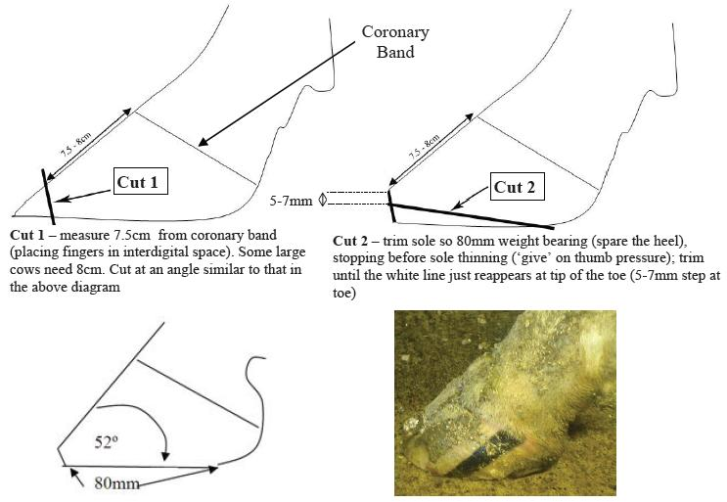

Step 2: Match opposite claw to trimmed claw, toe lengths should be even on both sides and hoof should lie flat when placed on the ground. To ensure that both soles are even the handle of the hoof knife can be placed against the sole to ensure there is balance.

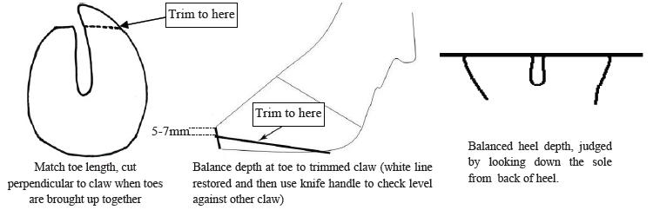

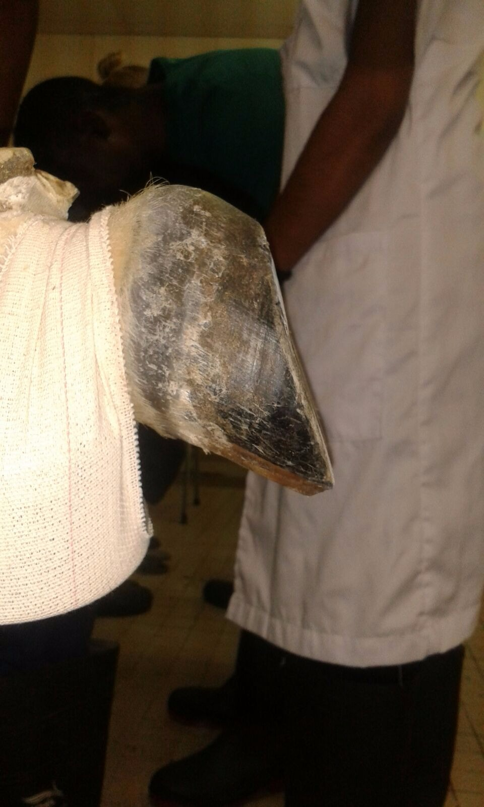

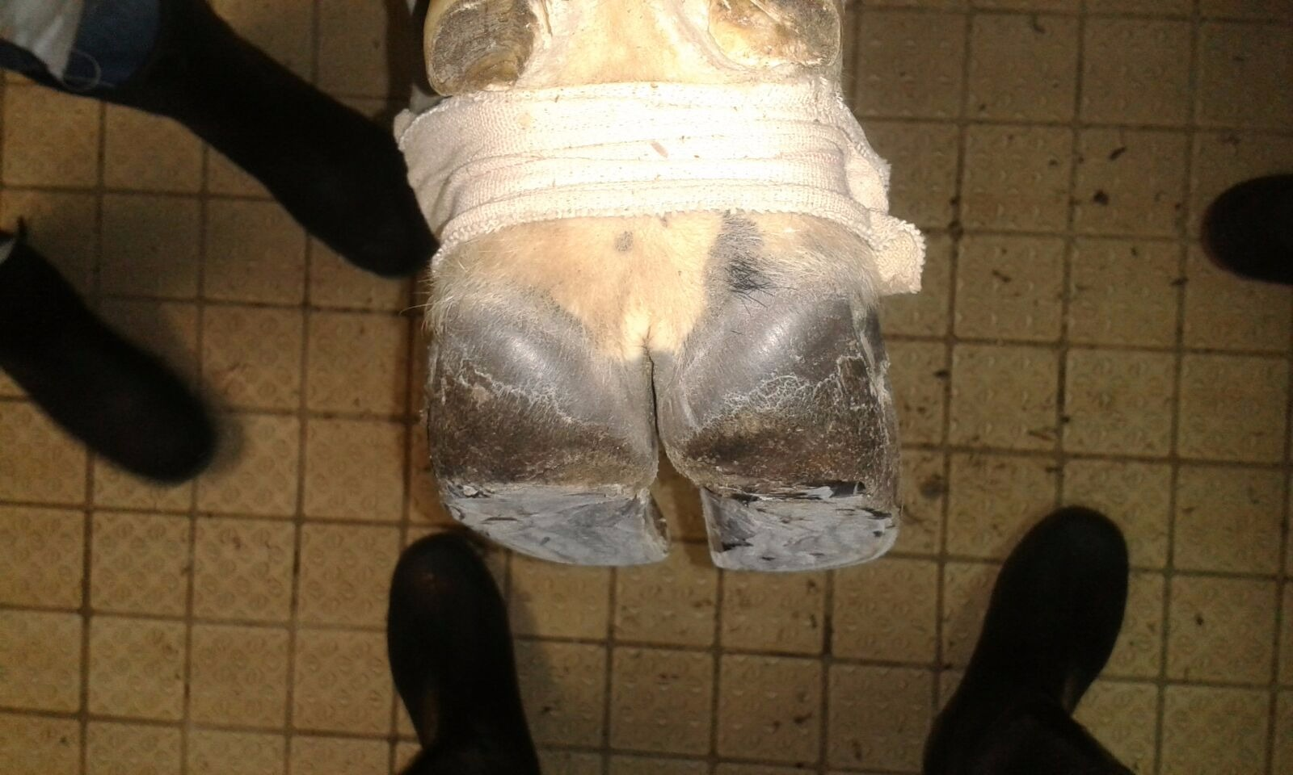
Step 3: Dishing out the non-weight bearing centre of the sole to redistribute weight to the outer wall of the claws. It is important to establish a ‘working two-thirds’ of the hoof and spare the cranial one-third when dishing out the inner sole.
It is also important to use a2:1 ratio when modelling so that the more weight-bearing claw is given a greater concavity than the non-weight-bearing claw.

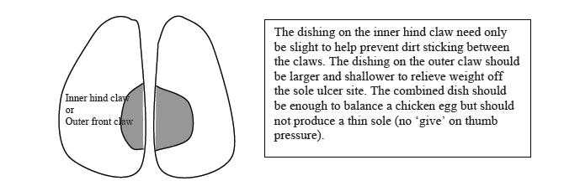

NB: If the hoof is normal and there is no pathology or damage, this will be the final step of the hoof trimming process.

Step 4: Corrective trimming to spare a painful or injured claw.
This can be done by trimming down the painful claw so that the weight is shifted off the injury. If there is an ulcer present a looped knife can be used to trim a ‘moat’ around ulcer in order to remove all weight.

Another option to remove weight off of the injured claw is to apply a plastic, rubber or wooden block to the normal claw for a few weeks to allow enough time for bruising to heal.
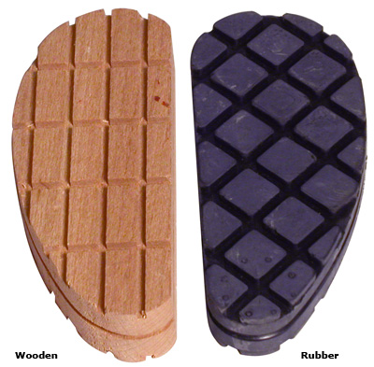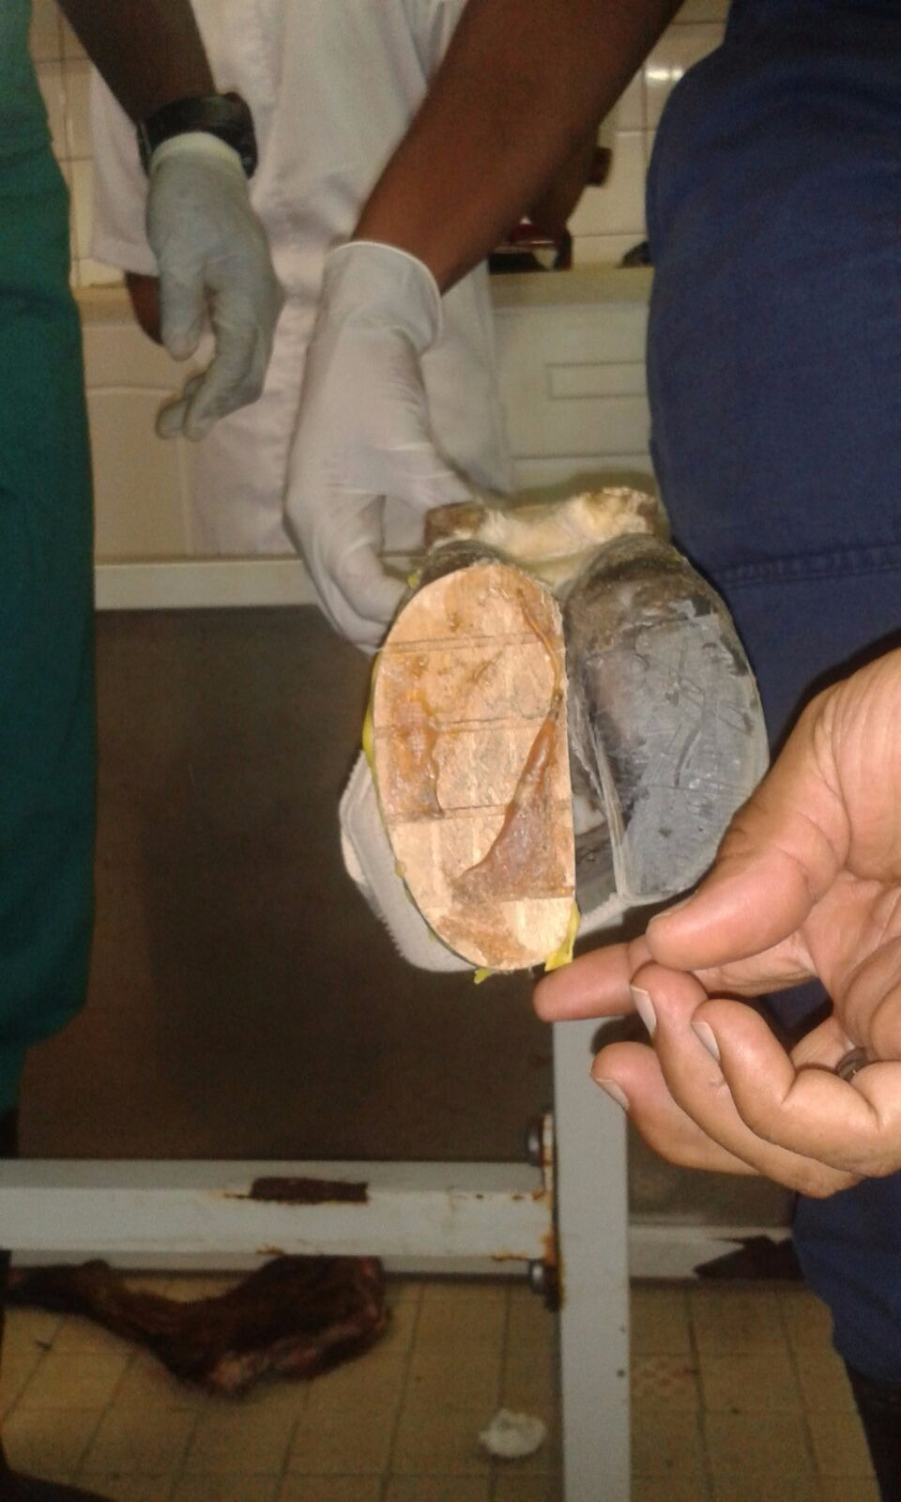

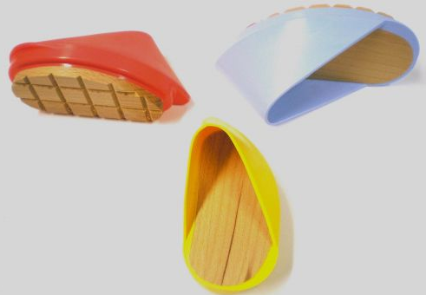
The hoof is first dried using a hoof dryer or a makeshift dryer (hair dryer), blocks are then bound to the base of the claw using a glue/ paste which forms a hard resin. Blocks will usually fall off or wear off after approximately 6 weeks, which will allow adequate time for healing of ulcerated claw.

Commonly used hoof bond:
