**POST-OP MANAGEMENT AND RECOMMENDATIONS**

**HOOF TRIMMING**

The hooves can be coated with iodine after trimming, to help dry the hoof and act as a bactericide. Several other practices to compliment your hoof trimming are Keep cattle areas dry.

* Wet floors tend to keep the soles soft, so they are subject to more mechanical injuries and foot rot. Use a copper sulfate foot bath to help control foot rot.
* Allow the cows plenty of room to exercise so they wear feet down.
* Don’t turn freshly trimmed cows out on rough, frozen ground.

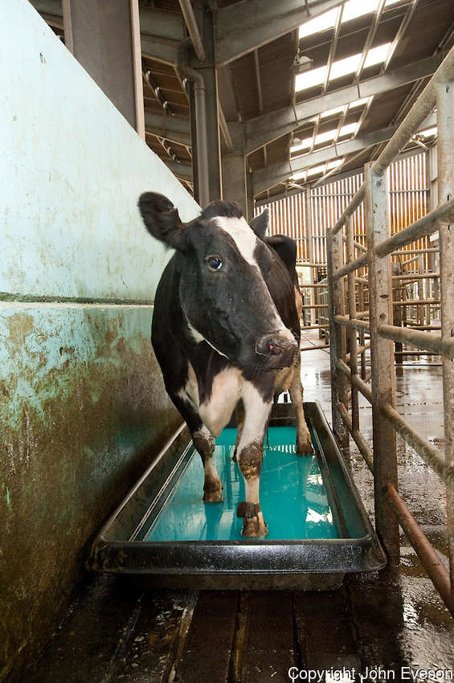

**DIGIT AMPUTATION AND FLEXOR TENDON REMOVAL SURGURY**

* The surface of the wound is covered with an antiseptic or antibiotic dressing and a bandage applied to control hemorrhage and excessive pathogen exposure. The bandage should be removed or changed in about 1 week if there was no need for maintaining drainage of septic regions proximal to the incision.
* If a tendon resection is performed the bandage should be removed in 2 or 3 days. Depending on the environment the cow must live in after surgery either no bandage is placed after the first one is removed or a light wrap to minimize painful contact with environmental objects.
* Parenteral antibiotics such as flunixin meglumine for pain management and Penicillin Streptomycin for bacterial control are usually given for about 5 days.

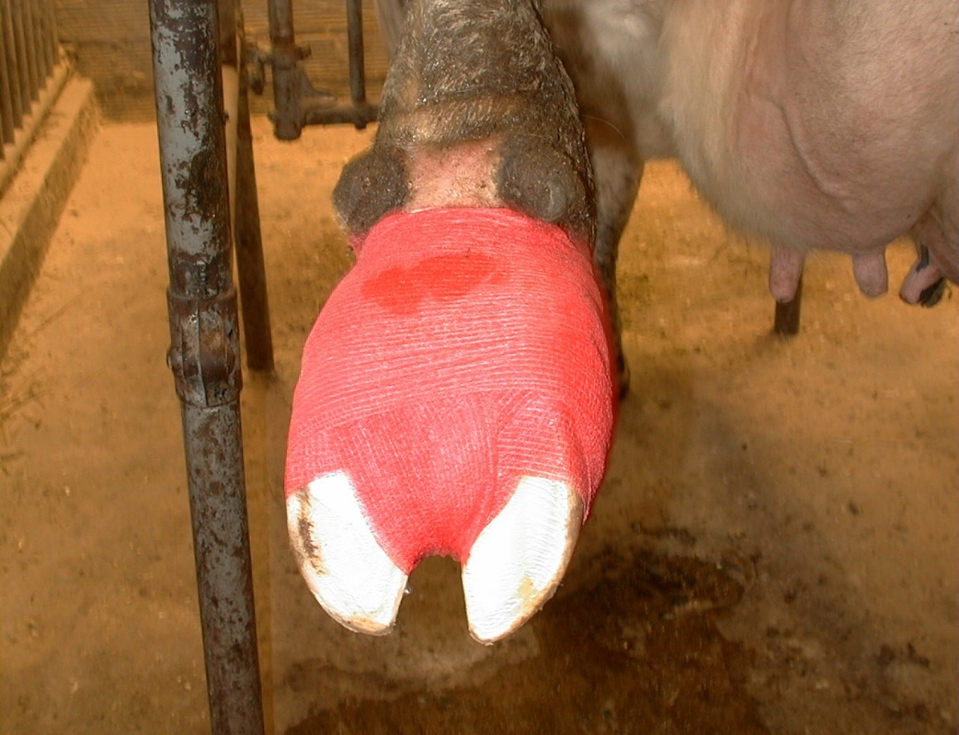

**AFTER TREATING SOLE ABCESSES**

* If the claw has had an extreme amount of tissue removed, it may be advisable to glue a wooden block to the bottom of the unaffected hoof. This will keep weight off the injured claw and prevent further mechanical injury.
* An important role of the dairy herdsperson is to decrease the incidence of sole abscesses through good management. Develop a regular hoof trimming program. It’s best to trim cows’ feet toward the end of lactation or as they are being dried off.
* Keep cows on well balanced diets with adequate amounts of fiber. High concentrate diets tend to lead to more foot problems.
* Select cows for better feet and legs. Prevention and early diagnosis are keys to eliminating sole abscess problems.

