**TEAT LACERATION CLASSIFICATION**

Teat lacerations are classified by:

* Duration from time of trauma
* Localization and Conformation
* Thickness (full or partial)

**ALL ARE CONSIDERED SEVERY CONTAMINATED!**

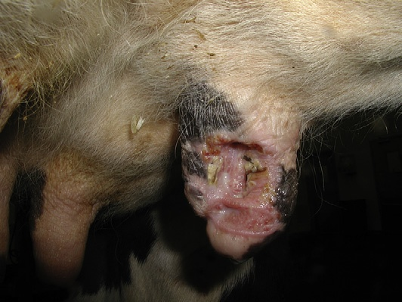 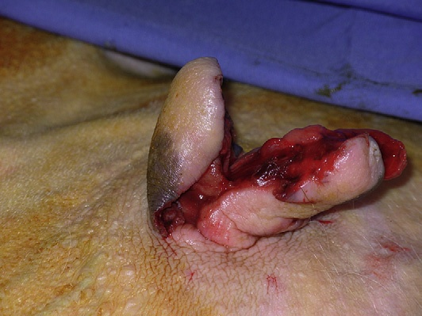

**Chronic Complex**

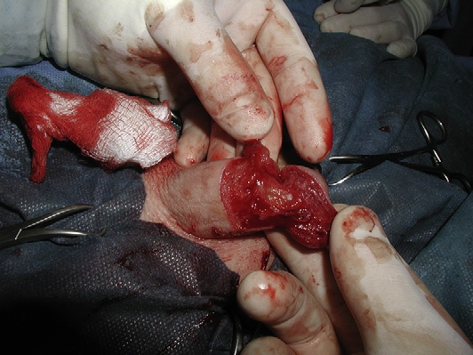 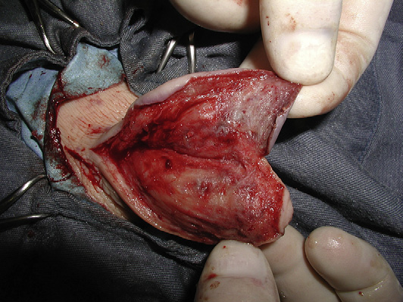

**Transverse Partial Thickness**

|  |  |  |  |
| --- | --- | --- | --- |
| ***CLASSIFICATION*** | ***INFORMATION*** | ***TREATMENT NOTES*** | ***PROGNOSIS*** |
| Acute | <12 hours old |  | Acute > Chronic  Vertical > Horizontal  Proximal > Distal  Sharp > Crushing  Distal end of teat and sphincter involved – Poor prognosis due to fibrosis interfering with normal milking  Streak Canal involvement decreases prognosis  Depends on a combination of factors including severity, tissue necrosis, duration of time to repair and placement of lesion |
| Chronic | >12 hours old | Debridement, thorough cleansing and suturing (not always) |
| Simple |  |  |
| Complex | Inverted “Y” or “U” | Primary Closure (even if older than 12 hours) with later Surgical Revision |
| Partial Thickness (Superficial) | Skin or Skin and stroma |  |
| Full Thickness (Deep) | These are medical emergencies!  Mastitis should always be expected to develop  -Include vertical, horizontal, degloving injuries (teat flap normally develops) | If the lumen is penetrated, then multiple repairs are required |

* Always include antibiotic therapy (Procaine Penicillin 22,000 IU/kg IM BID), intramammary cannula and pain control (Flunixin Meglumine 1mg/kg IV)
* Untreated or poorly treated punctures and lacerations lead to fistula patency
* Swelling of the teat can benefit from hydrotherapy and NSAIDs before attempts to close defect

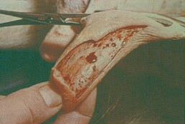 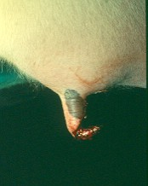

Superficial Deep

Other classifications include Longitudinal, Transverse, Proximal and Distal

* Transverse injuries cause more damage to blood supply resulting in more oedema, avascular necrosis and dehiscence post operatively as compared to Longitudinal injuries
* The more circumference involved the worse the prognosis
* Distal injuries compromise defense mechanisms against mastitis putting the animal at a higher risk. They also lead to avascular necrosis