Epidural anesthetic techniques
The “hanging drop” technique
o This involves removing the stylet of the spinal needle, filling the hub of the needle with saline or anesthetic solution, and allowing one drop to hang from the hub.
o As the needle is advanced through the ligamentous structures, the drop does not move.
o However, upon penetration of the ligamentum flavum, the negative pressure in the epidural space will draw the drop of solution into the needle, indicating proper placement in the epidural space.
o A “pop” felt through the needle is usually encountered when the spinal needle is passed through the ligamentum flavum.
o The chance for a successful “hanging drop” technique is greater in large dogs than in smaller dogs and cats.
o If the “hanging drop” technique fails, the “lack of resistance” technique can be used.
The “lack of resistance” technique
o This indicates proper placement of the injection needle in the epidural space based on the amount of resistance to the injection of air or saline.
o Once in the epidural space, the injection of air, saline, or anesthetic solution will encounter minimal resistance.
o A separate syringe of normal saline (3 ml or air preferred by others) should be prepared for the “lack of resistance” technique.
o When minimal resistance to the saline injection is encountered, the saline syringe is replaced with a syringe-containing anesthetic, and the injection is completed.
o To rule out the possibility of administering drugs into the venous sinus (presence of the blood) or subarachnoid space (presence of CSF), it is important to aspirate or allow a few seconds to check bleeding before epidural injection.
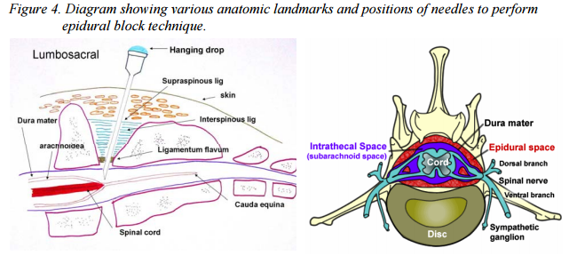
Epidural anesthesia in bovine
• In the ox, the spinal cord ends in the region of the last lumbar vertebra, but the meningeal sac goes to the 3rd/4th sacral segments.
• For caudal and epidural anesthesia the injection site used is between coccygeal C1 and C2 (located by raising tail in “pump handle” fashion, the first obvious articulation behind the sacrum being C1 /C2).
• For a 500 kg bovine; 5-10 ml 2% lidocaine will give caudal anesthesia without causing hind limb ataxia or paralysis.
• Onset of paralysis of the tail should occur in 1-2 mins. The block will last 1-2 hours. Larger doses will produce increasingly anterior effects.
• By the time 100-150 mls 2% lidocaine is injected, the block will be sufficiently anterior to allow surgery of the hindlimbs, mammary tissue, flanks and abdominal wall.
• However, the bovine will be recumbent. Injection of local anesthetics can be carried out at the lumbosacral junction in order to produce an anterior block with less anesthetic.
• However, there is a danger of accidental subarachnoid injection. Segmental epidural anesthesia, where the anesthetic is injected into the epidural space at the region required can be used for analgesia of any ‘segment’ with less overall side effects. It is more difficult to perform; penetration of the meninges is likely, but in skilled hands it is a very useful technique.
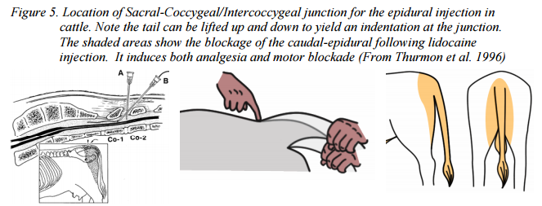

Epidural anesthesia in the sheep and goat
• In both sheep and goats, anterior epidural anesthesia, induced by injection at the lumbosacral junction is easily performed and provides excellent analgesia and muscle relaxation for abdominal surgery.
• Recumbency may occur but is not a problem in these small animals. As in cattle, there is a risk of subarachnoid injection.
