INTRAOPERATIVE PROCEDURE FOR EXPLORATORY LAPORATOMY
As the sheep had already had a previous exploratory laparotomy and adhesions were anticipated, the decision was made to go caudal to the previous incision site (which was midway between the last rib and the tuber coxae on the right side) about 3 inches away, closer to the tuber coxae side. The sheep was draped around the shaved area. A sharp skin incision was made about 20cm in length using a scalpel.
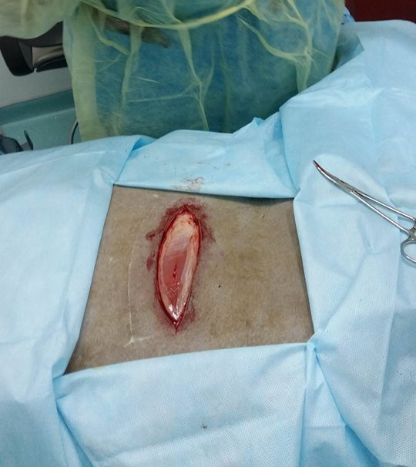
Picture showing skin incision
The cutaneous trunci was also incised. Bleeding was controlled by using haemostats to clamp off the blood vessels and induce haemostasis. When the skin, fascia and cutaneous trunci were incised, the external abdominal oblique muscle was revealed with its caudo-ventral running muscle fibres. This muscle was incised exposing the internal abdominal oblique muscle. These fibres go cranio-ventral direction. These muscles were incised revealing the transverse abdominal muscles, which was carefully incised with the peritoneum by tenting and cutting with a scissors as not to also incise any internal structures with it. Blotting was done throughout the incising to get rid of the blood that was blocking the view for further incising.
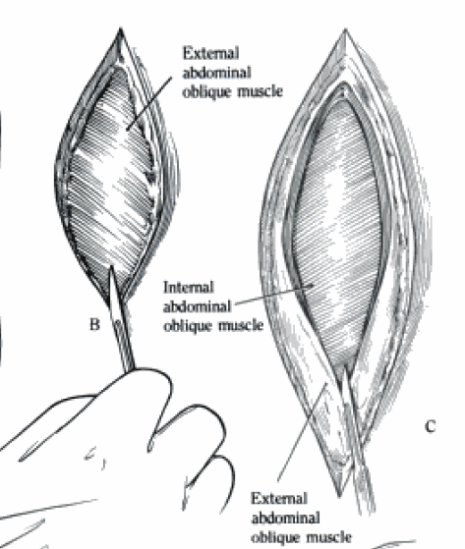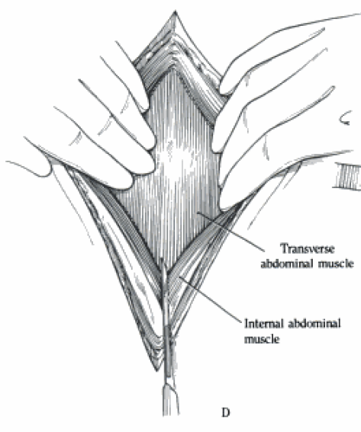
Diagrams showing the external & internal oblique as well as the transverse abdominal muscles

On entering the abdominal cavity and palpation near the previous incision, it was noticed that there was a lot of adhesion that were hindering the exploration of the cranial abdomen. These adhesions were broken down by hand by tugging on them tell they have way, taking care not to cause omental bleeding. The following structures were palpated in situ:
- The mesenteries at the incision site
- The intestines
- The liver- the hand was placed cranial to the incision site and the sharp edges of the liver were felt.
- The omasum
- Diaphragm- identified as a blockage to further cranial advancements past the omasum

The following structures were removed from the abdomen and/investigated:
- Omentum
- Intestines- filled with faeces
- duodenum
- jejunum- peristalsis was observed here as movement of gas as the animal was fasted prior to the surgery
- ileocecal junction
- Caecum
- Pancreas
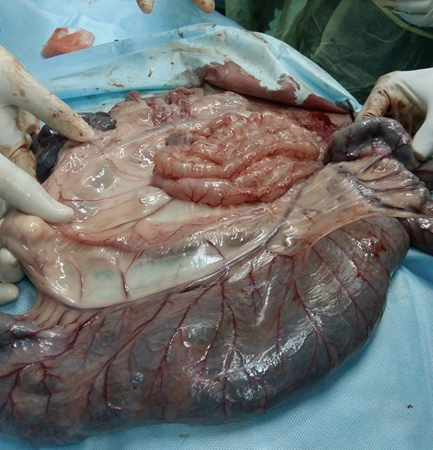
Picture showing visceral organs outside of the abdomen
The viscera was kept moist with saline during the investigation to prevent adhesions after the operation.
After sufficient investigation, the viscera was replaced, inserting the organs removed last first until the omentum was replaced. The wound was closed using three layers. 1-The transverse abdominal muscles and peritoneum were sutured together using simple continuous suture pattern. 2-The external and internal oblique muscles were closed together using simple continuous suture pattern and 3-finally the skin was closed using ford interlocking suture pattern. The simple continuous sutures were made with No. 1 synthetic absorbable while the skin sutures was made with non- absorbable 2-0.
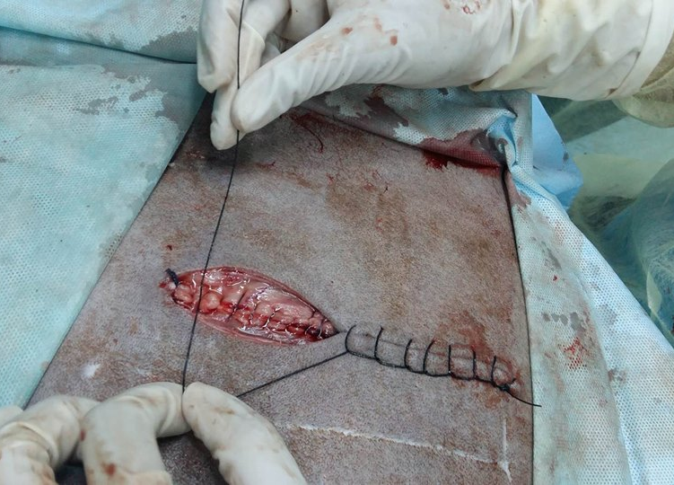
Picture showing wound closure using ford interlocking suture
Then the wound was dressed using tetravet spray, lavicid spray and silver bandage spray :
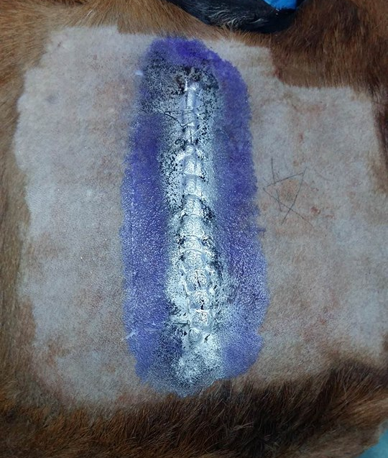
PICTURE SHOWING WOUND AFTER DRESSING

