DRUG | TRADE NAME | ACTIVE INGREDIENT | INDICATIONS | DOSAGE | CONTRAINDICATIONS | WITHDRAWAL TIME
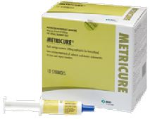 | Metricure 500mg | Cephapirin 500mg | Treatment of subacute and chronic endometritis in cows (at least 14 days after parturition) caused by bacteria sensitive to cephapirin | The contents of one Metricure syringe should be introduced into the lumen of the uterus using a catheter.  In animals that have been inseminated, Metricure may be used at one day after insemination. | Not to be administered to animals with known allergy to cephalosporins.  Not to be administered intrauterinely together with other antibiotic preparations | Meat: 4 days  Milk: Nil
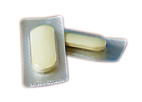 | Metricyclin | Chlortetracycline hydrochloride | Prophylactic treatment of puerperal infections caused by chlortetracycline-sensitive micro-organisms in cattle. | For intra-uterine administration shortly after calving.  Prophylactic: 1 bolus  Therapeutic: 1-2 boluses | Dangerous to the Environment. | Milk: 7 days  Meat: 7 days
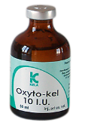 | Oxyto-kel | Oxytocin 10 I.U. | Uterine inertia, retention of the placenta, agalactia, prevention of haermorrhages after caesarian section or after hard delivery |  | Closed pyometra.  Incomplete or no opening of cervix.  Mechanic obstruction of partus, e.g. physical obstruction, an abnormal presentation or position of foetus, convulsive contractions, or malformations of birth channel. | ____
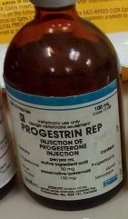 | Progestrin rep | Progestrone | Used in habitual abortions, treats sterility and oestrous control. | Cows and mares: 50-100mg  Sheep and goats:10-15mg  Sows:10-25mg | Should not be in lactating dairy animals.  Overdose can result in cystic ovaries | _____
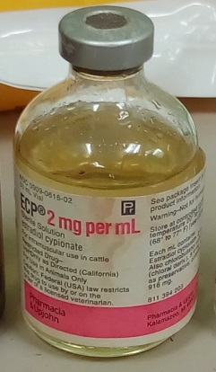 | ECP 2mg/ml | Estradiol cypionate | To induce estrus in the absence of a follicular cyst.  To aid in the treatment of retained corpus luteum.  To expel purulent material from the uterus in pyometra of cows.  To induce expulsion of retained placenta and mummified fetus. | Administration: IM only.  Cows: Anestrus - 3-5 mg (3-5 mL)  Pyometra - 10 mg (10 mL) | Estrus is contraindicated when a desired pregnancy exists.  During pregnancy, may cause fetal malformation. | _____
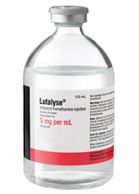 | Lutalyse | Dinoprost/ Prostaglandin F2 alpha | Used in luteolytic agent in estrous synchronization, unobserved estrous in lactating dairy cattle. | Administered IM.  Cattle:  Estrus Synch: 1shot 25mg IM given twice, 11 days apart.  Silent estrous and Pyometra/Endometr-itis TX: 25mg IM.  Swine:  Estrus synch: Day 15-55 of gestation, 15mg IM, and then 10mg IM 12 hours later.  Abortifacient: 5-10mg IM.  Induce Parturition: 10-25mg IM 2-6 days before expected parturition  Horses:  ~ DTBM & estrus control: 1mg/45kg IM.  ~ Abortifacient: 5mg IM (< 12days), 1mg/45kg IM (> 4 months pregnant), 2.5mg q12, 4 times. | Acute or sub-acute disorders of the vascular system, gastro-intestinal tract or respiratory system. | Pig: 1 day  Cattle:1 day  Treated horses may never be slaughtered for human consumption.
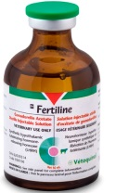 | Fertiline | Gonadorelin acetate | Treatment of ovarian follicular cysts in dairy cattle. Reduces time between calving to first ovulation and increase the number of ovulations within the first 3 months of calving. Used in cows with retained placentas to increase fertility. | Cattle: 0.1mg IM or IV  Sheep and Goats: 0.1mg daily for 4-5 days o induce ovulation | _______ | ____
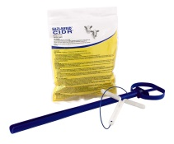 | EAZI-Breed CID-R  (controlled internal drug release) | Progesterone | To improve the effectiveness of reproduction programs by tightening estrus synchronization so groups of cows and heifers come into heat and can be bred in a narrow window. | Administer intravaginal.  Sheep: 0.3g progesterone/insert  Goat: 0.3g progesterone/insert  Dairy: 1.38g progesterone/insert

