**DRUGS-**

**Antibiotics**

**Gentamycin 100**

[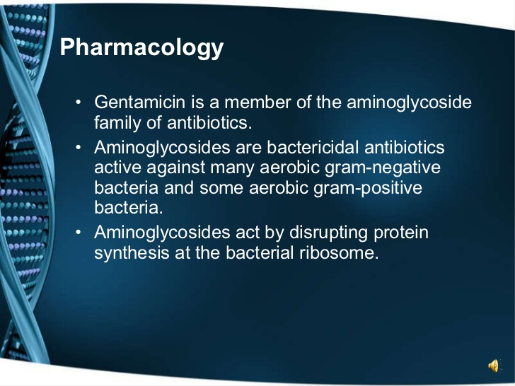](https://www.slideshare.net/kevfrost/gentamicin-and-the-yorkshirehartford-regimen)

**Amoxicillin** is an extended spectrum penicillin group pf antibiotics it is active against many gram positive and gram negative bacteria. Amoxillin acts by inhibiting bacterial cell wall. Lack of bacteria cell wall results in death due to lysis of bacteria.

Amoxicillin acts by inhibiting bacterial cell wall synthesis. Lack of bacterial cell wall results in death due to lysis of.

* **Cefokel 50mg/ml** suspension for injection.

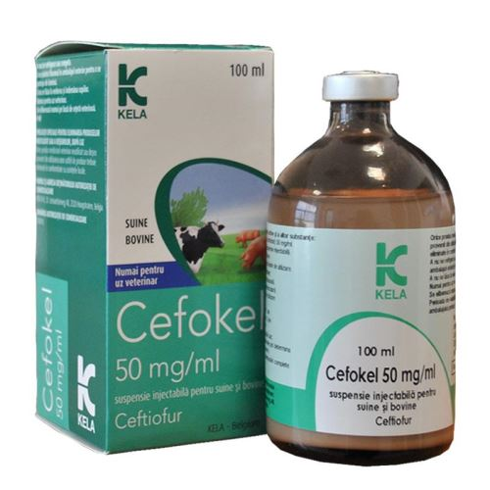

Infections associated with ceftiofur-sensitive bacteria.

Cattle:   
For the treatment of bacterial respiratory diseases associated with Mannheimia haemolytica, Pasteurella multocida and Histophilus somni .

**Combikel 40 L.A-** acombination of DHS and penicillinprovides a bactericidal synergistic action with a broad spectrum. Prevention and treatment of infections caused by penicillin G and/or DHS susceptible microorganisms such as respiratory tract infections (shipping fever, bronchopneumonias, upper respiratory tract infections), uro-genital tract infections.

**Anflox 10% injection**- Ofloxacin Belongs To The Group Of Medicines Called Fluoroquinolone Antibiotics. They Cure The Infection By Inhibiting The DNA Formation And Killing The Bacteria.

**Enroflox 8% [enrofloxacin**]- Enroflox® 100 is a sterile, ready-to-use injectable antimicrobial solution that contains enrofloxacin, a broad-spectrum fluoroquinolone antimicrobial agent. Enroflox 100 is indicated for the treatment of bovine respiratory disease (BRD) associated with Mannheimia haemolytica, Pasteurella multocida, Histophilus somni and Mycoplasma bovis in beef and non-lactating dairy cattle.

**Oxytet LA- 19%-**Oxytetracycline is effective against a wide range of gram-negative and gram-positive organisms that are pathogenic for cattle. The antibiotic is primarily bacteriostatic in effect, and is believed to exert its antimicrobial action by the inhibition of microbial protein synthesis.

**Anupco: Amoxycillin 150 LA -**Amoxycillin is a semi-synthetic broad-spectrum penicillin. It inhibits the peptidoglycan synthesis in the bacterial cell wall. Amoxycillin shows a bactericidal effect in a wide range of Gram-positive and Gram-negative bacteria. Pseudomonas, Klebsiella, most Proteus types and penicillinase-forming Staphylococci are resistant. With E. coli there is also a high level of resistance.

**Anupco: Tylosin 200**Tylosin is a macrolide antibiotic, mainly active against Gram-positive bacteria and mycoplasmas. It is also active against some Gram-negative bacteria, spriochetes, some rickettsia and chlamydia. At commonly recommended doses, tylosin acts bacteriostatically. It inhibits protein synthesis of susceptible micro-organisms by binding to subunits of the 50-S ribosome and by inhibition of the translocation step.