**TEAT CUP**-Teat cups are attached to the cow's teats, and then the cups alternate between vacuum and normal air pressure to extract the milk.

[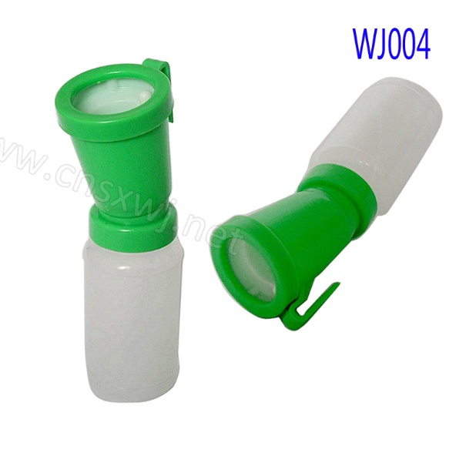](https://www.alibaba.com/product-detail/WJ004-Plastic-teat-dip-cup-dairy_60364614108.html)

Strip cup- Use the strip cup to detect mastitis. Squirt first stream of milk from each teat into strip cup. Inspect for flakes, lumps, and other signs of abnormal milk.

