DRUG | TRADENAME | ACTIVE INGREDIENT | INDICATION | DOSAGE | CONTRAINDICATION | WITHDRAWAL
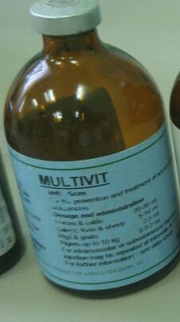 | Multivit | Vitamin A, D3,B1,B2,B6,B12,Nicotamide and Pantothenol | Comprehensive multivitamin supplement, providing a balance of vitamins and minerals to promote vitality. | Calf: 5ml/new born.  Piglet:0.5ml | Do not administer by IV route. IM or SC only | ___
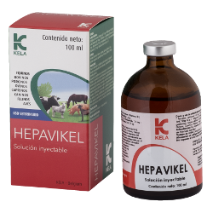 | Hepavikel | Vitamin B1, B2,B6, B12, Nicotinamide | Useful in case of anorexia, growth retardation and during the recovery period from diseases such as enteric infections, parasitic infestations | Foal, Calf, Piglet:  1 ml/5-10 kg IM, SC | ____ | ____
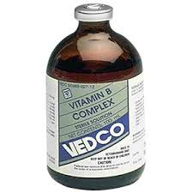 | Vitamin B complex | Vitamin B1, B2,B6,B12 |  | Adult Cattle- 1 to 2 ml/ 100lbs/b.w  IM or SC  Calves, Swine and Sheep- 5 ml/100 pounds of b.w IM or SC | Hypersensitivity reactions to products with thiamine. | ____
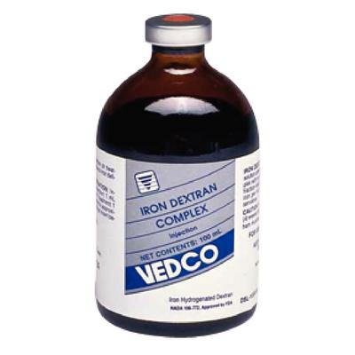 | Injectable iron | Iron hydrogenated dextran | Used to treat anemia in piglet due to iron deficiency | 1 ml (100 mg iron) at 2-4 days of age via IM | ____ | ____
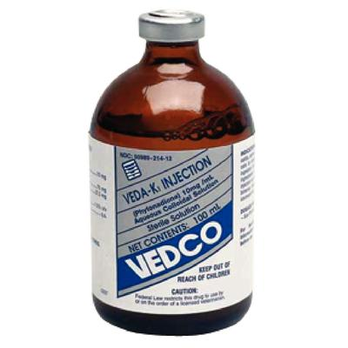 | Vitamin K injectable | Vitamin k | Indicated to counter hypoprothrombinemia induced by ingestion of anticoagulant rodenticides | Cattle, Calves, Horses, Swine, Sheep, and Goats: 0.5-2.5 mg/kg  SC/IM. | Hypersensitivity to any component in this solution
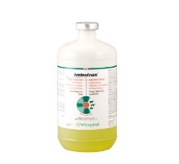 | Aminolean | Dextrose, calcium chloride dihydrate, potassium chloride, magnesium sulphate | Used in debilitated animals and for supportive treatment | Mature Cattle, Horses & Swine: 2 mL/kg of body weight.  IV/IP in cattle and swine. IV in horses. | _____ | ______
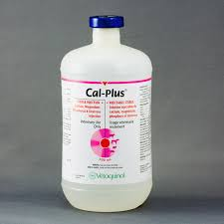 | Cal-plus | Calcium Borogluconate, Sodium Hypophosphite, Magnesium Chloride | Treatment of milk fever and other calcium, glucose, magnesium and phosphorus deficiencies of cattle, sheep, horses and swine. | Cattle & Horses 250-500 mL;  Sheep and Swine 50-125 ml. | ___ | ___
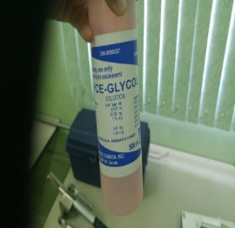 | PCE-Glycol | Propylene Glycol,  Choline Chloride,  Potassium Iodide,  Ethylenediamine Dihydroiodide,  Cobalt Sulfate | An aid in the prevention and treatment of acetonemia and used an energy source. | Cattle:  200 - 400 mL daily, dependant upon severity.  Sheep  75 - 125 mL daily, dependant upon severity. | ____ | ____

