VENTIPULMIN-Ventipulmin is a drug used to open the respiratory passages of horses and to help clear them of mucus. This can be beneficial in some allergic respiratory diseases, often associated with a cough, due to mould spores in hay and straw (chronic obstructive pulmonary disease or COPD). Ventipulmin is also useful in cases where infection of the respiratory tract is involved, such as equine influenza. Where bacterial infection is present, antibiotics can be used as well. Ventipulmin is available as Ventipulmin Granules or Ventipulmin Syrup to add to food. There is also a Ventipulmin Injection available.

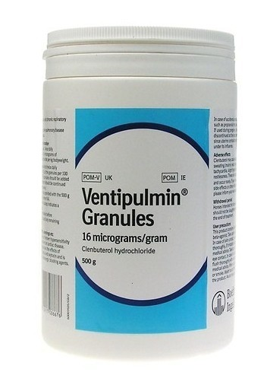

SCOURBAN-Oral Antibiotic for the treatment of bacterial enteritis

PCE-GLYCOL-Glucogenic as an aid in the prevention and treatment of acetonemia.