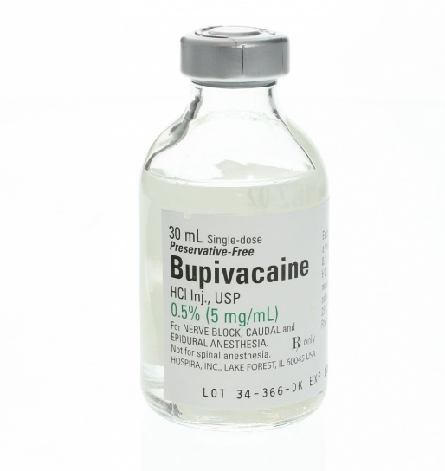
AGENT: Bupivacaine HCL
TRADE NAME: Marcaine
CHEMICAL NAME: 1-butyl-2’,6’ pipecoloxylidide-HCL
ONSET: 10-30 minutes (depends on route of
administration

DURATION: 180-480 minutes

AVAILABLE AS:
- An aqueous solution in various concentrations (0.25- 0.75%)
- The 0.5% (5mg/ml) formulation is most commonly used.

INDICATIONS:
Bupivacaine is a potent local anesthetic used in equine medicine. It is used to induce regional anesthesia for humane relief of pain, because it provides anesthesia that lasts 4–6 hr. The long duration of action of this drug renders it less suitable for diagnostic nerve blocks, but often more suitable for peri-operative analgesia of the distal limb. More proximal nerve blockade, however can compromise recovery quality because the patient effectively has a ‘dead leg’.

DOSAGE:
- For peripheral nerve blocks and caudal epidural anesthesia are in the range 0.05-0.08 mg/kg (i.e. 5-8ml of the 0.5% solution in an average adult horse).

