**How**:

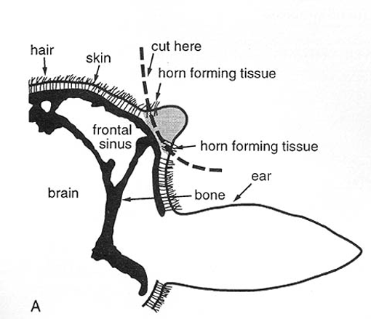 *Placement of dehorner*

Flowchart of procedure:

1. Anaethesia & pain relief
   1. Local Anaethetic – Lidocaine – acts for 60-90 mins
   2. Sedation for fractious animals- Xylazine or other alpha 2 agonists at low dose. Xylazine’s effect can be reversed using Tolazamine
   3. Combined anesthetic – Intramuscular injection of 0.02 mg/kg xylazine and 0.04mg/kg butorphanol
2. Prophylactic medication
   1. Long acting – Pen Strep (Combikel) at a dose rate of 20,000IU/kg
   2. Ivermectin- prevents myiasis – Dose 200 micrograms/kg
3. Nerve Block
   1. Cornual Nerve – midway between the eye and horn ventral to the frontal ridge. Advance the needle into the ridge, retract a bit, aspirate and administer. Massage site of administration after needle is removed.
4. Dehorning
5. Haemostasis and cauterization of the cornual artery

In this lab, the calf was given 6.5ml of systemic antibiotic (Combikel) before dehorning to help ward off any possible infection which might have resulted from the operation. Flunixin was also given to introduce analgesia so that pain was limited during and after the procedure.

**In goats:** There are two nerve blocks in goats - corneal branch of intra-trochlear nerve and the corneal branch of the lacrimal nerve. These are blocked prior to dehorning using Lidocaine and following the same analgesic protocol of IV Flunixin and the ketamine stun technique of sedation.