**How**:

Flowchart of procedure:

1. Palpate the zygomatic arch between the base of the ear and outer corner of the eye. Below this runs the corneal branch of the ophthalmic division of the cornual branch of the lacrimal nerve.  
   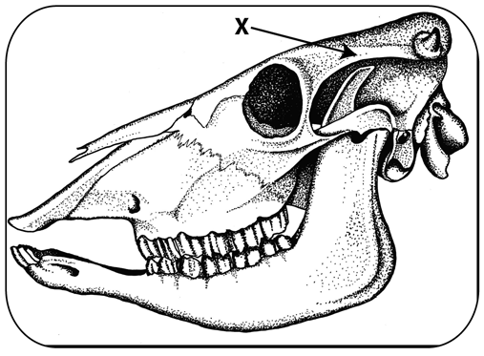*Area of injection of lidocaine*
2. Insert a 5/8 inch needle below the ridge to at least half the needle length. Draw back to check you are not in a vein and then inject 3-5ml of a local anesthetic such as lidocaine.
3. Repeat this on the other side of the head and then wait 5-10 minutes.
4. Check both sides are desensitized by pricking around the horn bud with a needle
5. Apply the preheated hot iron onto the bud using moderate pressure and rotate it for 10 seconds. Repeat until a copper ring around the edge of the burnt area is seen. This shows that the horn producing tissue is destroyed.

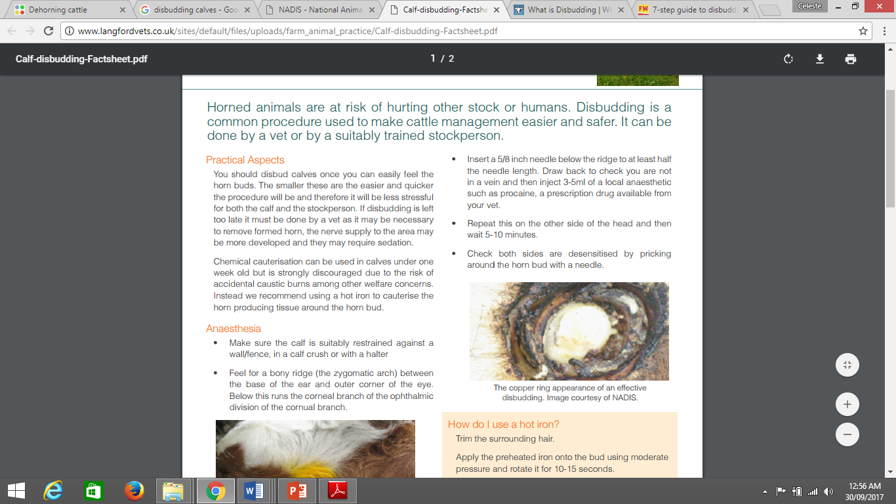 *Copper ring around cauterized horn bud*