**What**:

Disbudding involves destruction of the horn-producing cells (corium) of the horn bud. This is done without opening the frontal sinus. As soon as the horn bud is palpable, chemical disbudding, cauterization and/or surgical excision of the horn bud and surrounding skin can be done.

**Chemical disbudding:** This is caustic soda which destroys the horn bud cells. A disadvantage of this is non-specific caustic agent so if the product gets anywhere else it can cause significant irritation and tissue damage. Chemical cauterization can only be used on calves less than one week old.

**Scoop dehorner:** These disbud cattle quickly and efficiently, but cause significantly more pain and distress than disbudding with a hot iron.

**Hot iron disbudding:** Prior to disbudding it is useful to clip the hair around the horn bud so that it can be seen easily and a clean burn and proper cauterization can be achieved.

**Physical excision:** using a knife

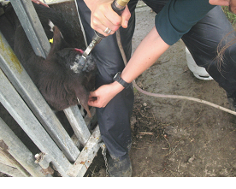*Hot iron disbudding*