DISBUDDING (HOT IRON)
Disbudding involves the removal of horn-producing cells in calves less than two months of age. At this stage, horn buds are still free-floating and not yet attached to the frontal bone of the skull. Hot iron dehorners are available in versions heated by a furnace or fire, 12-volt battery, 120-volt electricity, power packs. The head of the iron is a hollow circle and it fits over the horn bud. For electric irons, use a short extension cord as voltage drops with a long cord, limiting the amount of heat generated by the dehorner.
Technique
- Administer sedation, analgesia and local anaesthetic.
- Preheat the dehorning iron to a red colour. Both electric and gas irons work best when they are "red" hot.
- Wear gloves to protect your hands.
- Hold the calf's ear out of the way to keep it from being burned.
- Place the tip of the burner over the horn and apply slight pressure. When the burning hair begins to smoke, slowly rotate the dehorner by twisting your wrist.
- Continue the application of heat for 10-15 seconds. Do not leave the dehorner in place for much longer, especially in young calves. Heat can be transferred through the thin bones of the skull and damage the calf's brain.
- Dehorning is complete when there is a copper-coloured ring all the way around the base of the horn.
- The horn bud or button will slough off in 4 to 6 weeks.
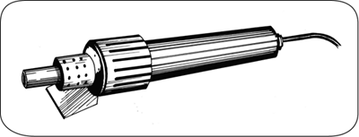
An electric hot-iron dehorner will destroy the horn-producing skin at the base of the horn bud.

