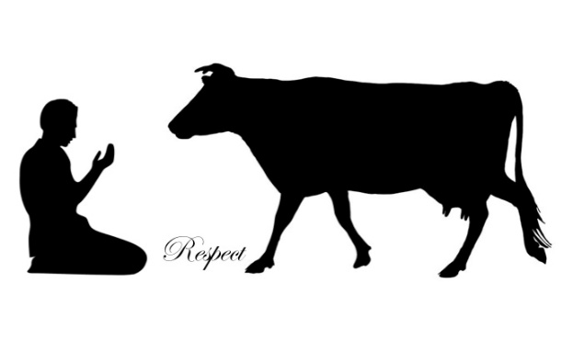
ANIMAL WELFARE

Animal Welfare Approved has the most rigorous standards for farm animal welfare. Its standards have been developed in collaboration with scientists, veterinarians, researchers, and farmers across the globe to maximize practicable, high‐welfare farm management.

What do the Animal Welfare Approved standards require?
The Animal Welfare Approved standards allow the castration of calves as long as it is performed by someone who is competent to carry out the operation, either through training or experience. The standards also place restrictions on which methods of castration can be used, as well as the age of the animal to be castrated.

The main welfare issues are:
1) Pain and healing responses due to castration procedures
2) The availability and efficacy of pain relief measures
3) Age limits before pain relief is required
4) Ability to perform the required task

