Purpose: to treat chronic heel or navicular pain especially when the horse is no longer responding to other treatment methods.
Techniques include:
- Guillotine – sharp dissection of the nerve
- Cryoneurectomy - double freeze-thaw cycle.
- Carbon dioxide laser - used to divide the palmar digital nerve with coagulation of the nerve endings by sealing the cut surface of the nerve endings
- Epineural capping – replection and ligation of the epineurium after transection of the nerve
These may be conducted on a recumbent horse or standing horse. A standing neurectomy should be performed on concrete in a dust free area and while the horse is restrained either by stocks or an assistant. ^{[1]}
Intraoperative: the foot is clipped circumferentially using a #40 clipper blade from the coronary band to the fetlock joint. Regional anesthesia is provided by blocking the palmar digital nerves at the abaxial level of the proximal sesamoid bones. Prior to surgery 3mg of Detomidine is given to provide sedation. Using the palmar digital nerve stripping technique, a 1.5 to 2cm incision is made using a #10 scalpel blade proximal to the collateral cartilage over the palmar aspect of the neurovascular bundle. The nerve is isolated from the vein and artery, separating the perineural issues with a mosquito hemostat and the nerve is elevated out of the incision. A second 2cm incision is made just distal to the base of the proximal sesamoid bone over the palpable nerve.
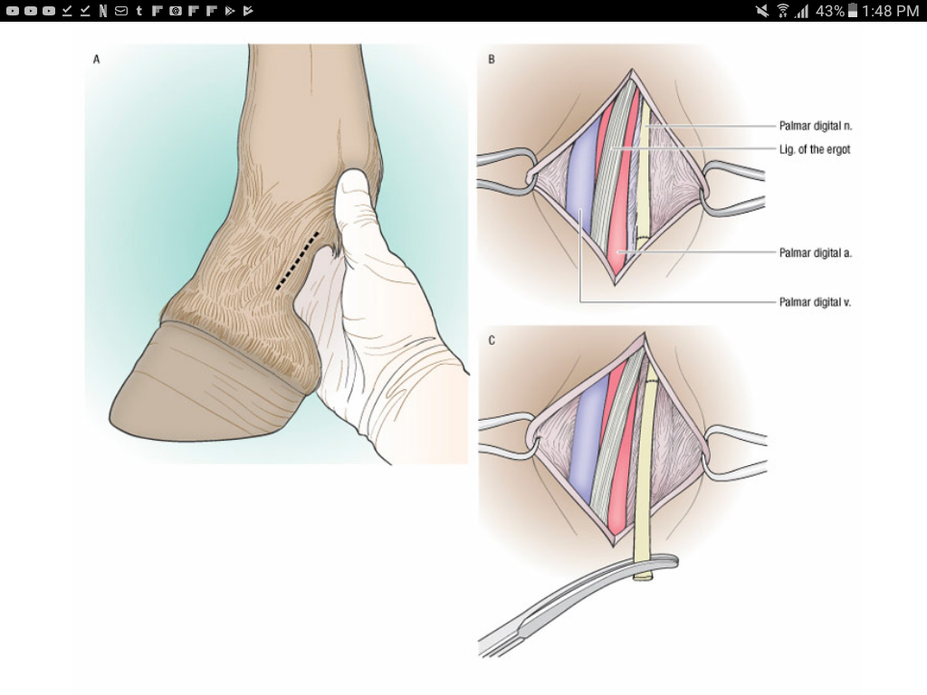
The nerve is stripped from the palmar aspect to the pastern to expose 8-10cm of the nerve and is then tensed sharply and transected at the proximal segment. This causes the proximal stump to withdraw into the tissues. The skin is closed with steel staples rather than sutures to minimize any inflammatory response near the transected nerve ends. A padded pressure bandage is applied distally from the coronary band to the proximal region of the cannon bone.^{[2]}

Post op care includes bandaging for 2 weeks postop, minimizing movement and inflammation. The bandage should be changed every 4 to 5 days for 2 weeks. The horse should be 30 days stall rested then spend 30 days in a small penned area, followed by gradual return to normal activity.

References:
- Palmar digital neurectomy, Robin M. Dabareiner DVM PhD Diplomate ACVS, Texas A&M University
- ‘How to perform Palmar Digial neurectomy in the sanding horse’ Clifford M. Honnas, Robin M. Dabareiner, AAEP Proceddings, 2001, Volume 47, Page 286

