**Surgical procedure for splint bone removal**

1. Once the exact position of each fragment has been determined, the horse is placed under general anesthesia and the limb is further prepped and draped.

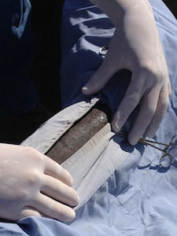

1. Following incision, the distal aspect of the splint bone (the button) is identified.

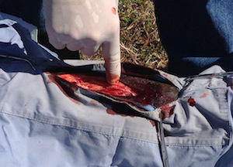

1. The button is grasped with forceps, which are used to apply upward traction on the distal bone fragment. This exposes the interosseous ligament, which resides between the fracture fragment and underlying cannon bone.

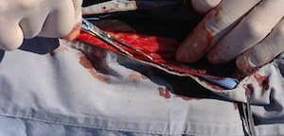

1. An osteotome (like a chisel) and mallet (hammer) are used to transect the interosseous ligament, thereby freeing the distal bone fragment from its attachment to the underlying cannon bone.

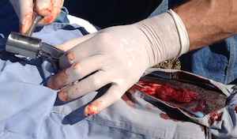

1. Once the distal fragment is removed, any middle fragments are identified and resected in similar fashion.

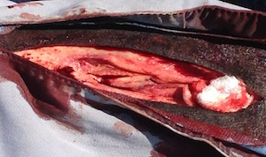

1. After all middle and distal bone fragments have been removed, the scalpel and osteotome are used to expose the lower (bottom) end of the proximal (intact) bone fragment. The majority of this fragment will remain with the horse following surgery.

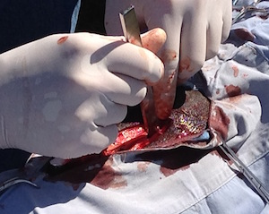

1. Once adequately exposed, the lower end of the proximal fragment is resected at an angle (i.e. tapered) to eliminate future interference of sharp bone edges with adjacent soft tissues.

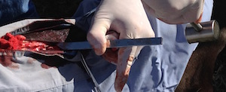

1. Once freed, the lower end of the proximal (intact) fragment is removed.

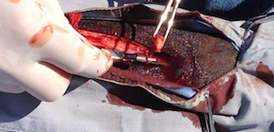

1. The incision is inspected and cleansed of persistent hemorrhage, abnormal (infected) soft tissues and any residual debris prior to closure.

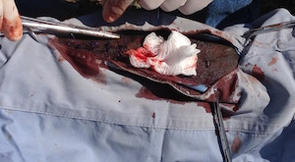

1. Closure is performed in two layers; Subcutaneous tissue and skin are apposed separately.

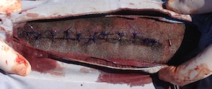

1. The incision is covered with a sterile wrap and a heavy, well-padded distal limb bandage is carefully applied prior to the horse's recovery.

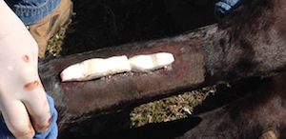

<https://www.youtube.com/watch?v=jNSJPzy9ZAc>

**Monitoring Anaesthesia**

• Potentially life-threatening values

o HR < 24 beats/min

o MAP < 60 mm Hg

o RR < 4 breaths/min

• Evaluation of CNS

o Eyeball position (central), pupil size, palpebral reflex (sluggish), corneal reflex (strong)

o Nystagmus can be present, but usually indicates light plane (exception: dissociative drugs)

o Lack of movement in response to surgery, muscle relaxation

• Evaluation of CVS

o Palpation of peripheral arterial pulse quality, rhythm

o CRT

o Evaluation of blood loss

• Evaluation of Respiratory system

o Color of mucous membrane

o Characteristics of breathing pattern

• ECG

• Blood pressure

o Direct measurement always if possible

o Maintain MAP above 60 mmHg, or 70 mmHg in heavy muscled breeds

o Dobutamine at the rate 1 – 5 mcg/kg/min very effective for inotropic support. (remember tissue perfusion depends both on BP and flow).