STEP
1 | -clip surgical site | 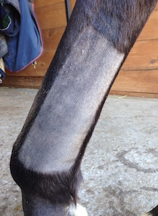
2 | -scrub with bactericidal soap | 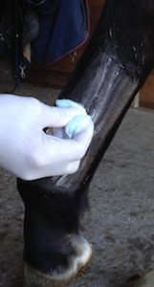
3 | -Inject local anaesthesia to desensitize the skin and subcutaneous tissues along the incision site | 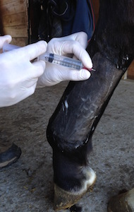
4 | -place IV catheter while scrub and local anaesthesia are working. (always on same side as affected limb so it will be facing upward during recovery) | 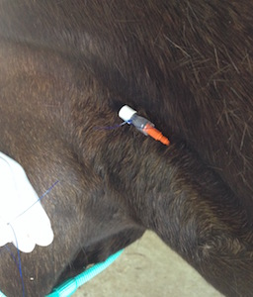
5 | -place skin staples to ascertain the specific location of each fragment | 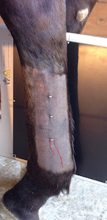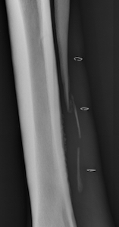
6 | -Place horse under general anaesthesia, and prep and drape the limb. | 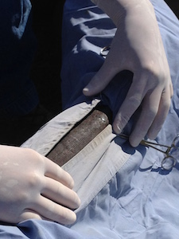
7 | Following incision, locate the distal aspect of the splint bone (the button) | 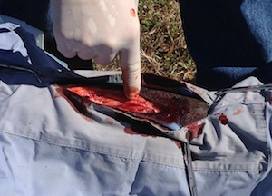
8 | -Grasp button with forceps.  -Apply upward traction on the distal bone fragment to expose the interosseous ligament. (between fracture fragment and cannon bone) | 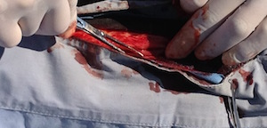
9 | -Use an osteotome and mallet to transect the interosseous ligament.  -remove distal fragment  - Any other middle fragments are identified and transected in a similar fashion | 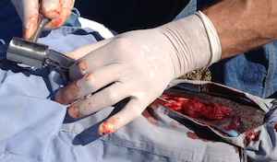
10 | -use scalpel and osteotome to expose the lower end of the proximal (intact) fragment. | 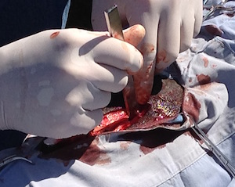
11 | Resect the lower end of the proximal fragment at an angle to reduce future interference of sharp bone edges with adjacent soft tissues.  -remove the resected fragment. | 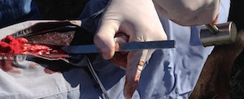
12 | -inspect and clean incision site of persistent haemorrhage, infected soft tissue and any residual debris before closure. | 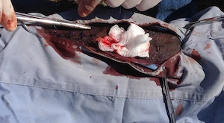
13 | Close the wound in two layers.  Subcutaneous tissue and skin should be apposed separately. | 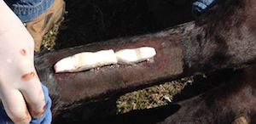
14 | -Ideally, post -op radiographs should be performed to confirm complete removal of the loose splint bone fragment(s), and proper tapering of the lower end of remaining fragment. | 