MEDIAL PATELLAR LIGAMENT DESMOTOMY

What?
A desmotomy is the cutting or division of ligaments.
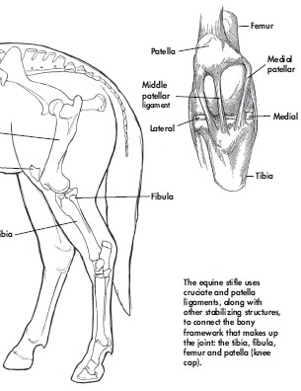

How?
Summary: The procedure is done standing. The horse is sedated and skin at the area of the incision is anesthetized with local anesthetic. A vertical incision several centimeters long is made over the ligament. A sharp, curved surgical instrument is passed under the ligament and the ligament is cut. The skin incision is sutured.
By cutting the medial patellar ligament completely, the patella no longer catches on the medial trochlear ridge of the femur, and so the stifle no longer locks.

Procedure:
Step 1:
The site is identified and anesthetized. It is then scrubbed and prepped for surgery.
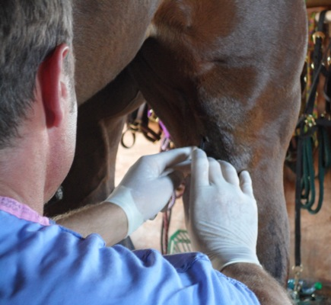
Step 2: An incision is made along the medial aspect (inside) of the medial patellar ligament. The incision is adjacent and parallel to the ligament.
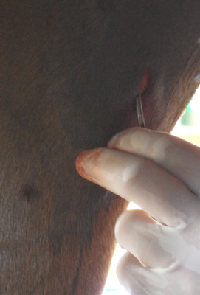

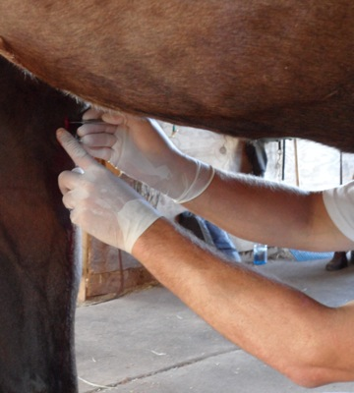

Step 3: The medial patellar ligament is isolated using a pair of hemostats and partially exteriorized from the incision. Once capture of all ligament fibers is confirmed, the ligament is transected (in a horizontal plane).

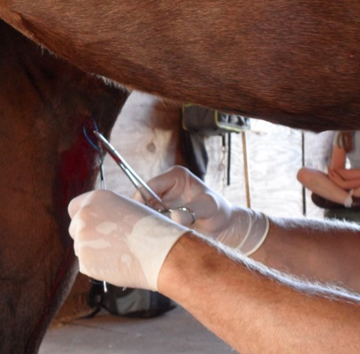

Step 4: Following complete ligament transection, the incision is closed with 3-4 interrupted sutures. Perioperative anti-inflammatory and antimicrobial therapy is recommended. Suture removal is typically performed at 2 weeks postoperatively.

Why?
Medial patellar ligament desmotomy (MPD), is a surgical procedure that is performed to correct the upward fixation of the patella (UFP), also known as a “locking” patella.

