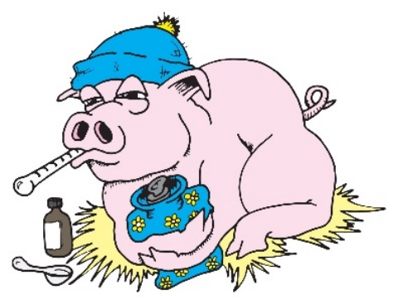

Complications
Post- operative care of patients minimizes the load of the surgical repair. Any cause of increased intra-abdominal pressure, such as excessive handling can predispose to failure of the repair. Tenesmus puts great strain on perineal hernias. Swelling, stiffness and increased lying time are the most prevalent adverse events observed following hernial repair. Animals need to be monitored for changes in gait indicating pain, and severe swelling in the area that may be a sign of severe infection.
Pain inherently is a part of the surgical procedure and cannot be avoided. Due to the use of general anesthesia the animal would be unaware of pain until it regains consciousness. Chronic pain is the longer-lasting pain that occurs in the days following post-op until the injury is healed. Therefore, minimizing pain is important for animal welfare, growth performance, and immune suppression. Pre-operatively and 24hrs, Flunixin meglumine (Banamine) a NSAID is administered to all patients. According to the severity of the incision site and the animal’s response to pain Banamine was administered daily to the patients.
Recurrent hernias can be caused by infections, extreme tension and inadequate nutrition of the exposed tissues. Technical failures such as the use of incorrect suture material or inappropriate tissue layers can lead to haemorrhage.

Other complications are as follows:
- Oedema (reduce with abdominal bandage)
- Hydrocele of sac
- Incarceration – adsorption of water in enterocele making reduction difficult
- Fly strike

