1. A longitudinal incision through the tunic was made on the most ventral aspect of the testis

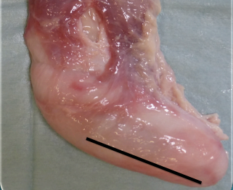

1. The testis and the funiculum were exteriorized as to perform an open castration. The ligament

of the tail of the epydidimis was severed and the vascular bundle ligated and or emasculated as proximal as possible.

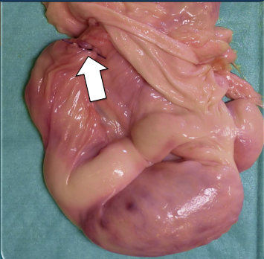

1. The bundle was then checked for any leakage and repositioned inside the vaginal tunica.

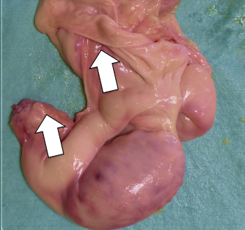

1. The vaginal tunic was brought distally and emasculated as proximally as possible, without comprising into the jaw of the emasculator also the vascular bundle already transected.

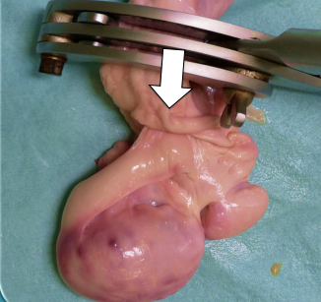

1. The final result of the vaginal tunic closed

