**Left Flank Celiotomy**

The left flank is prepared for aseptic surgery. Anesthesia is achieved by infiltration with a local anesthetic in a line block, inverted L block, or paravertebral block. A 20- to 25-cm dorsoventral skin incision is made 4cm caudal and parallel to the last rib and 6 to 8cm ventral to the transverse process of the lumbar vertebrae. It is important to locate the incision as close to the ribs as possible to allow a more complete examination of the cranial abdomen. The few centimeters gained over a midparalumbar

incision may be critical when the surgeon’s arm is placed through the incision and rumenotomy to

palpate the reticulum and reticuloomasal canal, especially in a large cow. However, one must be careful not to place the incision any closer to the ribs than described previously, because rumenotomy is a clean-contaminated procedure and postoperative incisional infection with osteomyelitis are possible.

The subcutaneous tissues, external and internal oblique muscles, transversus muscle, and peritoneum are incised in the same plane. When possible, a sterile, impervious sleeve should be

used for palpating the abdominal cavity. The caudal abdominal cavity is explored first including the urinary bladder, uterus, left kidney, dorsal and ventral sacs ofthe rumen, and intestinal mass. To reach the cranial abdomen the arm is passed ventral to the superficial layer of the greater omentum and directed cranially to locate the pylorus and pyloric part, body, and fundus of the abomasum, the omasum, and the reticulum. All parts of the reticulum must be palpated to verify whether adhesions and/or abscesses are present. The right side of the reticulum and left lobe of the liver where abscesses are most often found, must beespecially evaluated. The diaphragm, apex, and parietal surface of the spleen are also palpated.

Any adhesions found in the cranial abdomen must be assessed with gentle palpation to avoid disruption and minimize the risk of spreading inflammation. Adhesions in the cranial abdomen are more typical of traumatic reticulitis as the cause of peritonitis. Adhesions along the ventral body wall are more likely to be caused by perforating abomasal ulcers. If extensive cranial abdominal adhesions or ruminal distention prevent adequate palpation, a rumenotomy should be performed.

Two procedures have been used to secure the rumen to the skin:

1. The rumen board or Weingarth apparatus

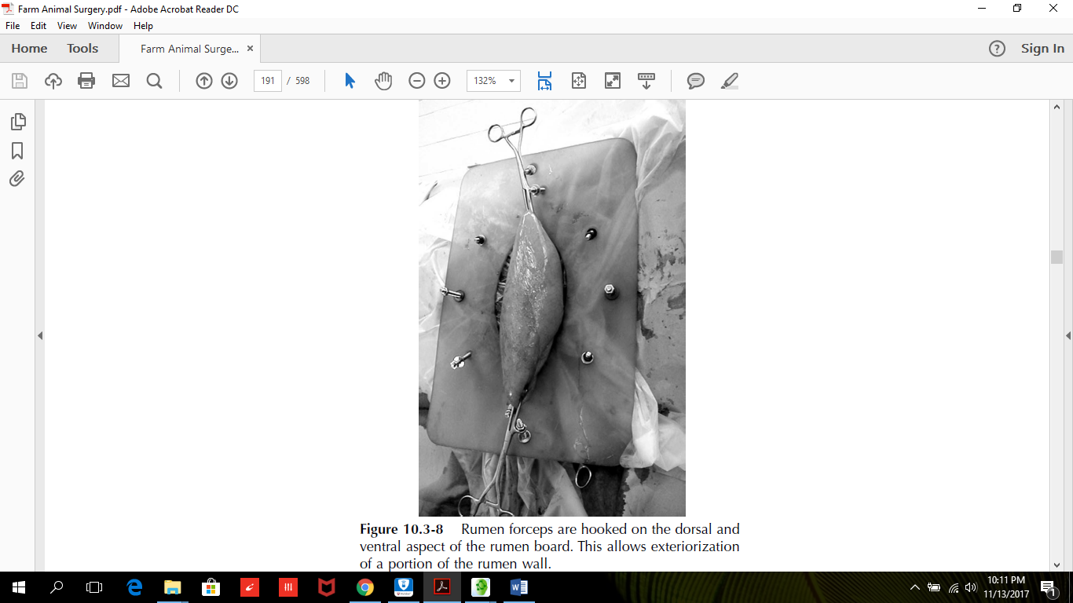

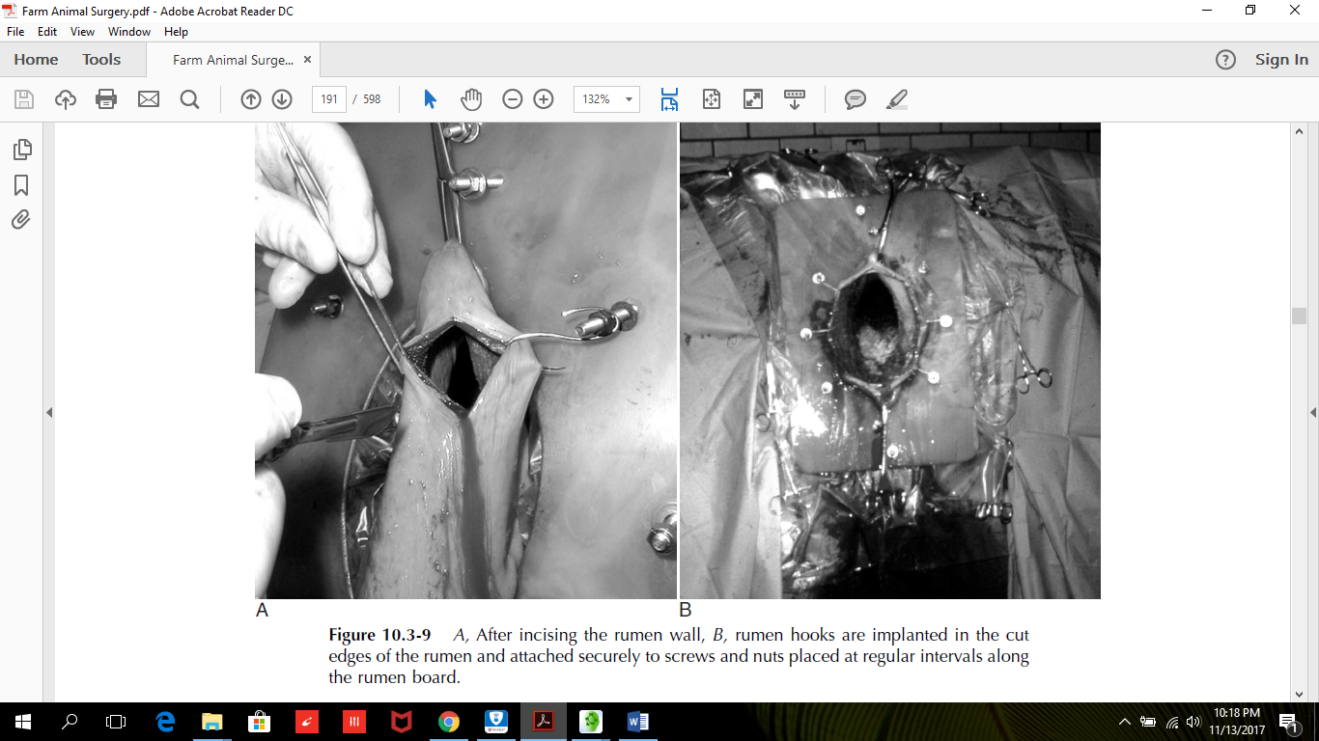

1. Suturing the rumen to the skin.

The rumenotomy site is in the dorsal sac of the rumen is used both techniques.

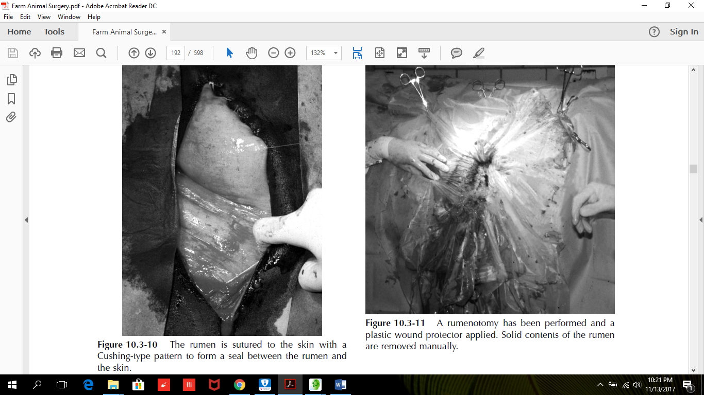

**Closure**

After gross contamination has been removed, the rumen wall is closed with No. 2 absorbable sutures with a two layer closure; at least one layer of which should be an inverting pattern. The surgery site is thoroughly lavaged, and all soiled instruments are discarded. If the rumen was sutured to the skin, the

suture is cut, and one quadrant at a time is freed. A moist sponge is used to wipe off ingesta trapped between the rumen and skin. The surgeon puts on fresh sterile gloves. The abdominal musculature is usually closed in two or three layers by using a simple continuous pattern of absorbable sutures in the muscle layers. The skin layer is closed with a continuous Ford interlocking pattern. It is wise to close the ventral aspect of the skin incision with two to three simple interrupted sutures. The possibility of incisional infection is obvious, and drainage can be easily obtained by removing these ventral two-to-three sutures if necessary.

**Post Operative**

Antibiotics are administered systemically to treat the septic reticuloperitonitis. Oral or intravenous fluids

may be needed to correct dehydration and metabolic alkalosis, if present. Rumen transfaunate can be given to re-establish normal flora and stimulate ruminal motility.