Surgical Preparation for Exploratory Laparotomy

**Step 1** The animal’s right upper and lower flank area was shaved. Specifically between the last thoracic vertebrae and moving caudally towards the hooks and ventrally down towards the umbilicus region.

**Step 2** The animal’s left and right cranial aspect of the forelimb between the elbow to the knee was shaved and also its ventral, and lateral side of its neck were shaved for placement of the Intravenous drip line.

**Step 3** The animal’s loin to rump was shaved. Specifically the lumbosacral region was clipped and shaved.

**Step 4** All drugs to be used in the surgery were pulled up.

**Step 5** All instruments and materials needed for this laparotomy surgery were placed on the clean surgery table.

**Step 6** A pink 20 gauge catheter was inserted into the animal jugular vein on the right side of its neck.

**Step 7** The induction drugs were given through the catheter’s valve with a syringe.

**Step 8** Drip bag containing saline and CRI fluids was attached to the animal via a drip line to the catheter in the animal’s jugular vein. A drip rate of 3 drops every 2 seconds was initiated.

**Step 9** The animal’s flank area and epidural area were cleaned with dilute chlorohexidine until the area was cleaned from dirt.

**Step 10** The animal was placed on the surgery table in sternal recumbency and the lumbosacral region was coated with povidone-iodine solution.

**Step 11** The lumbosacral space was located midline, slightly caudal to a transverse line between the points of the ileal wings. Using the thumb and middle finger to feel for the ileal wings, the index finger was used to identify the depression between the spinous process of the last lumbar vertebra (L6) and the spinous process of the first sacral vertebra (S1). The epidural needle was inserted slowly and directed perpendicularly into the spine and into the depression space. The tip of the needle is passed along a shelf of vertebral bone called the [lamina](https://en.wikipedia.org/wiki/Lamina_of_the_vertebral_arch)  before reaching the [ligamentum flavum](https://en.wikipedia.org/wiki/Ligamenta_flava) and the epidural space. Once place properly, there is a sudden loss of resistance to pressure on the needle and a slight clicking sensation or a “pop” may be felt by the anesthesiologist as the tip of the needle breaches the ligamentum flavum and enters the epidural space. Once there is no appearance of fluid coming out of the needle’s hub, a syringe is attached to the needle, the area is aspirated and the epidural drug is inserted.

In this lab, once the needle was placed and aspirated, clear fluid was seen coming out. This meant the needle had by-pass the epidural space and entered the subarachnoid space where there is clear cerebral spine fluid. Thus, a decision was made to give half the dose of the epidural drug calculated for this sheep which was 0.78 ml (½ of 1.56 ml)

**Step 12** Five minutes later, the animal was later placed on its left lateral side and left for the surgeons to attend to the surgery site on the right side of the animal.

**Step 13** The drip rate for the animal was set for 1 drip every 3 seconds and the animal was monitored under anesthesia for the surgery.

Image 1-

Showing students restraining the sheep to place in butterfly catheter in the cephalic vein.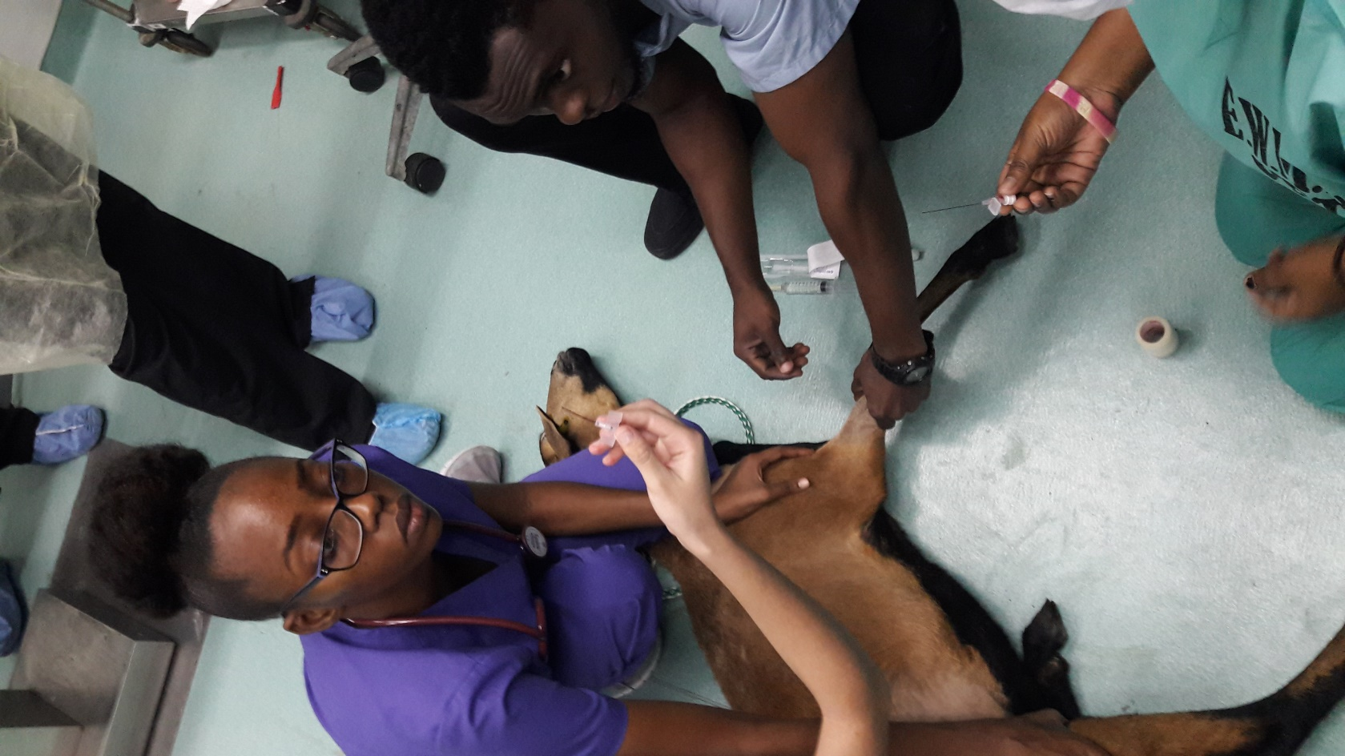

Catheter

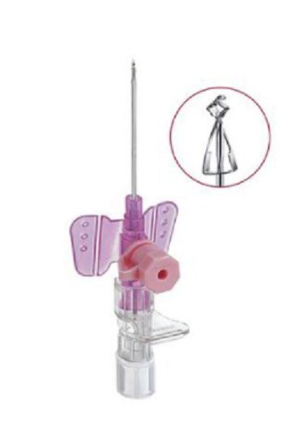

Eventually, the catheter was placed in the jugular vein.

Image 2- Showing surgical area and surgery students prepared and ready for the surgery.

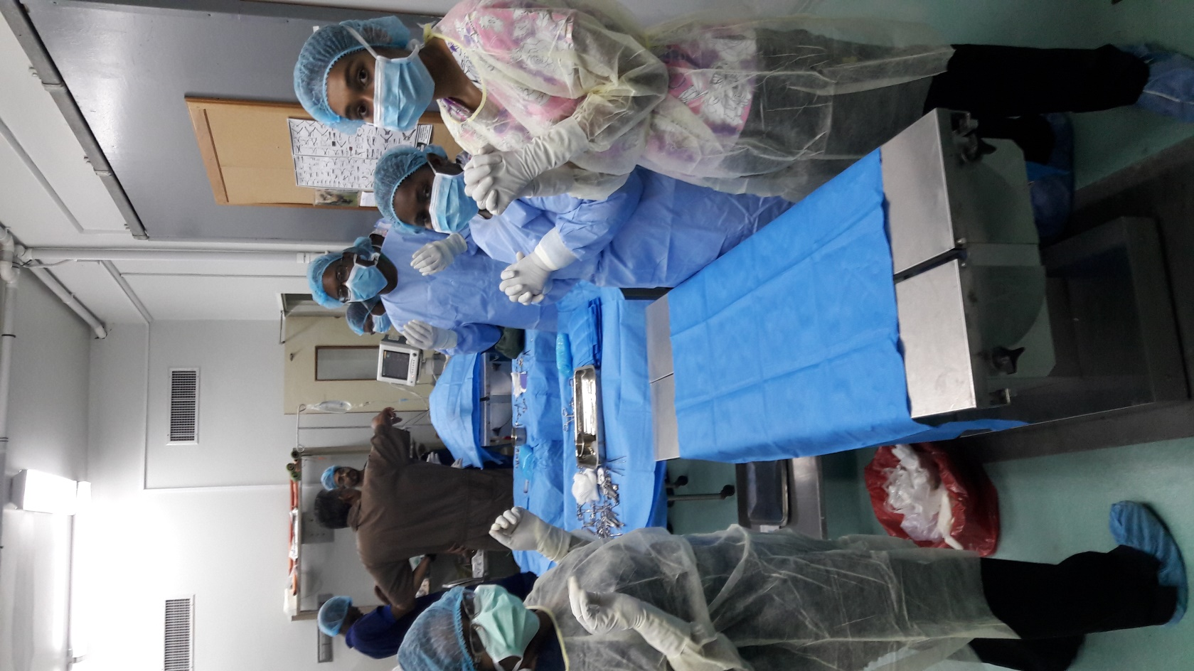

Image 3 Showing instruments used for this surgery.

