Nerve blocks used in Cattle for Ocular Surgery

- Auriculopalpebral Nerve Block
- Surgical manipulation of the eye is facilitated by nerve blockade of the eyelids. Auriculopalpebral nerve block can be placed to reduce upper eyelid movement prior to performing a Peterson or retrobulbar block.
- The auriculopalpebral nerve can be palpated as it crosses the zygomatic arch, roughly 5-6 centimeters behind the supraorbital process. Inject 5 milliliters of 2% lidocaine HCl subcutaneously on the dorsal aspect of the zygomatic arch at this location.

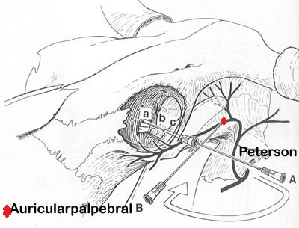
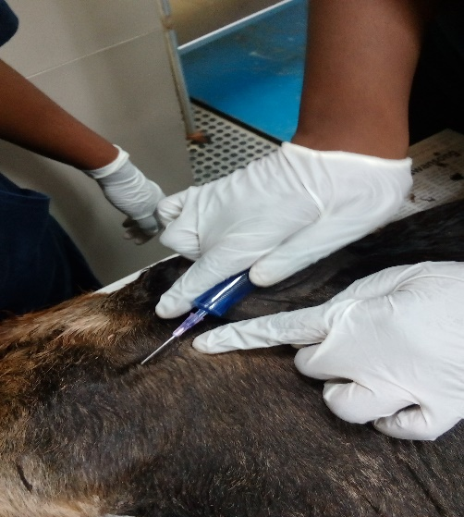

- Peterson Nerve Block
- After performing a small local skin block over the intended site of puncture, a 3.8-cm long 14-gauge needle is inserted through the skin as a cannula for introduction of an 18-gauge 9-cm long needle for the nerve block.

- The cannula is inserted caudal to the junction of the supraorbital process and zygomatic arch and is introduced through the skin. Then, the 18-gauge, 9-cm long needle is introduced through the cannula needle and is directed in a horizontal and slightly dorsal direction until the coronoid process is encountered.

- The needle is “walked off” the rostral aspect of the coronoid process and advanced in a ventromedial direction along the caudal aspect of the orbit until the needle encounters the bony plate encasing the foramen orbitorotundum.

- Once the needle is advanced to the foramen, it is advised that the needle be drawn back a few millimeters to reduce the risk of intrameningeal injection. After aspirating to assure the needle is not in the internal maxillary artery, 10-15 milliliters of lidocaine (2%) is deposited, with an additional 5 milliliters of lidocaine deposited as the needle is slowly withdrawn. Mydriasis indicates a successful block.

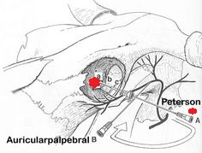
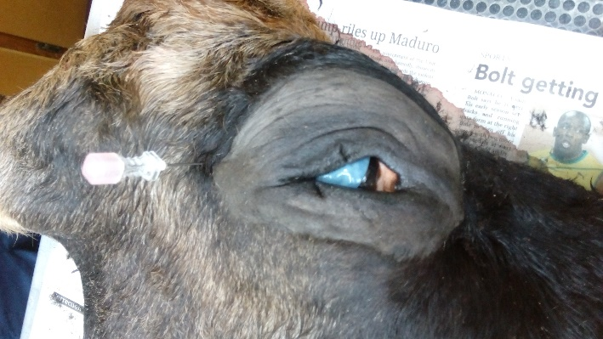

- 4 Point Retrobulbar Nerve Block
- The 4-point retrobulbar block is technically easier and can be done more rapidly as compared with the Peterson eye block.
- In this technique, an 18 gauge, 9-cm long needle is introduced through the skin on the dorsal, lateral, ventral and medial aspects of the eye, at 12, 3, 6, and 9 o´clock positions, respectively. Introduction of the needle through the conjunctiva should be avoided to reduce the occurrence of ocular contamination. The needle is directed behind the globe using the bony orbit as a guide.
- When the needle is introduced into retrobulbar sheath, the eye will move slightly with the tug of the needle. After this location is reached and aspiration is performed to assure that the needle is not in a vessel, 5-10 milliliters of lidocaine (2%) is deposited at each site. Mydriasis indicates a successful block.
- https://www.youtube.com/watch?v=n0NAGIdMnLA

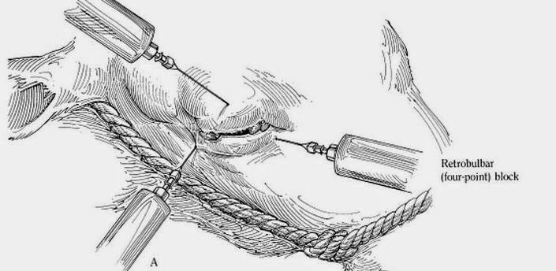

Subconjunctival injection

- https://courses.cit.cornell.edu/vet644/eyeInjection.html
- https://www.youtube.com/watch?v=xgFmdDnmOCU
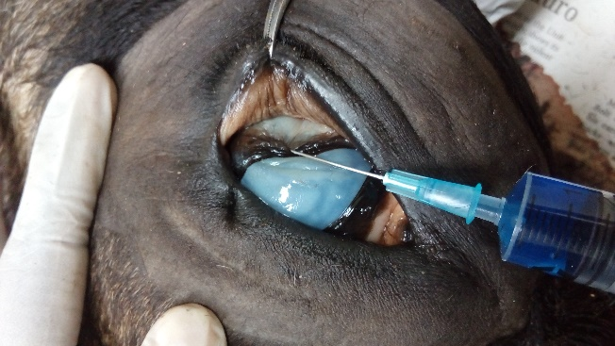
- https://www.youtube.com/watch?v=50m6ejh0eVA&t=2s

