DIGIT AMPUTATION USING OBSTETRIC SAW (GIGLI WIRE)
Surgical Procedure
- Proper pre-operative techniques are required (see pre-op techniques).
- Proper restraint and pain management.
Technique
- Using a scalpel blade make a skin incision along the axial and abaxial surface of the coronary band. Starting from the axial surface so that the surgical field is not obscured by blood

- Make vertical incisions along the dosal and palmar / plantar surface of the feet along the sagittal plane extending between both digits (vertical incisions should extend to the level of the dew claws).

- Another preferred method of making the skin incision is making only one vertical incision on the abaxial surface of the digit after the horizontal incision along the coronary band.

- Ensure that the skin and subcutaneous tissues are incised to the bone.

- Undermine the skin from the other lining tissues making a skin flap up to the level of the dew claws and retracted using towel clamps

- The gigli wire should then be placed between both digits (interdigital space) and directed around the digit being removed.

- The gigli wire should be positioned at a slight angle of 40-45 degrees applying some tension.

Amputation may be performed in two locations

- Low amputation is performed when only the coffin joint and distal phalanx are diseased; this amputation is directed through the middle phalanx.

- High amputation, which is used in cases with involvement of the coffin joint, distal phalanx, pastern joint, and middle phalanx. This amputation is directed through the junction of the middle and distal third of the proximal phalanx.

- Amputation commence by applying tension to the obstetrical saw and making long sawing motions.

- Once the digit has been removed, excess interdigital adipose tissue and all necrotic tissue, especially that involving the tendons and tendon sheaths, should be dissected sharply from the wound.

- If the interdigital artery can be located it should be ligated.

- The vertical skin incisions should then be sutured in a routine fashion (simple interrupted suture pattern).

- If the flap is not adequate tension sutures can be put in place.

- Complete closure is contraindicated because infection will resolve more rapidly if the skin flap is not completely sutured, to allow better ventral drainage.

- Apply antibiotic powder to the area and cover with gauze sponges. Then apply a tight bandage over the area.
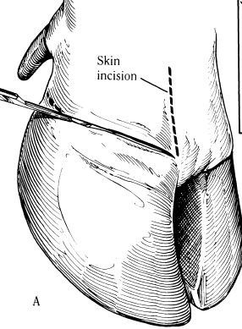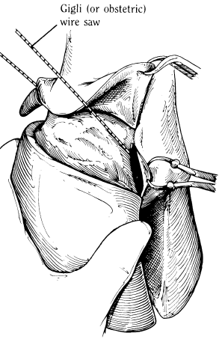
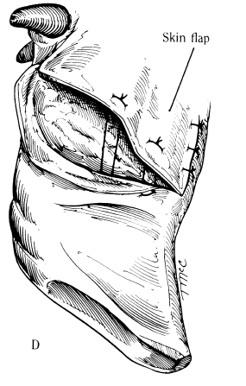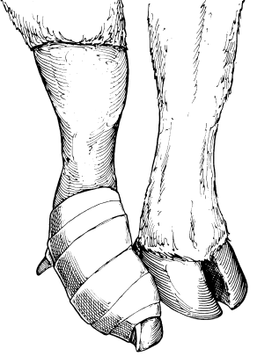

Digit amputation demonstration video: https://www.youtube.com/watch?v=orE7A5EZY1o

