Intraoperative:
Tools:
- A scalpel handle
- #11 surgical blade (for debridement)
- Small Metzenbaum scissors to trim necrotic tissue.
- Brown-Adson thumb forceps (tissue manipulation)
- Needle holder
- Mayo scissors
- Teat cannula, a syringe and some flushing solution.
- Absorbable suture material of size 3.0–4.0 (suturing the mucosa and the submucosal layers) Polyglycolic acid (Dexon II) or polyglactin 910 (Vicryl)
- 2.0 non-absorbable monofilament (to close the skin).
Procedure:
- The wound is debrided by scraping the tissue with a scalpel blade until pink, bleeding tissue is exposed and all necrotic tissue is removed. The margin of the skin may be trimmed using the scalpel blade or Metzenbaum scissors.
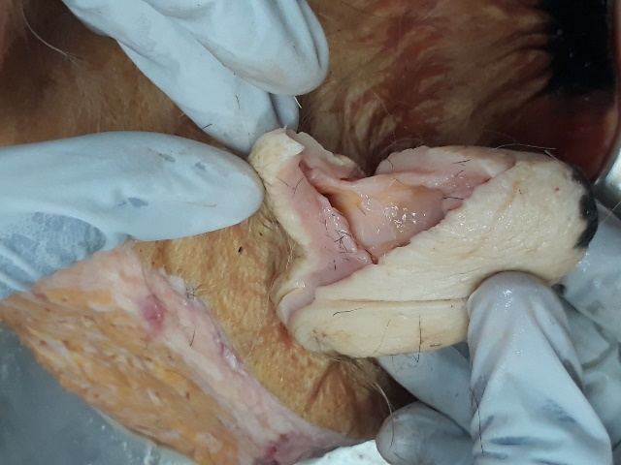
- The mucosa and submucosa are individually closed using 3.0 Vicryl in a simple continuous pattern, with sutures approximately 3mm apart from each other.
- A leak test is performed after suturing the mucosa by inserting a teat cannula into the teat orifice and injecting 5 ml of flushing solution to ensure no leaks are observed between the sutures. If any leaks are seen, a simple interrupted suture is placed and the test re-performed.
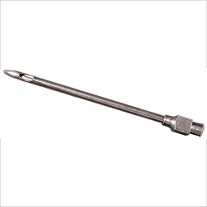
- The skin is carefully apposed using a vertical mattress, cruciate or ‘near, far, far near’ suture pattern. However, since this was a complex laceration, the “V” flap was also sutured with a corner suture to prevent wound dehiscence.
