Intraoperative repair of teat fistulas:
- Perform a local ring block at the base of the teat using 2% Lidocaine. A tourniquet can be placed around the teat base to prevent hemorrhage.
- Place a cannula into the teat sinus and make an elliptical incision around the fistula to remove all scar tissue.
- Suture the mucosa using simple continuous or simple interrupted suture patterns.
- Suture the skin using vertical mattress sutures, tying loosely to prevent wound edge necrosis post operatively.
Intraoperative repair of teat obstructions:
- Perforate the membrane with a milk cannula. The Huggs tumor device or a curette can also be used.
- Using a teat knife slit radially in three of four directions
- The cow should not be milked completely for about 10 days
- For apical obstructions, milk stenosis may be temporarily relieved by making longitudinal incisions in the fibrosed canal with a teat knife or by widening the canal with a teat slitter
- Place a self-retaining cannula to prevent post-operative milk stenosis
Intraoperative amputation of the mammary gland
- Epidural analgesia is administered and the cow is placed on dorsal or dorsolateral recumbency
- An elliptical skin incision is made around the discolored area and using a scalpel, dissection of the glandular tissue is performed along the suspensory ligament medially and the lateral ligament.
- Using a tenaculum forceps, dissect the udder from the body wall, beginning caudally
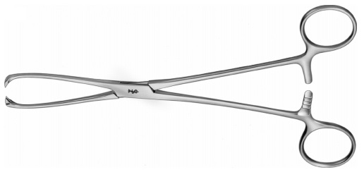
- Double ligate the external pudendal artery and vein, ventral perineal artery and vein and subcutaneous abdominal vein and transect the vessels between the ligatures
- Continue dissection of the udder cranially
- The subcutis is sutured in a simple continuous pattern using absorbable suture material
- Sterile gauze or latex drains are placed deeply and superficially in the wound
- The skin is then closed with simple interrupted sutures or in a Ford interlocking pattern.

