EQUIPMENT /TOOLS FOR HOOF TRIMMING

Electric Hoof Grinder  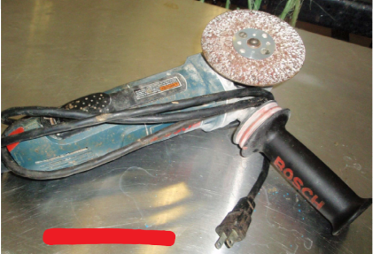 | Advantage: It is easier to use and less time consuming  than the manual hoof knife and hoof rasp.  Disadvantage: More expensive and needs experience  and knowledge to properly operate the machine.  https://www.youtube.com/watch?v=OR6B9i18xMY&feature=youtu.be
Rasp  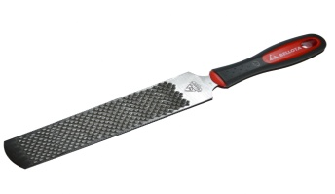  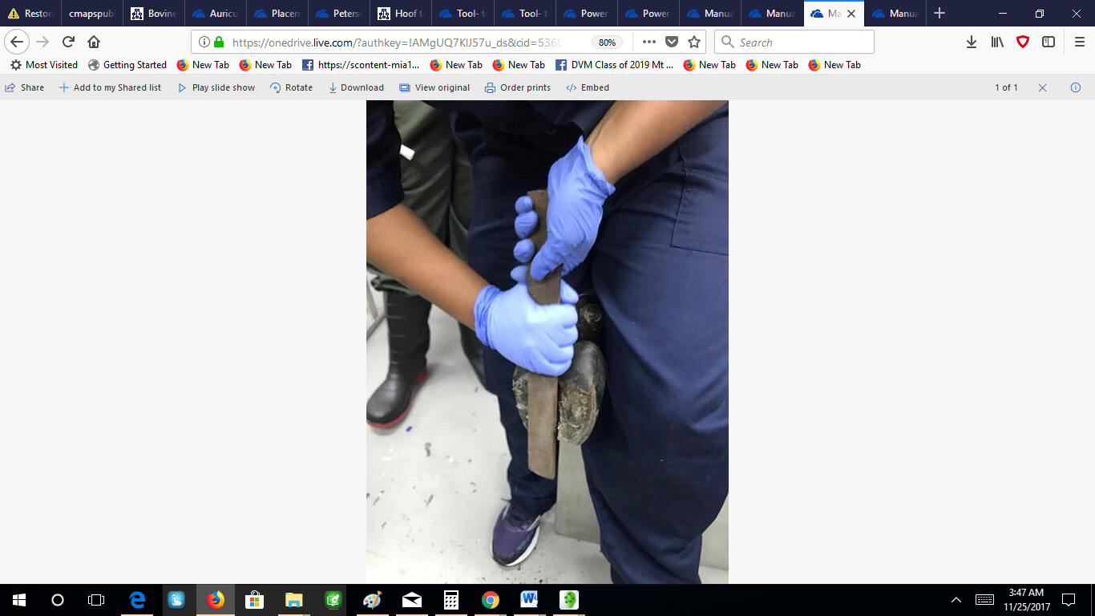 | Advantage: A rasp is a flat, metal bar that has sharp  projections on it. The rasp acts like a file to remove  small amounts of material at one time. It is used to  smoothen and shape the hoof and remove sharp points  made from the nippers/clippers.  Disadvantage: More time consuming and need  more effort and strength.
Hoof Nipper  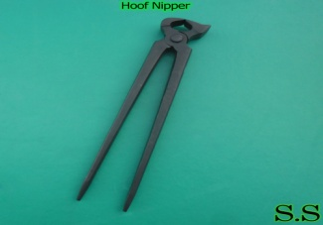 | Advantage: Used to reduce and align the apex of the  toes or hoof. It is cost affordable.  Disadvantage: Can be difficult to use if not properly  sharpened, and it needs more effort and strength  than the electrical cutter.
Electric Hoof Cutter  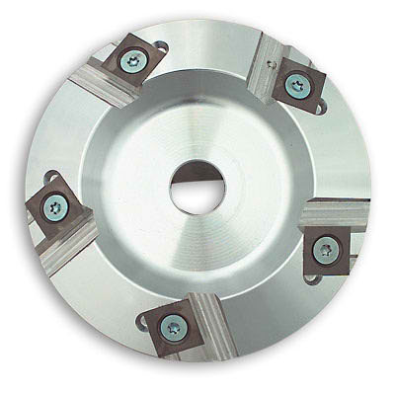 | Advantage: Much easier to use that than the hoof nippers, less strength and manual work Is needed.  Disadvantage: More expensive and needs experience and knowledge to properly operate the machine. It can cause a lot of damage to the hoof if not properly handled.
Electrical Hoof Knife  (Merlin)  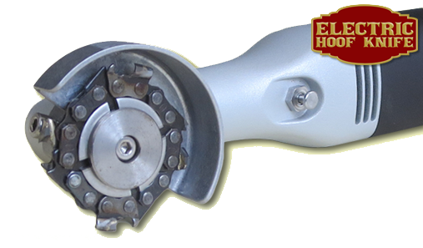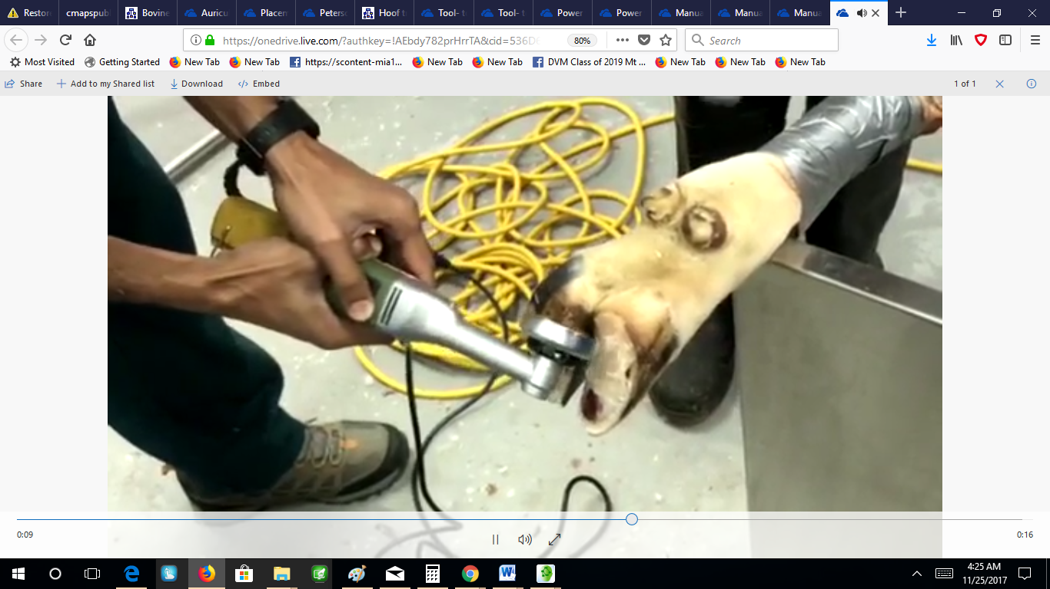 | Advantage: Used to make more precise cuts than the grinder and cutter  Easier to manipulate. Can be used to fine tune and smoothen the curvature on the axial hoof wall and is less time consuming than the rasp.  Disadvantage: More expensive, need prior experience and knowledge to properly operate.  https://www.youtube.com/watch?v=Dgz7xCx0o_A
Hoof Clipper/ Cutting shears  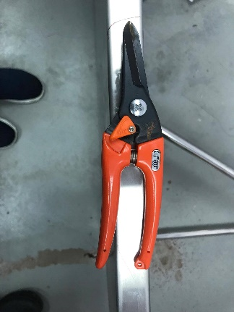 | Advantage: Used to trim the outgrowth of the hoof wall from the hoof.
Ruler  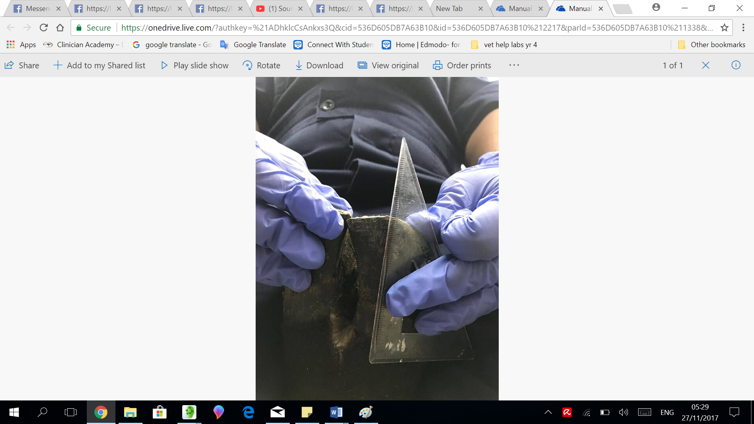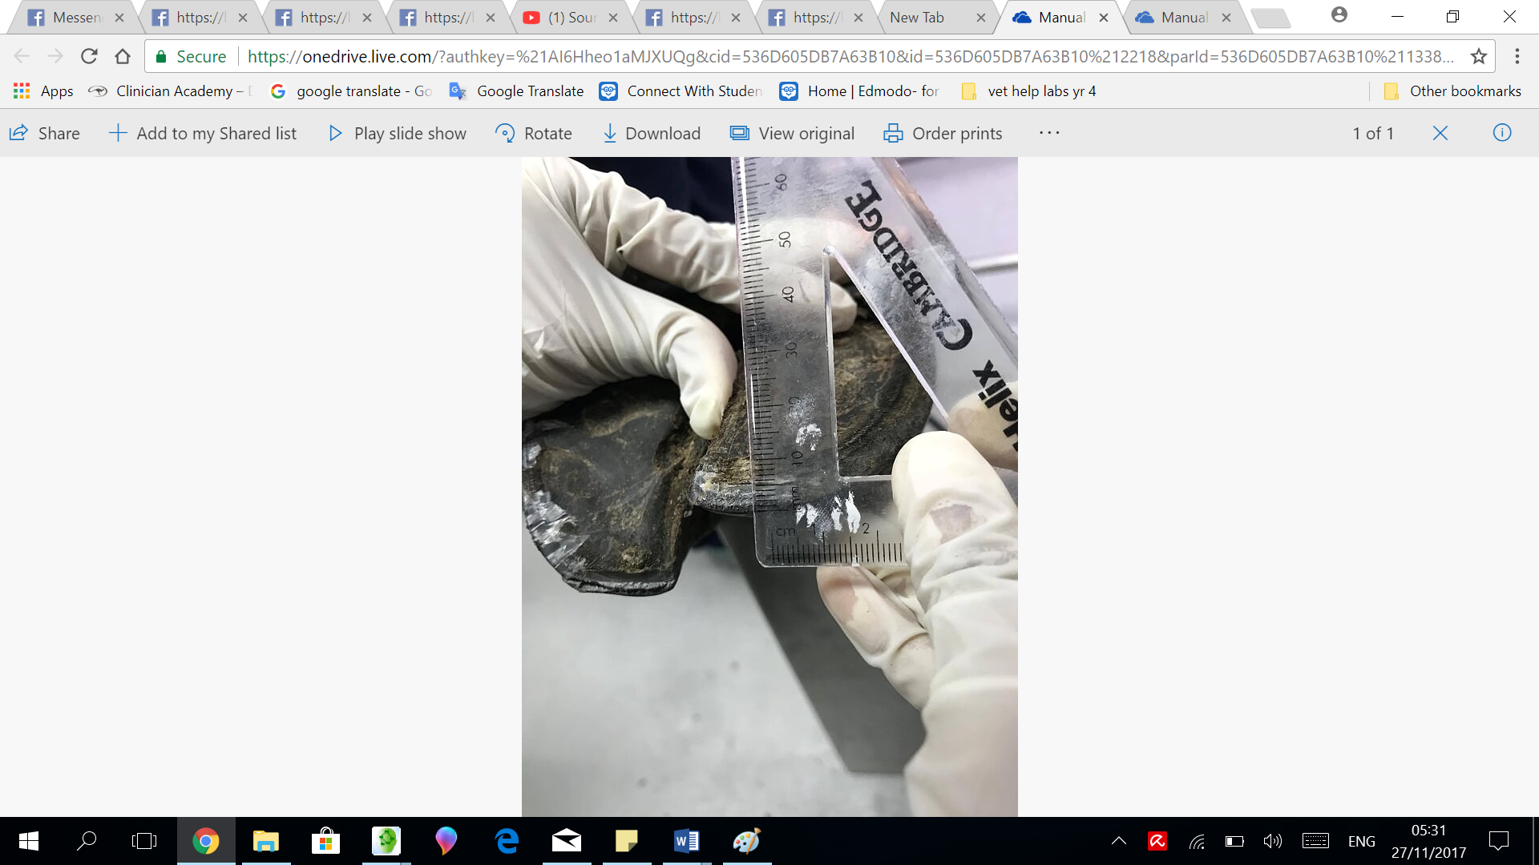 | Advantage : Used to measure the toe height and dorsal hoof wall to decipher how much of the hoof to remove.
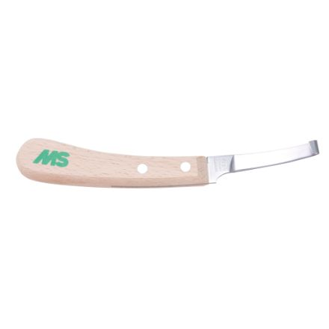  Hoof Knife  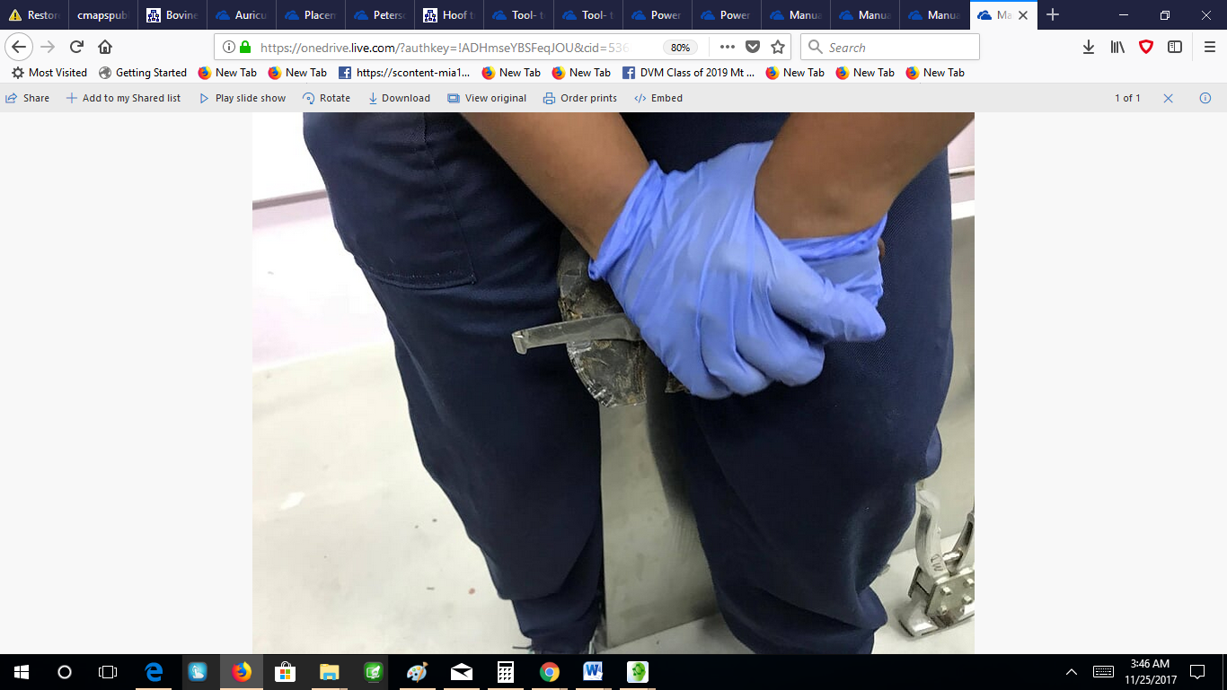 | Advantage: Used to debride the hoof and remove the sole, trim the shedding frog and sculpt the bars. To trim away dried out sole.  Disadvantage: More time consuming than the electric hand cutter. May make hand sore from usage.

REASONS FOR DOING HOOF TRIMMING

The Main reason is to prevent lameness associated with hoof problems, but in the case where problems do arise with the hoof, they can be corrected using specific hoof trimming techniques. This will in turn prevent a reduction in production due to lameness caused by hoof problems. The problems that tend to occur mostly include: Overgrown Horns, Hoof wall ulcers and Damage to the hoof.

Tools and materials used for digit amputation and disarticulation
Scalpel blade # 22 and scalpel holder 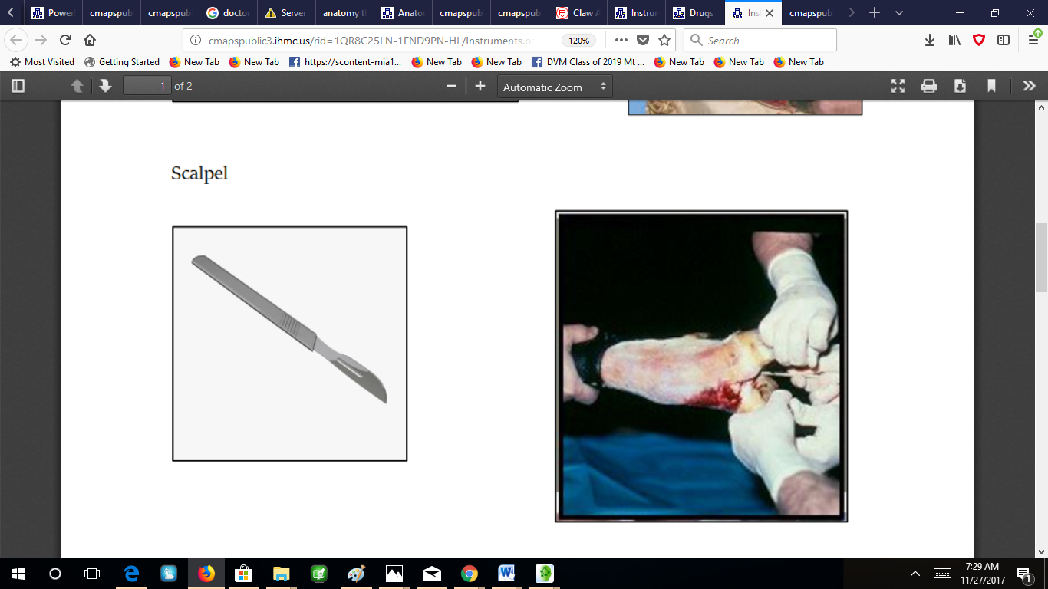 | Used to cut the skin and underlying tissues
Suture needle 20 G  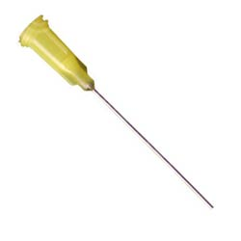 | used to insert nerve block drugs and was also used to suture the skin.
Suture material  For e.g Nylon | Used to suture the skin after procedure
Gauze 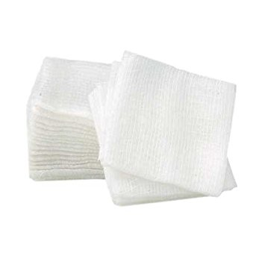 | Used to remove and liquid from the surgical site
Hemostats  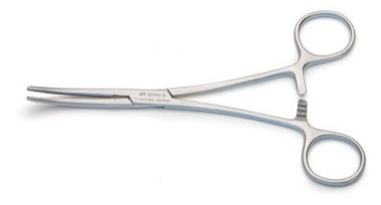 | Used to hold off tissues
Gigli wire  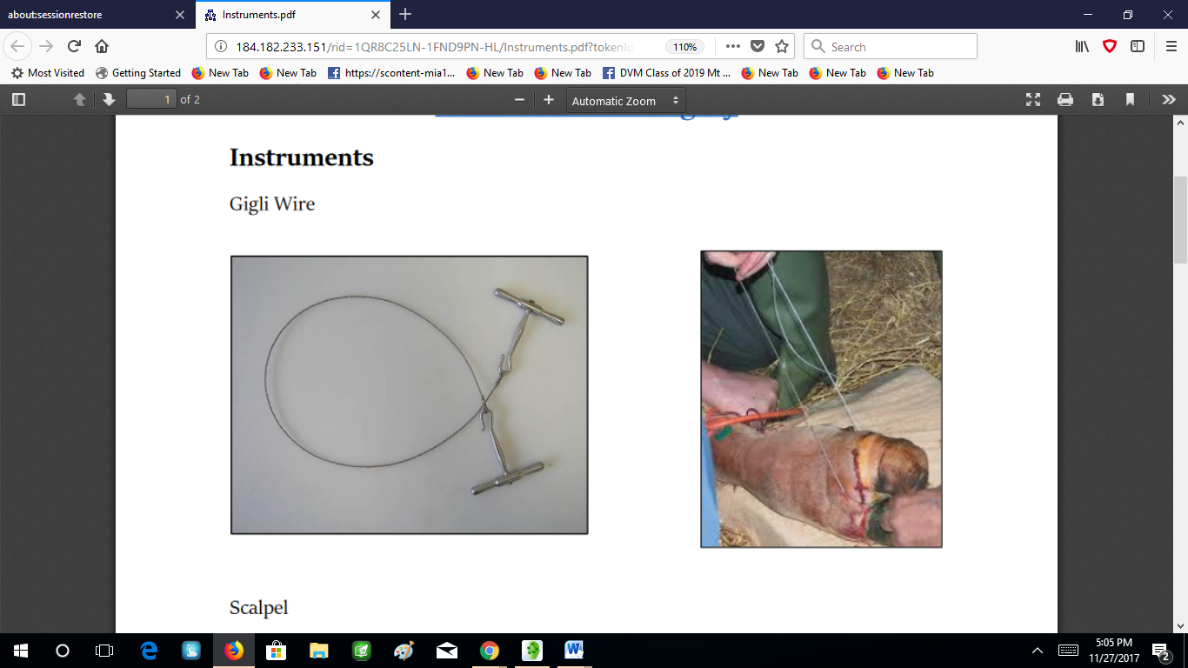 | a flexible wire saw used by surgeons for bone cutting. A Gigli saw is used mainly for amputation, where the bones have to be smoothly cut at the level of amputation.

Resection of the flexor tendon
Scalpel blade # 22 and scalpel holder | To incision the skin and tissues
Hemostats | To expose the tendon
Glove | To use as drainage material or tube. Acts as a Penrose drain
Buhner needle  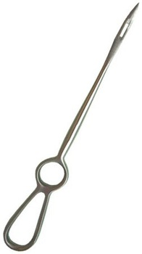 | To insert tube for drainage

