Drug | Species | Indications | Therapeutic Dose | Lethal Dose/ Toxicity | Contraindications | Pharmacology | Adverse Effects
Lutalyse Injection  (Dinoprost Tromethamine Prostaglandin F2α  Tromethamine)  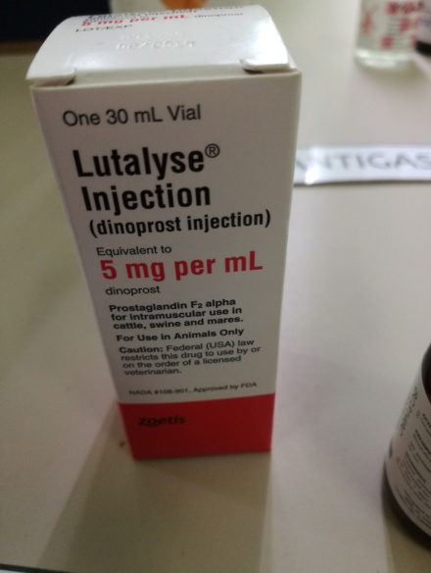 | Cattle, Horses, Swine, Sheep, Goats | Lutalyse® (Upjohn) is labeled for use in cattle as a luteolytic agent for estrous  synchronization, unobserved (silent) estrous in lactating dairy cattle, pyometra, and as an abortifacient in feedlot and non-lactating dairy cattle. It is labeled in swine to act as a parturient inducing agent. The product is labeled for use in mares as a luteolytic agent to control the time of estrus in cycling mares and to assist in inducing estrus in “difficult to breed mares.” | For estrus synchronization, inject 5 mL intramuscularly either once or twice at 10- to 12-day intervals.  For treatment of unobserved estrus, inject a 5mL dose IM. If estrus has not been observed by 80 hours after injection, breed at 80 hours; if the cow returns to estrus, breed at the usual time relative to estrus.  For postpartum treatment of pyometra, inject a dose of 5 mL IM at signs of pyometra | A slight and marked embryo lethal effect was observed in dams given 1.0 and 5.0 mg/kg/day respectively. This was due to the expected luteolytic properties of the drug. | Unless being used as an abortifacient or parturition inducer,  dinoprost should not be used during pregnancy in all species. Dinoprost is contraindicated in animals with bronchoconstrictive respiratory disease (e.g., asthma, “heavey” horses). It should  not be administered intravenously.  In swine, dinoprost should not be administered prior to 3 days of normal predicted farrowing as increased neonatal mortality may result.  According to the manufacturer, dinoprost is contraindicated in mares with acute or subacute disorders of the vascular system, GI tract, respiratory system or reproductive tract. | Prostaglandin F2α has several pharmacologic effects on the female  reproductive system, including stimulation of myometrial activity, relaxation of the cervix,  inhibition of steroidogenesis by corpora lutea, and can potentially lyse corpora lutea. | In cattle, increased temperature has been reported when  administered in overdose (5-10X recommended doses) quantities. Limited salivation and bacterial infections at the injection site have been reported. If administered intravenously, increased heart rates have been noted.  In mares, transient decreased body (rectal) temperature and sweating have been reported most often. Less frequently, increased respiratory and heart rates, ataxia, abdominal pain and lying down have also been noted. These effects are generally seen within 15 minutes of administration  and resolve within an hour.  In swine, dinoprost has caused erythema and pruritus, urination, defecation, slight ataxia, hyperpnea, dyspnea, nesting behavior, abdominal muscle spasms, tail movements, increased vocalization and salivation. These effects may last up to 3 hours. At doses of 10 times recommended, vomiting may be seen in swine.

