Absorbable Monofilament Suture Materials

Suture | Material | Qualities | Advantages | Disadvantages
Polydioxanone (PDS II)  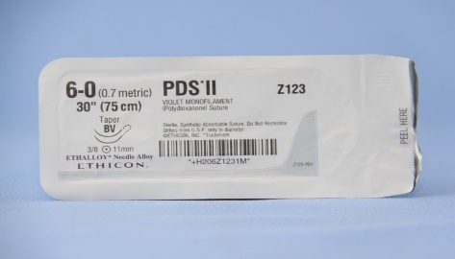 | Homopolymer of paradioxanone | Synthetic  Hydrolysed into natural metabolites  Acceptable to use for abdominal or thoracic wall closure or in the bladder tissue of sterile or infected canine urine. Rarely associated with calcinosis circumscripta in young dogs | Less tissue drag  Do not potentiate infection  Persists longer in tissues  High breaking strength | Brittle  Tendency to break at knots
Polyglyconate (Maxon)  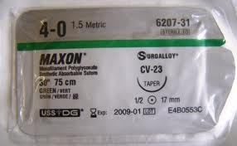 | Copolymer of trimethylene carbonate and glycolide | Synthetic  Degrades via hydrolysis  Used in general soft tissue approximation and/or ligation, and in peripheral vascular surgery. | Less tissue drag  Do not potentiate infection  Persists longer in tissues  high breaking strength | Less breaking strength  Greater stiffness  Inferior mechanical force  Compared to PDS  More rapid absorption pattern
Poliglecaprone 25 (Monocryl)  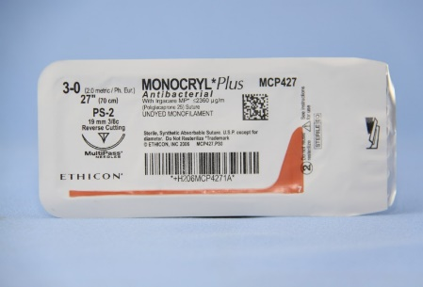 | Segmented block copolymer of caprolactone and glycolide | Synthetic  Degraded by hydrolysis  Recommended for ligation or tissue approximation during general soft tissue, oral and urinary bladder surgery, and for subcutaneous closures.1 Not recommended for use in cardiovascular, neurologic, microvascular or ophthalmic surgery | Better handling characteristics than other monofilament absorbable sutures  High initial tensile strength  Increased pliability  Good knot security  Minimal tissue drag | Rapidly absorbed  Maintains initial tensile strength for up to 2 weeks
Glycomer 631 (Biosyn)  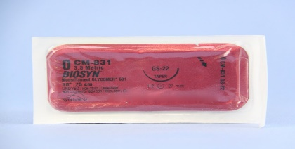 | Polyester of 60% glycolide,14% doxanonen and 26% trimethylene carbonate | Synthetic  Used in general soft tissue approximation, subcuticular skin closure and/or ligation including use in ophthalmic surgery. | Less tissue reaction than braided suture  More rapid absorption pattern  Superior strength at implantation | More rapid absorption pattern

