Non -Absorbable Monofilament sutures

Suture | Material | Qualities | Advantages | Disadvantages
Polyamide (Nylon)  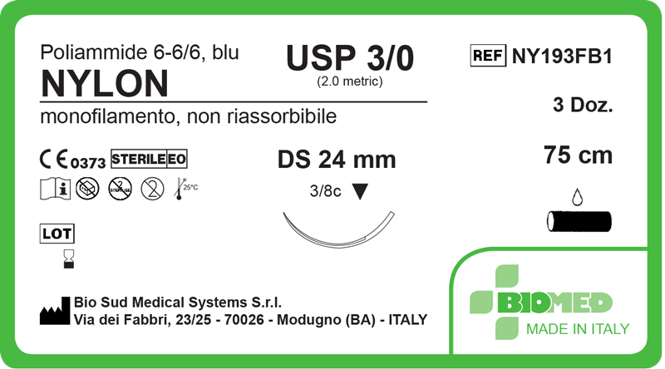 | Long Chained polymer | Synthetic | Inert  Maintains most of its initial strength  High degree of elasticity (useful for oedematous tissue and skin enclosure) | High Memory  Poor knot security  Bulky knot
Polypropylene  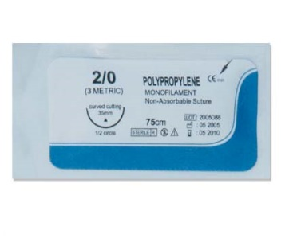 | Long chained polymer | Synthetic | Inert  Maintains most of its initial strength  Minimal tissue drag  Used in cardiovascular surgeries due to reduced thrombogenic potential | High memory  Poor knot security  Bulky knot
Polybutester (Novafil)  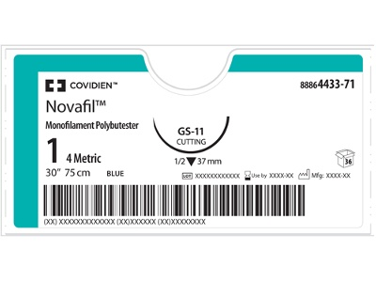 | Long chained polymer | Synthetic | Maintains strength after implantation  Highly elastic  Useful in tissues likely to become oedematous  Minimal Tissue drag | Poor knot security?
Stainless Steel Wire  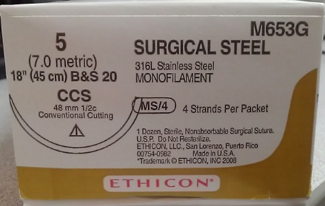 | Iron alloy (iron-nickel-chromium) | Non-absorbable  (comes in multifilament as well) | Strongest suture material.  Good knot security  Can be repeatedly sterilized  Does not potentiate infection like other sutures | Difficult to handle  Bulky knots  Can cut tissues and surgical gloves

