Non- Absorbable Multifilament Suture Materials

Suture | Material | Qualities | Advantages | Disadvantages
Silk  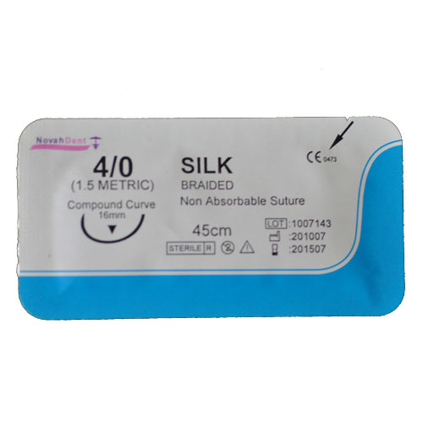 | Protein filament from silkworms | Slow absorption by proteolytic degradation within 2 years  Natural material  Used in general soft tissue approximation and/or ligation, including use in cardiovascular, ophthalmic, microsurgery, and neurological surgery. | Excellent handling Properties  Good knot-holding properties | Potentially allergic  Capillary action
Polyester (Ethibond))  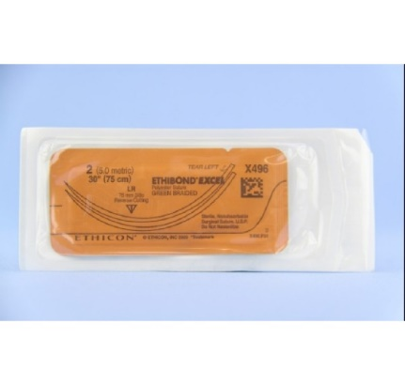 | Polymer of ethylene glycol and terapthalic acid | Synthetic, non- absorbable  Coated or Uncoated  Used in general soft tissue approximation and/or ligation, including use in cardiovascular, ophthalmic and neurological procedures.¹ | Inert  Prolonged Strength | Uncoated Forms Creates capillary and tissue drag  Coating reduces the knot security  Potentiation of infection
Polyamide (Nylon)  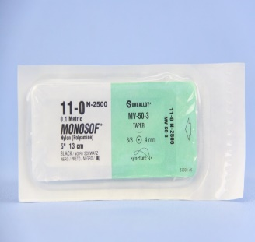 | Long -chained ploymer | Non-absorbable  Synthetic  Use in general soft tissue approximation and/or ligation, including ophthalmologic procedures. | Inert  Maintains most of its initial strength | High memory  Poor knot security  Bulky knot
Polymerised Caprolactam (Supramid) | Related to Nylon  Used in skin closure | Non-absorbable  Synthetic  Braided and coated | Coating minimizes capillarity  High tensile strength  minimal tissue reaction | Some knot slippage  Potentiation of infection

