**Scalpel Holders**

Reusable handles with detachable single use blades are used mostly in veterinary medicine but disposable units are also available. #3 and #4 handles are used most frequently with #3 being used more often than #4. #4 handle is larger than the #3 and has a larger fitment for large blades such as #20. The #7 handle is used for more delicate incisions.

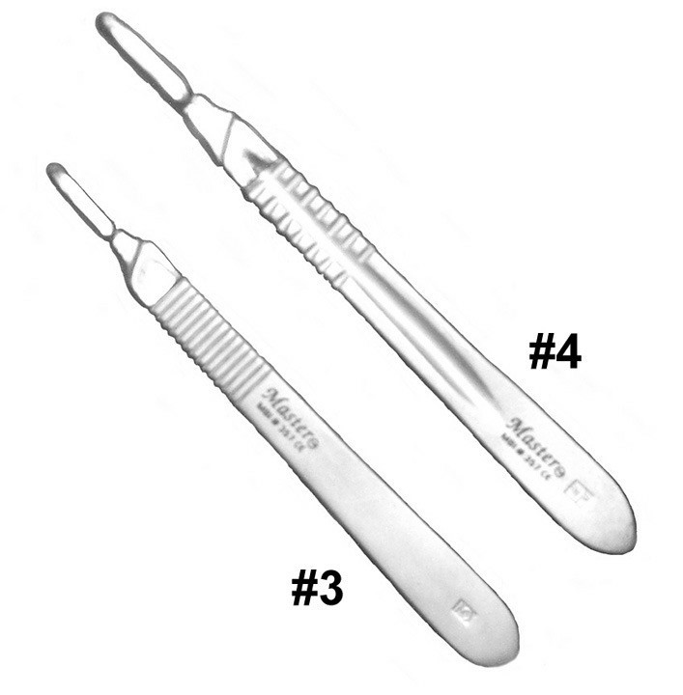

**Scalpel Blades**

Various blade shapes and sizes are available to perform specific procedures based on surgeon preference. Blades #10, 11, 12, 12B, 15 and 15C fit the #3 scalpel handle, whereas blades #20, 21, 22, 23 fit the #4 scalpel handle. In veterinary medicine, #10 blades are most commonly used.

A table showing Blades used in Veterinary medicine :

|  |  |
| --- | --- |
| Scalpel blades | Characteristics |
| #10 | * The No.10 blade has a curved cutting edge and is one of the more traditional blade shapes and is used generally for making varying sizes of incision in skin and muscle |
| #11 | * No.11 blade is generally used for making large incisions in the skin and subcutaneous tissue, as well as cutting other soft tissues. The No.11 blade is an elongated, triangular blade sharpened along the hypotenuse edge. |
| #15 | * The No.15 blade has a small, curved cutting edge. It is one of the most popular blades in small-animal surgery because its shape is ideal for making short and precise incisions. It is utilized in a variety of surgical procedures, including the excision of small skin lesions, organ biopsy, and fine neurological applications. |
| #20 | The No.20 is a large version of the No.10 blade with a curved cutting edge and a flat, unsharpened back edge. Used for orthopaedic and general surgical procedures it fits handle No. 4, |
| #22 | * The No.22 blade is a larger version of the No.10 blade with a curved cutting edge and a flat, unsharpened back edge. It is often used for creating large incisions through thick skin, and for soft tissue dissection in large-animal surgery |

* The No.15 blade has a small, curved cutting edge. It is one of the most popular blades in small-animal surgery because its shape is ideal for making short and precise incisions. It is utilized in a variety of surgical procedures, including the excision of small skin lesions, organ biopsy, and fine neurological applications.
* The No.22 blade is a larger version of the No.10 blade with a curved cutting edge and a flat, unsharpened back edge. It is often used for creating large incisions through thick skin, and for soft tissue dissection in large-animal surgery