**Hand -held Retractors**

Hand held retractors require that an assistant retract tissues by holding the retractor in the desired direction.

* **Army-navy retractors** are relatively flat instruments with 90-degree blades at either end. The blades on the retractor come in varying sizes, depending on the depth required. This instrument is commonly used to retract large muscle groups during neurological and orthopaedic procedures.

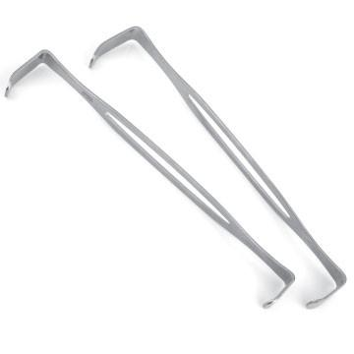

* **Senn retractors** have three curved, sharp prongs at one end and a right-angle blade at the other end of the instrument. These are used to retract skin and superficial muscles.

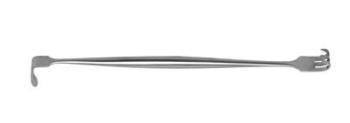

* **Hohmann** **retractors** have a large blade with a central extension known as a 'beak'. This instrument allows exposure of the shaft of a bone while the blade is pushing away surrounding muscle. Hohmann retractors are available in various lengths and blade widths. A mini-Hohmann retractor is also available.

