**Miscellaneous**

* **Allis tissue forceps**- They have a varying number of teeth on their gripping surface and are available in various sizes. These forceps are extremely traumatic and should only be applied to fascial planes or connective tissue (if applied to any tissues at all).

Used to firmly grasp tissue that is going to be removed from the body, e.g. tumours, hence the interlocking sharp teeth (very traumatic).

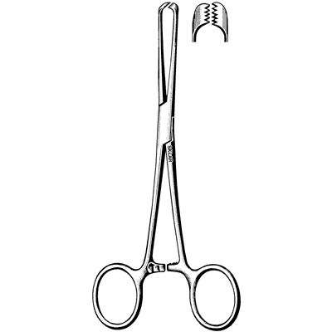

* **Towel clamps** are introduced through the ground drapes (at a corner where two drapes meet) and through the patient's skin to securely hold the surgical drape during a surgical procedure. Towel clamps can also be used to secure suction lines, electrocautery cables, and power equipment lines to drapes but this is less desirable because it creates a hole in the drape in an area that may not have been surgically prepared. Towel clamps are considered contaminated once they have penetrated a drape. Therefore, towel clamps must be discarded and replaced with new ones if repositioning is required.

