The Aberdeen knot is commonly used for surgical wound closure and is known for its tensile strength and reliability. It is often used at the end of wound suturing. It has also been shown to be stronger and more secure than a surgeon's knot for ending a suture line.

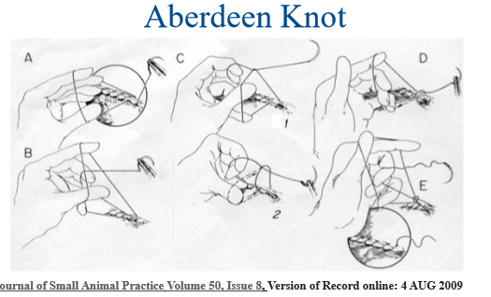

Aberdeen knots provide advantages over surgeon’s and square knots in overall strength, size and weight in. Strength advantages are because the configuration Aberdeen knots allow the suture strands to slide within the knot, absorbing energy and increasing the force require to break the suture material