Some specific examples with possible prognosis:
CONDITION | CLINICAL SIGNS | TREATMENT | PROGNOSIS
Accessory carpal bone fractures  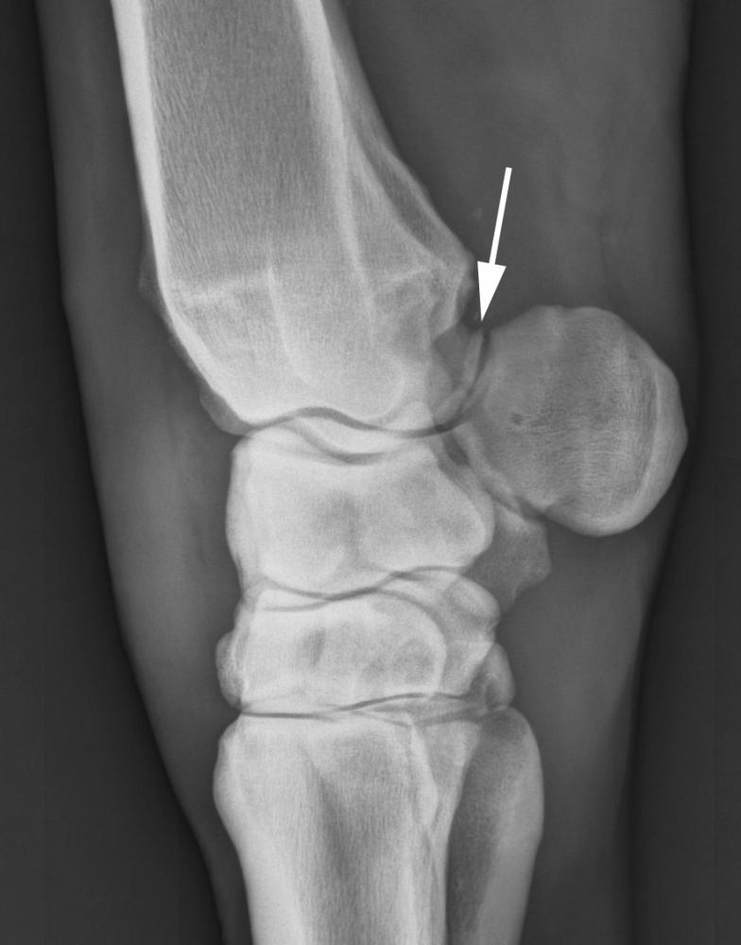 | Severe lameness and carpal swelling | Rest and bandaging for 8-12 weeks | Fair to poor for pleasure horses;  Poor for race horses
Bones cyst  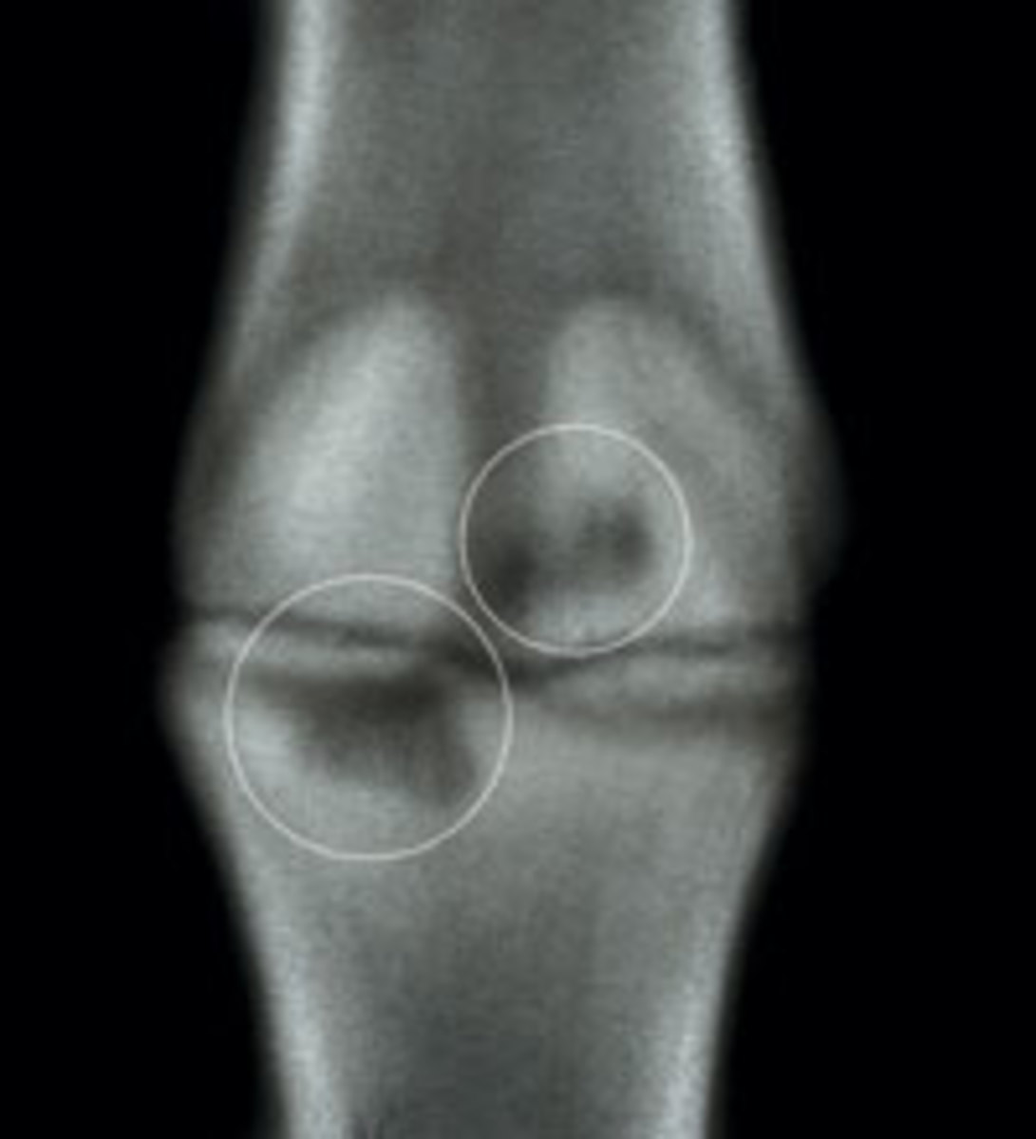 | Swelling and heat over carpal joints, pain on flexion, lameness | Rest and intra-articular medications | Good
Osteochondrosis  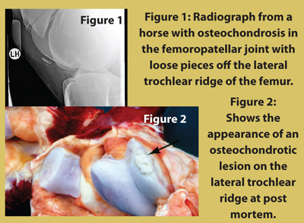 | Joint swelling, stiffness +/- lameness | Surgical removal | Excellent
Collateral ligament injury | Swelling over side of | Rest | Poor
Proximal suspensory desmitis | Mild to moderate lameness, heat, swelling and pain on palpation in acute cases | Stall confinement for 3 months with walking exercise | Excellent
Carpal sheath Tenosynovitis  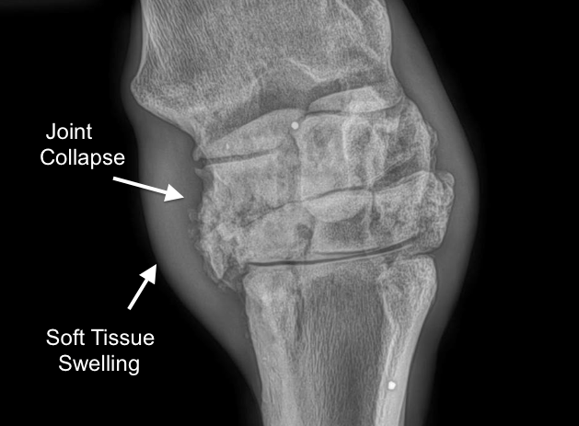 | Lameness, and carpal sheath swelling | Carpal sheath medications, keyhole surgery (tenoscopy), rest | Depending on the soft tissue injury: fair-good
Radial Osteochondroma  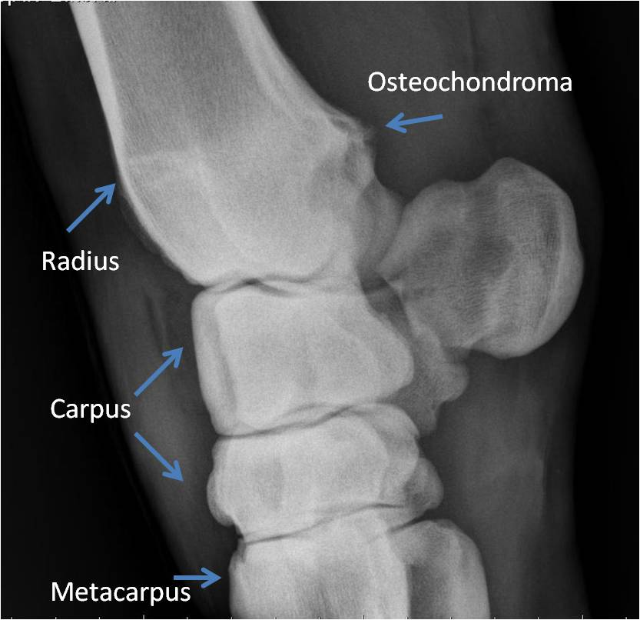 | Mild lameness, carpal sheath swelling | Tenescopy | Good if not severe damage to deep digital flexor tendon
Intercarpal ligament injury | Lameness, joint swelling, concurrent carpal bone injuries | Treatment of concurrent injury and rest | Depends on degree of other carpal pathology present
Carpal hygroma  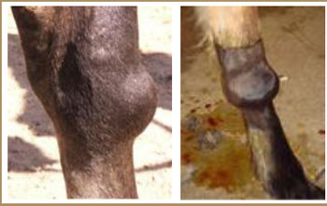  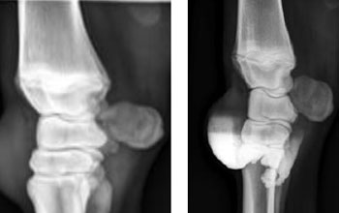 | Large non-painful swelling over front of carpus, +/- lameness | For cosmetic reasons, surgical removal of lining of hygroma, injections are usually unsuccessful | Variable, often good for surgical resection; re-occurrence common
Osteoarthritis of one or more joints  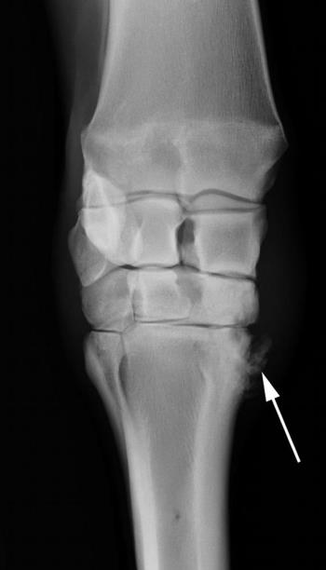  - Osteoarthritis of the carpometacarpal joint. | Joint swelling, decreased range of motion, lameness | Intra-articular medications, joint supplements | Dependent on severity and progression, but good in mild-moderate cases
Chip fractures (osteochondral fragmentation)  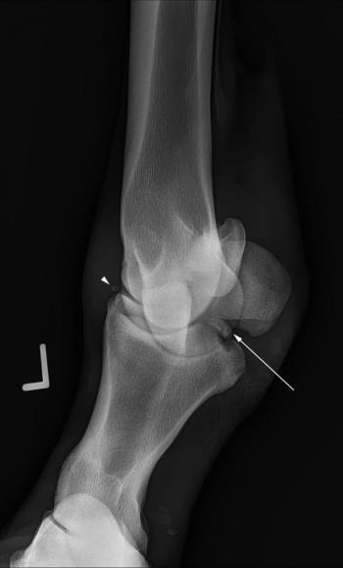  - Arrow pointing to osterochondral fragments | Joint swelling, lameness | Surgical removal of the chips | Good to excellent depending on associated osteoarthritis
Third carpal bone sclerosis | Joint swelling, lameness | Box nest for 2 months, treatment with bisphosphonates | Fair to good; if training continues without treatment, risk of fracture
Slab fractures of one or more bones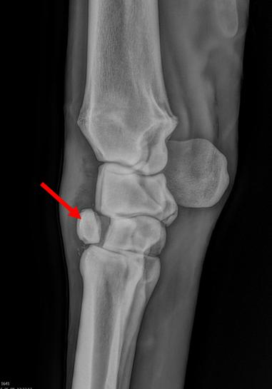 - third carpal bone slab fracture. | Joint swelling, lameness | Surgical removal if small; surgical fixation with screws if large | Fair to good

Ref link: https://www.google.tt/search?q=equine+lameness+large+animal+surgery&rlz=1CATAAB_enTT708TT709&source=lnms&tbm=isch&sa=X&ved=0ahUKEwiu2I2albXdAhWS7lMKHf1dAtsQ_AUICigB&biw=1280&bih=623#imgrc=pWIE3TncidQQtM

