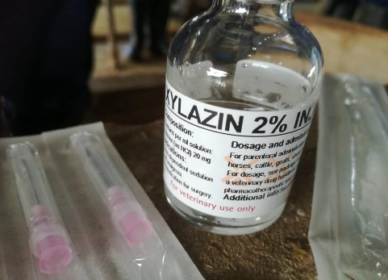 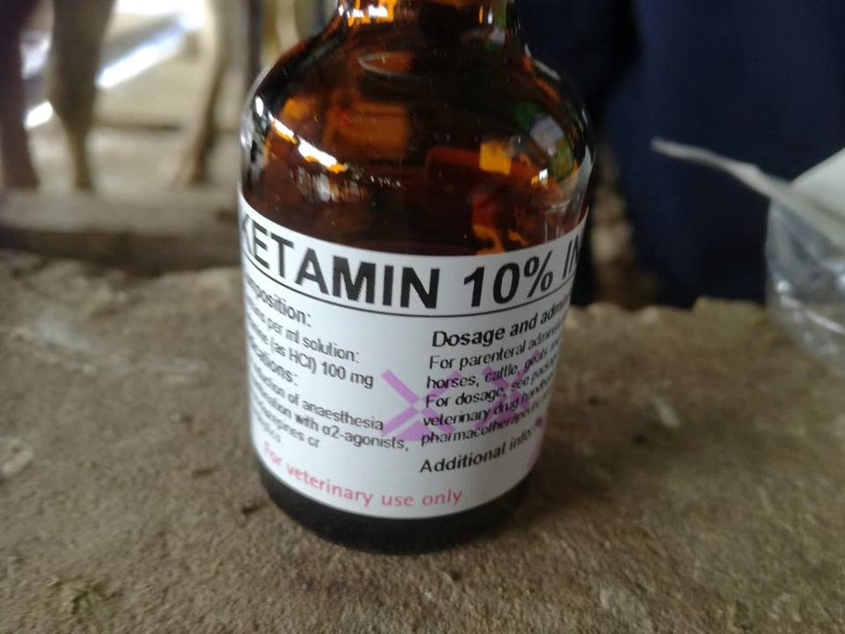 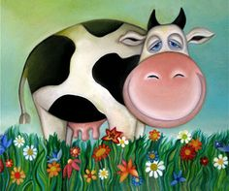

Distance and Physical Examinations were conducted to ensure that the animal was in good health prior to conducting sedation procedure.

**Materials required:**

* 2- 1 mL syringes
* Cottons swabs soaked with 70% isopropyl alcohol
* 2% Xylazin
* 10% Ketamin
* 10% Tolazoline
* Epinephrine
* Atropine
* 18 Gauge needles

Calculations for each drug (including emergency drugs) were performed as follows:

To administer 2% Xylazin:

* Dose: 0.025 mg/kg
$$Volume=\frac{Weight ×Dose}{Concentration}$$

* Concentration: 20 mg/mL
* Weight of Cow #126: 450kg

$$Volume=\frac{450 kg ×0.025 mg/kg}{20 mg/ml}$$

$$Volume=0.6 ml$$

To administer 10% Ketamin:

* Dose: 0.05 mg/kg
$$Volume=\frac{Weight ×Dose}{Concentration}$$

* Concentration: 100 mg/mL
* Weight of Cow #126: 450kg

$$Volume=\frac{450 kg ×0.05 mg/kg}{100 mg/ml}$$

$$Volume=0.3 ml$$



Atropine is used to reverse any signs of bradycardia

Epinephrine is used in case the animal develops an anaphylactic reaction.

Tolazoline is used to reverse Xylazin.

To administer Atropine:

* Dose: 0.04 mg/kg
$$Volume=\frac{Weight ×Dse}{Concentration}$$

* Concentration: 0.54 mg/mL
* Weight of Cow #126: 450kg

$$Volume=\frac{450 kg ×0.04 mg/kg}{0.54 mg/ml}$$

$$Volume=33.33 ml$$

To administer Epinephrine:

* Dose: 0.02 mg/kg
$$Volume=\frac{Weight ×Dose}{Concentration}$$

* Concentration: 1 mg/mL
* Weight of Cow #126: 450kg

$$Volume=\frac{450 kg ×0.02 mg/kg}{1 mg/ml}$$

$$Volume=9 ml$$

To administer 10% Tolazoline:

* Volume of Xylazin used: 0.6mL at concentration 20mg/mL
* Concentration of Tolazoline: 100mg/mL

$0.6ml×20 mg/kg ={Volume}_{2}×$ $100mg/kg$

$${Volume}_{1}× {Conc.}_{1}={Volume}_{2}×{Conc.}_{2}$$

*12mlmg/kg= Volume2 x 100mg/kg*

*Volume2= 12mlmg/kg/ 100 mg/kg*

*Volume2= 0.12ml*

For mildly depressed animals: **2** times xylazin dose: 0.12 ml x 2= *0.24ml*

For severely depressed animals: **4** times xylazin dose: 0.12 ml x 4= *0.48ml*