Cornual Nerve Block
What is it?
The cornual nerve block is used to desensitize the cornual branch of the lachrymal nerve and as a result anaesthetize the region of the horn for dehorning in Cattle.
Indications: dehorning and treating horn injury.
About the nerve and its location: The horn and horn base in cattle are innervated by the cornual branch of the zygomaticotemporal nerve, also known as the lachrymal nerve. It is a branch of the ophthalmic division of the trigeminal nerve. The zygomaticotemporal nerve, which is relatively superficial, 7 to 10 mm deep and covered only by a thin layer of frontalis muscle and the skin, can generally be palpated halfway from the lateral canthus of the eye super to a point 3cm from the lateral base of the horn, between the frontalis and temporal muscles. In large bulls the nerve lies deeper, at about 2.5 cm.
Method:
- Insert a 2.5 cm, 18-gauge needle into the upper third of the temporal ridge, immediately behind the ridge and about 2.5 cm below the base of the horn, to a depth of 0.7 to 1.0 cm.
  - The nerve may be palpable, between the frontalis and temporal muscles, about half way from the lateral canthus of the eye to a point about 3cm below the lateral base of the horn.
  - In large bulls the needle should be inserted to about 2.5 cm deep.
- Draw back on the plunger to check that the needle is not placed intravascularly.
- Inject 5 to10 ml 2% lidocaine hydrochloride (the amount required depends on the size of the animal).
- A blink response should be noted during administration; drooping of the upper eyelid is a good early sign of correct anaesthesia.
- Failure may occur if the anaesthetic solution is injected too deeply, into the temporal muscle aponeurosis.
- Note: In large individuals with well-developed horns make a second injection about 1 cm caudal to the first injection, to block the posterior division of the nerve.
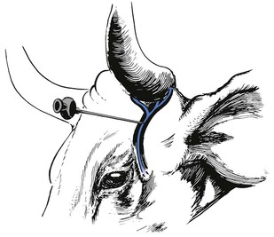- Picture showing the position and placement of the needle for the cornual nerve block.
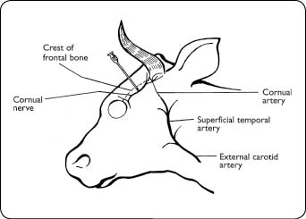 picture showing anatomical location of cornual nerve as well and surrounding structures.

Risks/complications:
- Failure may occur if the anaesthetic solution is injected too deeply, into the temporal muscle aponeurosis.
- In individuals with well-developed horns a second injection may be required, posterior to the horn or as an elliptical ring block around the horn base.
- Injection under the skin at the horn base may be difficult as the skin is tightly applied to the skull in this area.
Auriculopalpebral Block
What is it?
This block can be used to prevent the eyelids from moving during clinical examination or surgery. The Auriculopalpebral nerve supplies motor fiber to the orbicularis oculi muscle. It runs from the base of the ear along the facial crest, past and ventral of the eye, giving off its branches on the way.
Indications: It is used to keep the eye open, for example, as an adjunct in ophthalmic surgery and serves as one of the most commonly used techniques to block the motor function of the upper eye lid for ophthalmic surgery and to prevent eyelid closure during examination of the eyeball.

Method:
- The needle is inserted in front of the base of the ear at the end of the zygomatic arch and is introduced until its point lies at the dorsal border of the arch.
- 2% lidocaine 10-15 ml is administrated at injection site.
- Onset of analgesia occurs 10-15 minutes and duration of analgesia is approximately one hour.
- This block does not produce analgesia of the eye or the lids. In conjunction with topical analgesia (2% lidocaine), it is useful for the removal of foreign bodies from the cornea and conjunctival sac.
- This block has no sensory effects but paralyses the muscles of the eyelid.

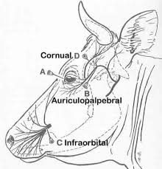 - picture showing location of the Auriculopalpebral nerve block (B) and Cornual nerve block (D)

