Sedation in Cattle:
The ketamine stun technique is a form of chemical restraint in ruminants where adding a small dose of ketamine to injectable chemical restraint cocktails can dramatically improve patient cooperation and systemic analgesia.
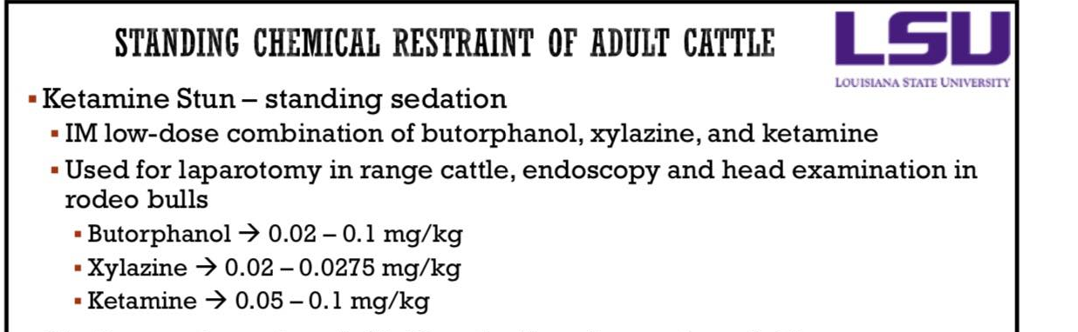
A Ketamine stun was used to provide a sedative effect on a cow to carry out the anaesthetic procedures. This was done by administering a drug combination of Xylazine 0.25mg/kg and Ketamine 0.05mg/kg intramuscularly.
Below shows some properties of the drugs used for sedation in the practical:
Xylazine:
- A potent hypnotic which provides deep sedation and popular as premedicant
- Onset of action following IV injection at 2 min, reaching peak effect in 5 minutes.
- Dose dependent severe cardiovascular effect: bradycardia AV dissociation, myocardial depression (decreased cardiac output)
- May cause hypoxemia and hypercapnia and pulmonary oedema (this is most notable/ predictable in small ruminants, particularly in the sheep)
  - – 0.1 mg/kg IV (1/10th of equine dose) in cattle
  - mg/kg IV provides sedation without recumbency, but 0.2 -0.3 mg/kg IV provides recumbency in llamas
- 0.1 mg/kg IV will induce recumbency and light plane of anaesthesia for an hour in cattle but recumbency may be induced even at a lower dose
- Some variation of sensitivity to Herefords has been shown to be more sensitive than Holstein, and Brahmans seems most sensitive
- Other side effects: Hyperglycaemia, Diuresis, Sweating, GIT motility depression, Platelet aggregation, Uterine contractions in cows. Detomidine in this regard has been regarded better alternative both in cows and mares.
- Reversal is carried out by using Tolazoline (or by other alpha 2 antagonists such as yohimbine or atipamezole) if indicated(e.g. for expedient recovery)
Ketamine:
- Ketamine alone will not cause seizure in cattle but the quality of induction is poor
- Ketamine is associated with increased muscle rigidity and excessive salivation
- Ketamine is better used in combination with other sedatives (most commonly with benzodiazepines or alpha 2 agonists)
- Ketamine may cause increased heart rate, cardiac output, and blood pressure.
Ketamine-Xylazine:
- Xylazine is given to adult cattle either IM at 0.1 – 0.2 mg/kg or IV at 0.05-0.1 mg/kg to produce deep sedation often recumbency.
- Butorphanol 0.1-0.2 mg/kg IV can be included in this combination for better analgesia and muscle relaxation.
- Ketamine is then given IV in doses of 2 mg/kg to induce anesthesia
- Often, ET intubation can be performed soon after the xylazine injection and before ketamine is given and whenever possible this should be done, as ketamine appears to produce copious salivation or an inability to swallow the normal saliva volume
- Hypoxia due to hypoventilation during the use of this combination has also been reported. For this reason, supplemental oxygen is recommended.
Ref link: https://instruction.cvhs.okstate.edu/vmed5412/pdf/24RuminantAnesthesia2006.pdf

