To administer Pen- Strep (Combikel®):

* Dose: 10,000 IU/kg
$$Volume=\frac{Weight ×Dose}{Concentration}$$

* Concentration: 200,000 IU/mL
* Weight of Cow #263: 150kg

$$Volume=\frac{150 kg ×10,000 IU/kg}{200,000 IU/ml}$$

$$Volume=7.5 ml$$

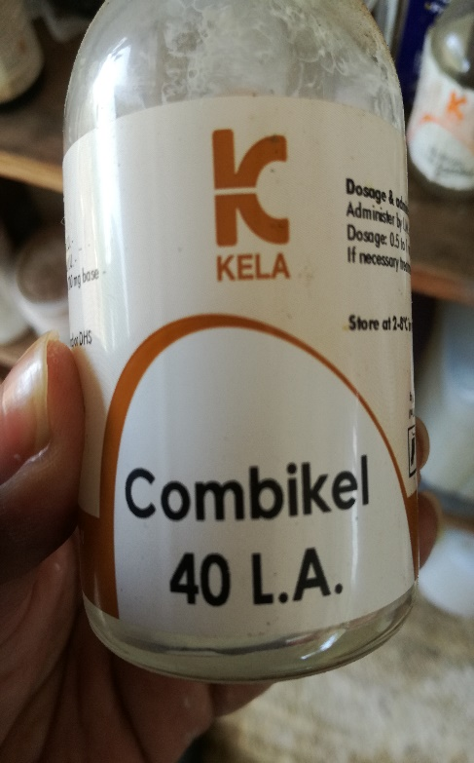 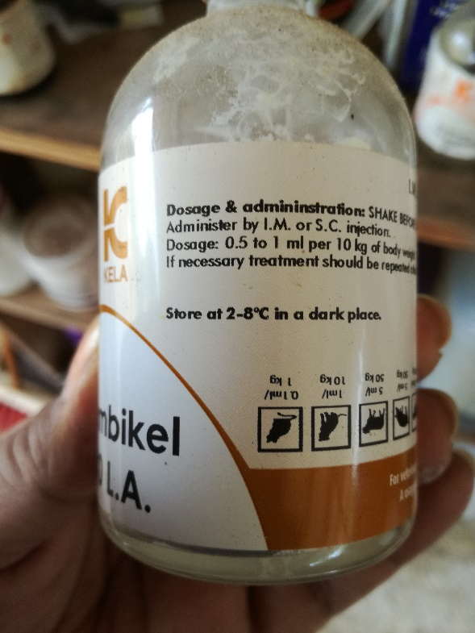 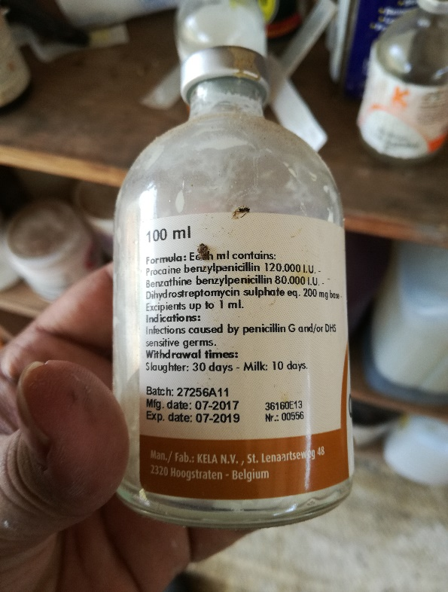

**Penicillin** shows a marked bactericidal action against most commonly occurring Gram-positive cocci, bacilli and anaerobes, and also against some Gram-negative germs (e.g. *Actinobacillus, Haemophilus, Leptospiren,*some *Pasteurella* strains, anaerobes such as *Fusobacterium* and *Bacteroides*).   
  
**Dihydrostreptomycin** is an aminoglycoside antibiotic predominantly active against Gram-negative cocci and bacilli, and against some Gram-positive bacteria (e.g. *Staph. aureus, Mycobacterium*).   
  
The**combination of DHS and penicillin**provides a bactericidal synergistic action with a broad spectrum.

Prevention and treatment of infections caused by penicillin G and/or DHS susceptible microorganisms such as respiratory tract infections (shipping fever, bronchopneumonias, upper respiratory tract infections), uro-genital tract infections (e.g. pyelonephritis by *Corynebacterium*renale, endometritis), infections of skin and wounds, *streptococci* infections in horses (strangles, Str. zooepidemicus infections in foals), erysipelas in pigs, panaritium, necrobacillosis in calves and piglets, anaerobe infections (clostridial infections, tetanus, anthrax), polyarthritis (navel ill), mastitis, septicaemia, bacterial infections secondary to viral ones.    
The drug also can be used in postoperative prevention of infections.

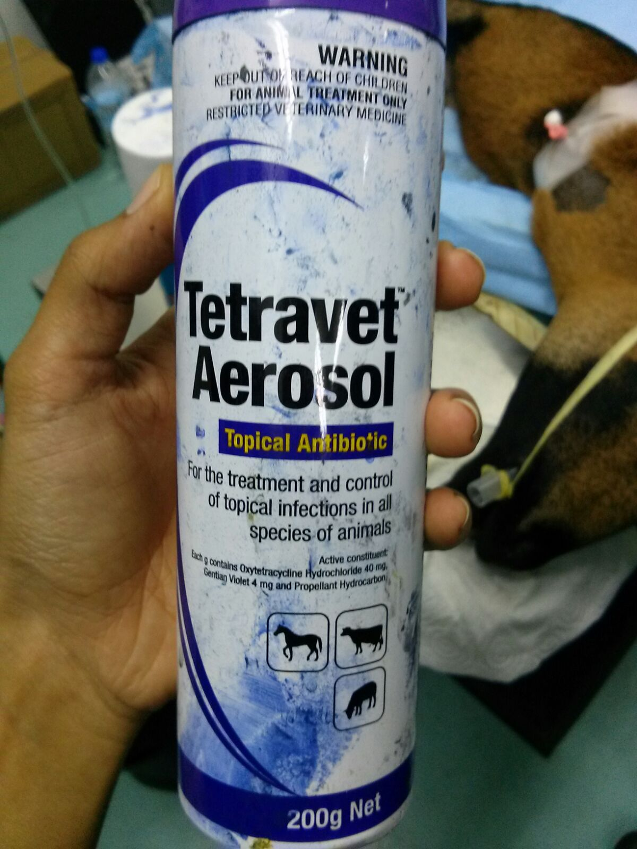

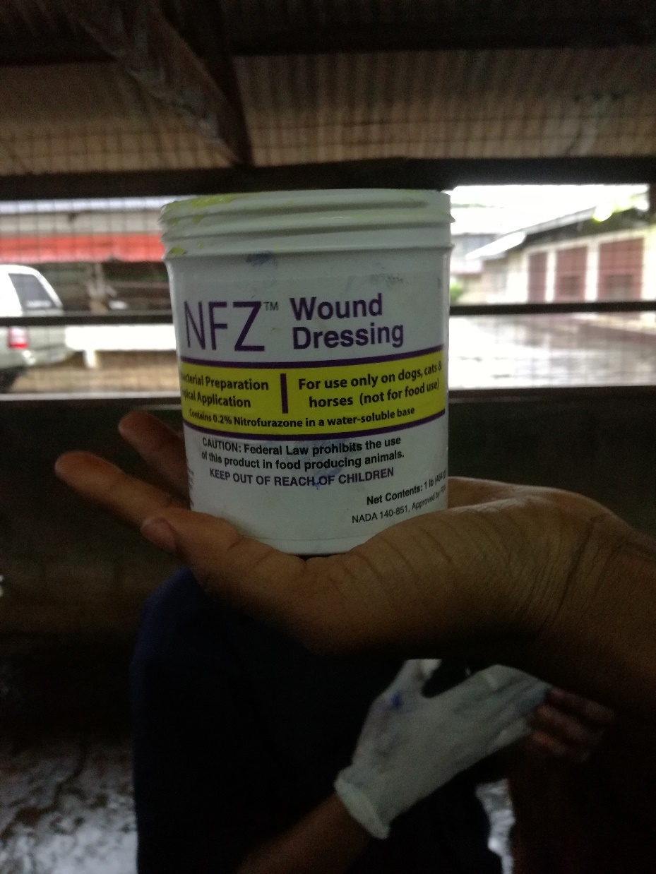

NFZ Wound Dressing is a water soluble antibacterial ointment for the prevention or treatment of surface bacterial infections of wounds, burns, and cutaneous ulcers.