**What is disbudding?**

Firstly, horns are a pair of hard, bonelike, permanent growths projecting from the heads of cattle. They grow from a unique area of skin cells at the base of the horn. At about two months of age, horns become attached to the frontal bone of the skull. A sinus lies within the skull beneath the horn bud. As the horn grows and attaches to the skull, this frontal sinus joins into the adjacent portion of the horn.

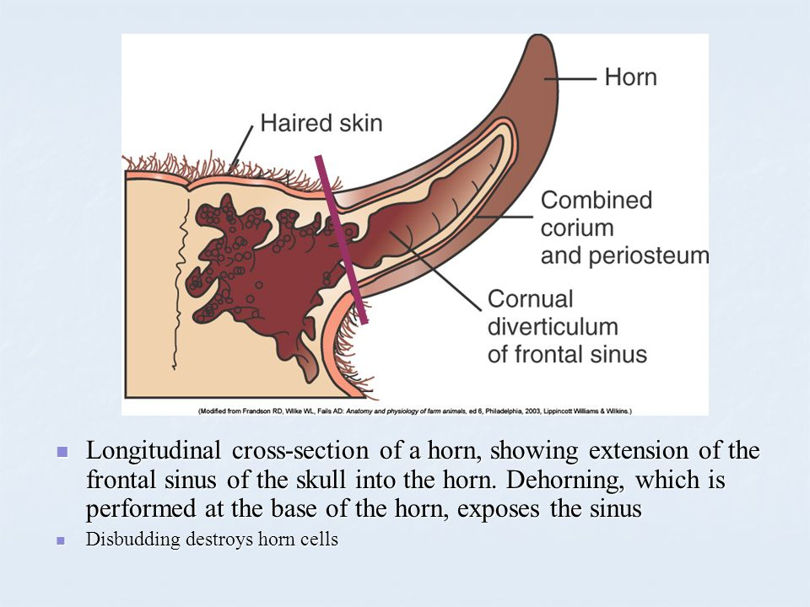

Horned cattle have horns because they have not been dehorned or they are not polled. Some breeds are naturally (genetically) hornless. Disbudding involves the removal of horn- producing cells in calves less than two months of age. At this stage, horn buds are still free- floating and not yet attached to the frontal bone of the skull.

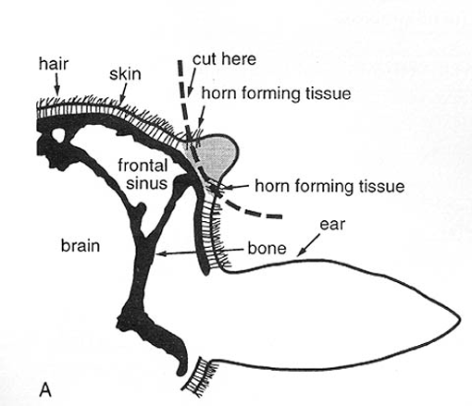

There are two methods:

1. Chemical Method
2. Mechanical Method

**Chemical Method:**

Caustic chemicals will prevent the growth of horns when properly applied to the horn buds of new-born (less than one to three weeks of age) calves. The chemical destroys the horn-producing cells around the horn bud. The chemicals are available as sticks or pastes. To protect yourself, wear gloves when applying the chemicals. To protect the calf, avoid application near its eyes. Do not use caustics in rainy weather.

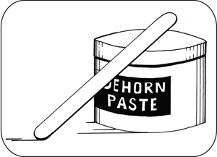

**Technique**

1. Administer sedation, analgesia and local anaesthetic.
2. Expose the horn bud (about the size of a 5-cent piece) by trimming the hair.
3. Apply petroleum jelly to prevent burning the skin.
4. Apply the caustic to the horn button. Use a wooden applicator. Apply a thin layer.
5. Re-position the hair over the paste and horn bud - i.e., cover the horn bud.
6. Although the package insert may instruct operators to clip hair at the horn bud, experienced operators have shown that not clipping hair is preferable, because the hair keeps the caustic in place, reduces the risk of irritation to the cow’s udder and flanks and reduces irritation to other facial skin of the calf.
7. Protect the calf and the cow from accidental caustic burns. One method is to place a patch of duct tape over each horn bud. The duct tape usually falls off in a few days. For dairy calves, keep in individual pens.
8. In some countries, the technique is only permitted in calves less than eight days of age.

**Mechanical Method:**

The mechanical method is using other means of disbudding using various forms of equipment to get the job done. Hot-iron disbudding is commonly performed and is reliable, but it is considered to be quite painful and local anaesthetic should always be used with this procedure.

* Hot iron

