DISBUDDING GOATS
Supplies needed to disbud a kid:

- A goat disbudding iron
- A hair clipper
- A piece of wood to test the disbudding iron to ensure it is hot enough
- A goat disbudding holding box
- Heavy duty gloves
- An assistant (if available)
- Antibacterial and anti-myiasis spray

STEPS: Done after proper restraint, nerve blocks and tetanus toxoid.
Step 1. Plug in the dehorning iron and preheat for approximately 10 minutes. Trim hair around the buds on the head of the goat.
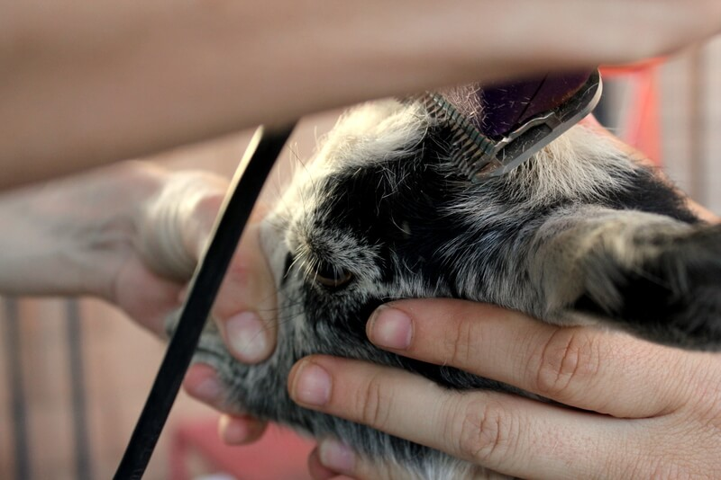

Step 2. Place the kid in the disbudding holding box which provides excellent restraint especially if working alone. The baby goat’s head should be through the u-shaped slot with the head pulled out and the ears held back.
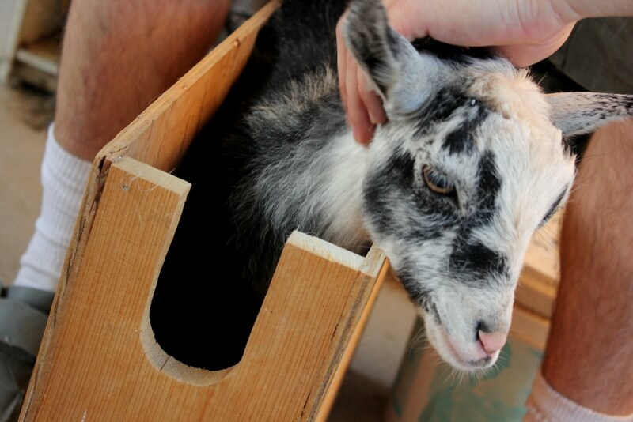

Step3. Test the iron on a piece of wood to ensure it burns a nice ring within 2 seconds. Place the hot iron down around the tip of bud. Using light pressure for a full thickness burn slowly rotate the iron around in a clock-wise manner for 10 seconds. Not more because you run the risk of the terminal meningitis. What you want is a nice copper ring approximately 1/4 -3/4 inch around the base of the bud. This is to remove the horn, germinal cells and surrounding skin. Tip- You may not get the copper ring on the first try. Burn the second bud while the first side cools.
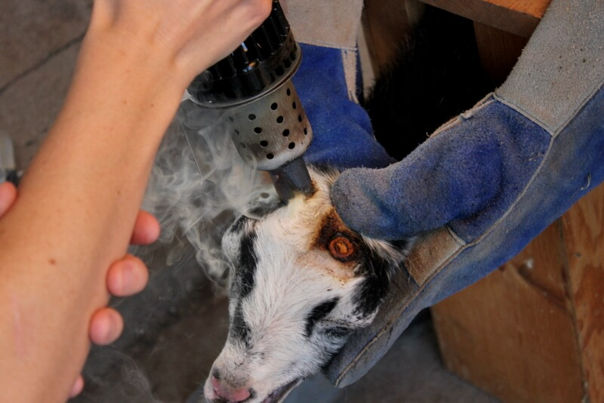

4. Cut or break off buds with hands.
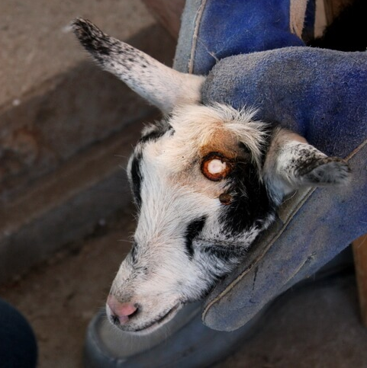

5. Using the side of the iron move it around to burn the base of the bud. It there is any bleeding from breaking the horn bun off this will cauterize it. Repeat for other horn.
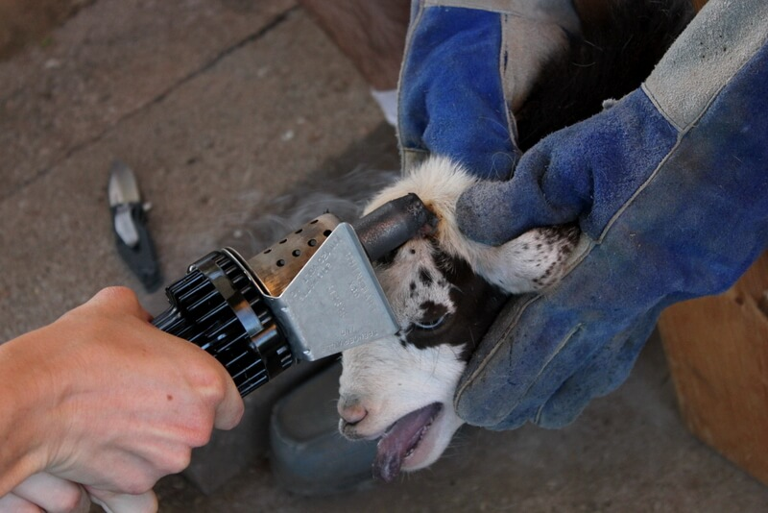

6. Male goats have a sent gland medial and caudal to where the horn buds are, you need to burn an extra ring overlapping the original ring in a figure of eight pattern. This prevents scurs (partial abnormal horns) from growing as well as reduce the buck scent.

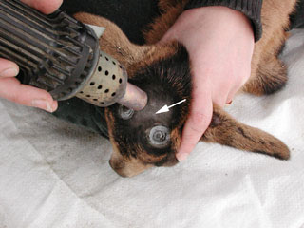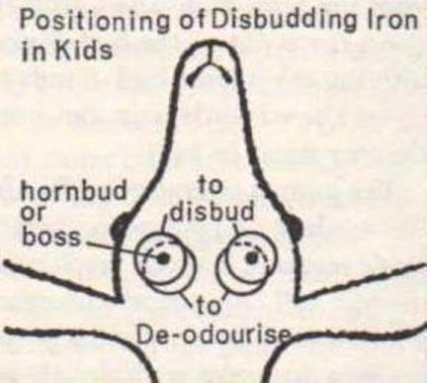

7. Check your work. Ensure buds are properly burned brown all around!
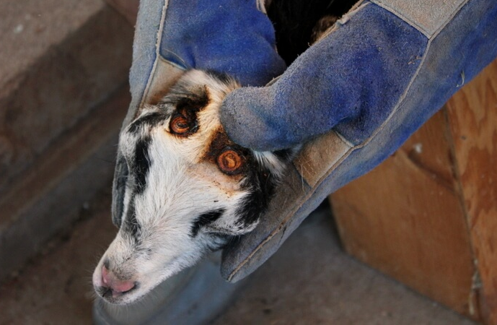

8. Spray area with antibacterial and anti-myiasis spray. Monitor daily and treat wound until healed.

References
1. Disbudding, Descenting, and Dehorning Goats [Internet]. Infovets.com. 2018 [cited 30 September 2018]. Available from: http://infovets.com/books/smrm/C/C158.htm
2. Wolford D. How to Disbud & Dehorn a Baby Goat - Weed 'em & Reap [Internet]. Weed 'em & Reap. 2018 [cited 30 September 2018]. Available from: https://www.weedemandreap.com/how-disbud-dehorn-baby-goat/

