**Disbudding**

**Post-procedure**

**Ketamine stun (xylazine/ketamine)**

The ketamine stun utilized for sedation of the calf induces its effects after about 2 minutes, reaching maximum effect after around 5 minutes post administration.

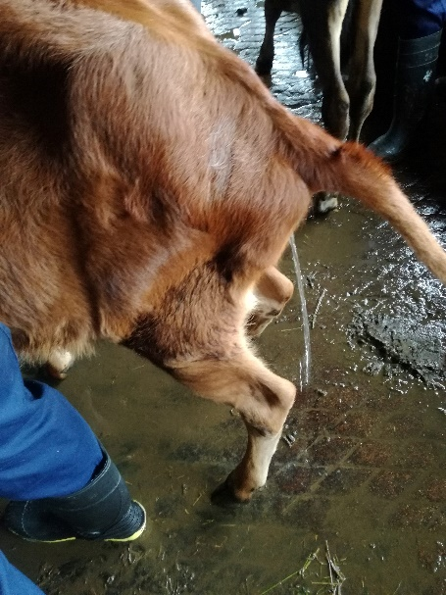

Signs observed upon onset include:

* Increased salivation
* Voiding of urine and faeces

(Our calf began urinating 11mins after the block was given)

* Lowering of the head
* Decrease in alertness

**Cornual block of the lacrimal nerve**

2% lidocaine was administered to block the cornual branch of the lacrimal nerve typically its effects initiates within 2-5 minutes. Its anaesthetic effects last approximately 1- 1½ hours, providing sufficient time to conduct the disbudding procedure with greater ease.

The block is confirmed by the needle prick test, where a needle is used to repeatedly pierce the skin of the corium surrounding the base of the horn. Absence of a reaction when this is done, confirms complete desensitization of the area, ensuring the block has taken full effect.

**Post-disbudding**

Use of the disbudder must be done carefully to ensure full coverage of the area where the germinal epithelium is located. The cauterization must be adequate right around the horn bud to ensure the prevention of regrowth. This is observed by a dark brown ring that circles the horn bud, affecting both the horn and the surrounding corium.

**Wound Care**

With disbudding, no open wounds were created while using the hot iron disbudding technique therefore it is of least risk to the animal. Fly management is of utmost importance and topical antibiotics.