Gigli Wire

What is it?

A long piece of wire is attached to two handles, then moved back and forth rapidly to saw through the horn base plus a ½-inch circle of skin.

Technique for Gigli Wire (as done in lab)

* Animal was sedated with a ketamine stun and region of the horn was anaesthetized with local anaesthetic (2% lidocaine) by conducting a cornual nerve block.
* With use of a scalpel blade the margin of a ½ inch circle was cut around the horn.
* Placed at the cut skin at the base of the horn the Gigli wire was then moved back and forth rapidly in long strokes to saw through the horn.
* After the horn was removed, a haemostat was used to clamp the artery to control bleeding of the blood vessel.
* A hot iron was also used to cauterize the area and further stop bleeding as well as form a copper ring around the skin from which the horn was removed to ensure the destruction of the horn producing cells.

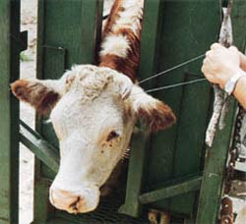 -*picture demonstrating use of a gigli wire for dehorning*

*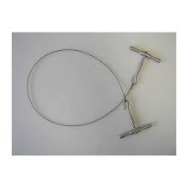 - image of a Gigli Wire*

*Video link:*

[*https://youtu.be/GxV35EZ1px4*](https://youtu.be/GxV35EZ1px4)

*\*note technique in video may have not included use of anaesthesia; it should also be noted that any dehorning and disbudding procedures should be done with the use of anaesthesia to minimize any pain or discomfort felt by the animal during the procedure.*

[*https://youtu.be/zF3_aIWV0j8*](https://youtu.be/zF3_aIWV0j8) *- Link demonstrates the use of a Gigli wire for dehorning.*

**Advantages:**

* Can be used to remove horns in older cattle.

**Disadvantages:**

* Greater risk of exposed sinus, infection and blood loss
* painful
* may lead to set-backs in overall health and performance, including weight loss
* requires follow-up care
* poses risk of injury to the animal and handler.