*Keystone Dehorner /Dehorning cup/guillotine shears /*

**What is a Keystone Dehorner?**

A keystone dehorner has two handles that move a blade downward against a plate or another blade, slicing through the base of the horn and surrounding skin.

**How is it used?**

[**https://youtu.be/JmmbpOG5NzQ**](https://youtu.be/JmmbpOG5NzQ)

**\*skip to 3:03 mins to demonstration of use of a Keystone Dehorner.**

**IMPORTANT**: It should be advised that **ANY** dehorning procedure be carried out with the animal under anaesthesia effect to minimize pain and discomfort.

**Advantages:** Can be used in older cattle with large horns.

**Disadvantages:**

* Greater risk of exposed sinus, infection and blood loss
* painful; may lead to set-backs in overall health and performance, including weight loss
* requires follow-up care; poses risk of injury to the animal and handler.

**Ref link: http://www.dehorning.com/dehorning-methods/keystone-or-guillotine-dehorning**

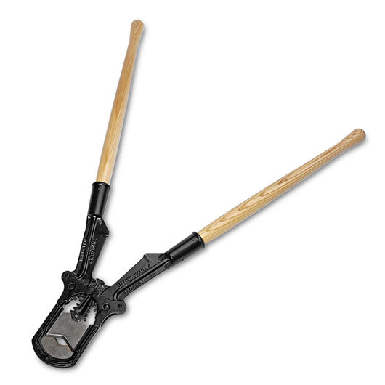 **-** *picture showing a Keystone Dehorner*

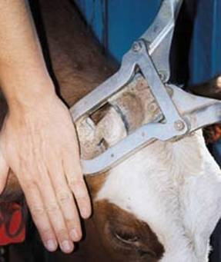 *- figure showing demonstration of the use of a Keystone Dehorner.*